|  |  |  |
| --- | --- | --- |
|  | **CAN THO UNIVERSITY SOFTWARE CENTER** |  |
| **MEKONG DELTA - APTECH** |

**SEMESTER PROJECT – II**

**CERTIFICATE GENERATION SYSTEM**

|  |  |
| --- | --- |
| **Instructor:** | **Class:** CP1896G05 |
| Ms. Lê Thị Minh Loan | **Team:** 4 |
|  | **Students:** |
| 1. A18097- Phạm Hoàng Tâm  2. A18118- Nguyễn Trường Giang  3. A18103- Nghiêm Anh Tú  4. A18120- Trần Một Em |

Can Tho, 7/2019

|  |
| --- |
| *The ABC Institute's certification office is the place to register for courses and issue certificates to students, previously all work was done manually and time-consuming, due to the increasing needs of students. Many manual jobs no longer meet the needs of the job, so we need to advance our work by creating an online certification system. Creating and certifying students who have completed the course, all of the work here is done in the most advanced way from input to output. The registration process is fast and convenient, students register and modify information online on the system and the payment is also made in many different forms, students can be assured after completing the course, the certificate issuance in the shortest time and ensuring student information is accurate, minimizing information errors as well as the time of issuing certificates at the lowest level. To done these works, we decided to deploy the Client-Server model for Certificate Generation System of the ABC institute. The certificate system will build a LAN network and apply the Client-Server model. The server is a centralized place for managing tasks and hosting, managing clients. Server is also the place to store accounts of Admin, Certificate Cell, Student with different access rights to the system. Client computers will be required to login when they want to access the system. The model will help improve information security.* |

**Client/Project Undertaken:** *Certificate Generation System*

1. **List of inputs to the system**

* Certificate Cell information (Certificate ID, Certificate Name)
* Student information (Student ID, Name, Address, DOB, Gender, Phone, Address)
* Admin information (ID, Name, Address, DOB, Gender, Phone, Role)
* Teachers(TeacherID, Name, DOB, Gender, Phone, Address, Academic Level, Technique)
* Course(CourseID, Course Name)
* Marks of students
* Class of students (Class ID, Class Name)
* Subjects of Course (Subject ID, Subject Name, Fee)
* Grade of Certificate(GradeID, Grade Name)

1. **List of ouputs expected from the system**

* Personal information of students (Marks, Certificate, Payment status, …)
* Report and statistic of Admin & Certificate Cell, Students, Teachers, Course, Exam, Class, Subject, Certificate
* List of Admin & Certificate Cell, Students, Teachers, Exam, Class, Subject, Grade, Teaching, Course, Certificate
* List or report of students who are eligible and not yet eligible to complete the course
* Student list or report has received the certificate

1. **Overview of processes involved in the system**

* Log in, Log out (*The log in portal appears every time you enter the system, asking the user to confirm the access. The system contains three login: Admin, Certificate Cell, Student Login*).
* Admin:
  + Manage Admin & Certificate Cell Account
  + Manage Students
  + Manage Teachers
  + Manage Class
  + Manage Grade of Certificate
  + Manage Course
  + Manage Subjects
  + Manage Exam
  + Manage Teaching
  + Manage Certificate
  + Create reports
* Certificate Cell:
  + Manage issued certificate for the students
* Students:
  + View their payments status for the course
  + View my profile

1. **Hardware and software required for implementing the project**

* **Hardware Requirements:**
  + Server:
    - CPU: Intel Core i5-5200U, 2.5GHz
    - RAM: 4GB or higher
    - HDD: 500GB Hard Disk space or higher
  + Client:
    - CPU: Intel Core i3 or higher
    - RAM: 2GB or higher
    - HDD: 128GB Hard Disk space or higher
* **Software Requirements:**
  + Server:
    - Windows 8/ 10 (or higher)
    - SQL Server 2012 (or later)
    - JDBC, JDBC Driver 1.8
    - J2SE
  + Client:
    - Windows 8/ 10 (or higher)

|  |  |
| --- | --- |
| **S.No** | **Customer’s Acceptance Criteria** |
| 1. | Login, Logout |
| 2. | The system contains three login: Admin, Certificate Cell, Student Login |
| 3. | Create a registration form for students |
| 4. | Update Database |
| 5. | Create lists or report from Database |
| 6. | Create Fees Structure |
| 7. | Marks Entry for subjects |
| 8. | Manage the certificate for the students |
| 9. | Verifies the status of the students |
| 10. | Check whether the students have given the all exam |
| 11. | Generate the appropriate message to the students |
| 12. | Students can view their registration and certification information. |
| 13. | Students can check the balance remained and result form |
| 14. | Data is backed up, updated regularly. |

**Project Plan**

1. **Project Details**

* **Name of the Client:** *Certificate Generation System*
* **Date of Project Plan:** 10 September, 2019
* **Project Vision/Objectives:**
* Provide Certificate Generation System for ABC Institute.
* Build management system help computerize the Certificate Department. And to overcome the problems that the ABC Institute is facing.
* Increase efficiency and accuracy in student management.
* Save time, money and minimize management staff.
* **Scope:**

Depending on the decision taken by the management ABC Institute, following are the requirements based on which the Certificate Generation System needs to be developed*:*

* Build Certificate Generation System based on client-server model
* The system will be maintained and repaired if any problems occur with the system
* The system has the functions as stated:
  + Login, Logout
  + The system contains three login: Admin, Certificate Cell, Student Login
  + Create a registration form for students
  + Update Database
  + Create lists or report from Database
  + Create Fees Structure
  + Marks Entry for subjects
  + Produce the certificate for the students
  + Verifies the status of the students
  + Check whether the students have given the all exam
  + Generate the appropriate message to the students
  + Students can view their registration and certification information.
  + Students can check the balance remained and result form
  + Data is backed up, updated regularly.
* **Our understanding of the client organization:**

*(Give the range of services, functions, overview of the process, and so on.)*

* Building The Certificate Generation System for ABC institute. Overcomeissues of ABC institute.
* Building the system according to the desired organization: contains information of 3 accounts including: (Admin, Certificate Cell, Students)
  + Admin account contains functions to maintain the database, mark entry for subjects, create a registration form for students, create fees structure
  + The Certificate Cell account contains functions for issuing certificates to students when they have completed their payment and completed all exams.
  + Student accounts allow them to view payment status and personal information
* **Project Organization with Responsibilities and Authorities:**

*(Given the name of project team members theirs roles and responsibilities)*

|  |  |  |
| --- | --- | --- |
| **Members** | **Role** | **Responsibilities** |
| Pham Hoang Tam | Leader, Developer, Tester | Project planning. Report job status. Code, CRS and Testing |
| Nguyen Truong Giang | Developer, Tester | Code, Testing, CRS |
| Tran Mot Em | Developer, Tester | Code, Testing, CRS |
| Nghiem Anh Tu | Developer, Tester | Code, Testing, CRS |

1. **Project Initiation/Requirement Documents**

* Information required from the Certificate Generation System
* Building Client-Server application with Socket in Java ([https://gpcoder.com/3679-xay-dung-ung-dung-client-server-voi-socket-trong-java/](https://gpcoder.com/3679-xay-dung-ung-dung-client-server-voi-socket-trong-java/#Mo_hinh_Client-Server_su_dung_Socket_o_che_do_co_noi_ket_TCP))
* Certificate Generation System | International Journal (<https://www.academia.edu/9148268/Certificate_Generation_System>)

1. **Deliverables**

* Source code
* Document: CRS, Design Document, Installation Manual, User Manual, Maintenance Manual, and Code documents
* File .JAR

1. **Project Dependencies**

Any event or task outside the scope of the project, which will affect the success of the project

* Depend on time
* Depend on Internet

1. **Major Project Milestones**

* Analyzing (from 10-Sep-2019 to 15-Sep-2019): analyze and find solutions to meet with the requirement of the problem.
* Designing (from 16-Sep-2019 to 23-Sep-2019): start designing database and the overall interface for the project after analyzing the problem.
* Coding (from 24-Sep-2019 to 13-Oct-2019): begin coding after designing database and interface.
* Testing (from 14-Oct-2019 to 17-Oct-2019): test all the functions to make sure that everything run correctly.

1. **Quality Plan**

* **Review Activities**
* Two days review work once
* **Testing** **Activities**
* Test case design or test case writing
* All team members together
* **Backup and recovery strategies**
* Save to USB
* Use GitHub to synchronize the code
* Upload Google Drive, Fshare, MediaFire, OneDrive

**Document Design**

|  |  |
| --- | --- |
| **Propertiy** | **Value** |
| Document theme and color scheme | Blue, White |
| Form-Background color | Blue, White |
| Title-Font Size | 18px |
| Title-Font Color | Black |
| Title-Font Style | Times New Roman |
| Title-Alignment | Center |
| Background color of Controls on the form | Blue |
| Foreground color of Controls on the form | Blue, White |
| Control Caption-  Font size | 14px |
| Control Caption-  Font Style | Times New Roman |
| Control caption and controls-Alignment | Center |
| Command button-Alignment | Center |

1. **List of forms to be created**

|  |  |  |
| --- | --- | --- |
| **Document Name** | **Description** | **Controls on the Document** |
| Log In | The interface used to log in |  |
| Manage Admin & Certificate Cell | The interface used to manage admin and certificate cell |  |
| Manage Admin & Certificate Cell | The interface used to view profile of admin or certificate cell |  |

|  |  |  |
| --- | --- | --- |
| Manage Students | The interface used to manage students |  |
| Manage Teachers | The interface used to manage teachers |  |
| Manage Course | The interface used to manage course |  |

|  |  |  |
| --- | --- | --- |
| Manage Grade | The interface used to manage grade of certificate |  |
| Manage Class | The interface used to manage class |  |
| Manage Subjects | The interface used to manage subjects |  |

|  |  |  |
| --- | --- | --- |
| Manage Exam | The interface used to manage exam |  |
| Manage Teaching | The interface used to manage teaching |  |
| Manage Certificate | The interface used to manage certificate |  |

|  |  |  |
| --- | --- | --- |
| Search & Verify Student Profile | The interface used to search & Verify Student Profile |  |
| Search & Verify Student Profile | The interface used to search & Verify Student Profile |  |
| Search & Verify Student Profile | The interface used to search & Verify Student Profile |  |

|  |  |  |
| --- | --- | --- |
| Search & Verify Student Profile | The interface used to search & Verify Student Profile |  |
| Search & Verify Student Profile | The interface used to search & Verify Student Profile |  |
| Search & Verify Student Profile | The interface used to search & Verify Student Profile |  |

|  |  |  |
| --- | --- | --- |
| Search & Verify Student Profile | The interface used to search & Verify Student Profile |  |
| Search & Verify Student Profile | The interface used to search & Verify Student Profile |  |
| View Personal Information | The interface used to student view Personal Information |  |

|  |  |  |
| --- | --- | --- |
| View Personal Information | The interface used to student change password |  |

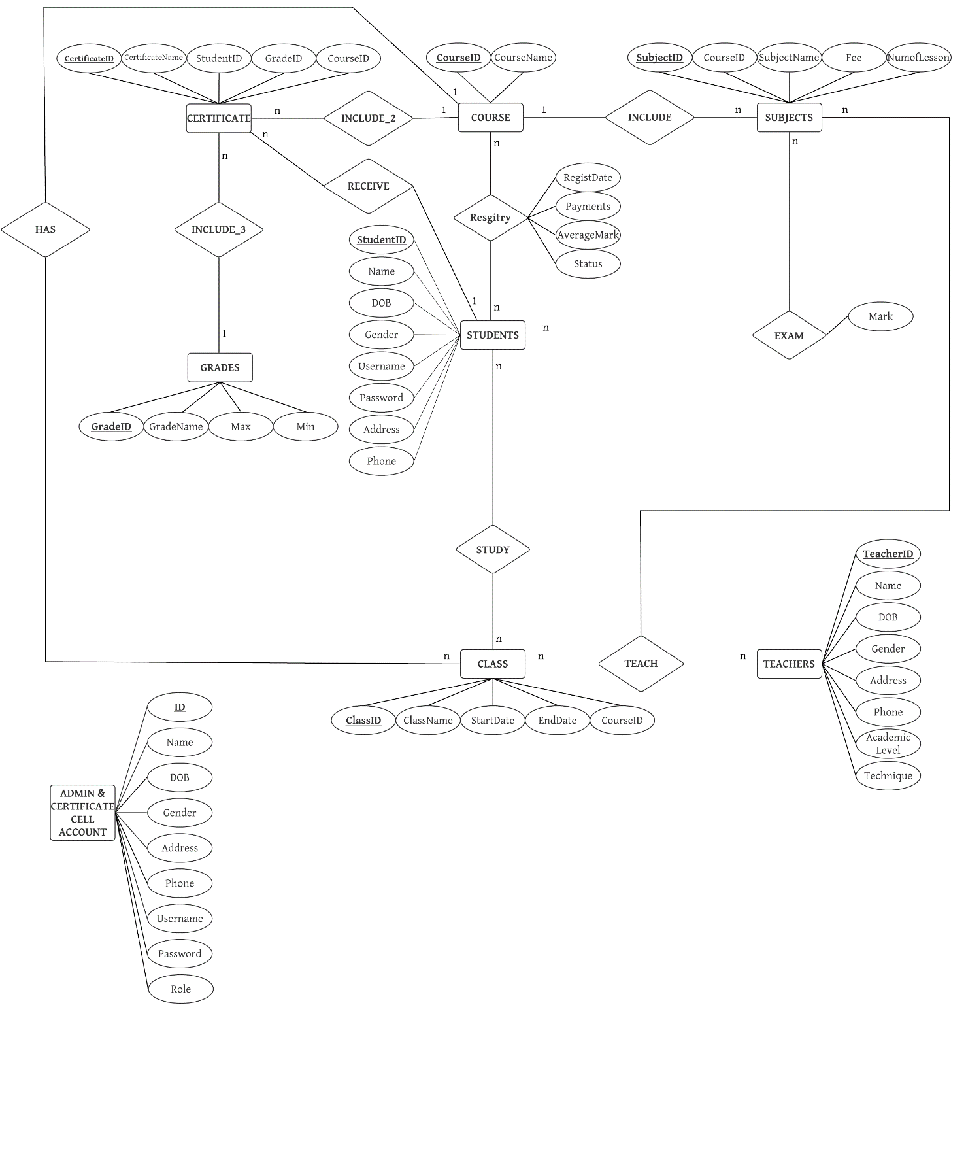

|  |  |  |  |  |  |
| --- | --- | --- | --- | --- | --- |
| **Name of the table** | **Table Description** | **Number of Fields** | **Primary Key** | **Related Table** | **Foreign Key** |
| ADMIN & CERTIFICATE CELL ACCOUNT | Stored Admin & Certificate Cell Information | 1. ID 2. Name 3. DOB 4. Gender 5. Address 6. Phone 7.Username 8. Password 9. Role | **ID** |  |  |
| STUDENTS | Stored Students  Information | 1. StudentID 2. Name 3. DOB 4. Gender 5. Username 6. Password 7. Address 8. Phone | **StudentID** |  |  |
| TEACHERS | Stored Teachers Information | 1. TeacherID 2. Name 3. DOB 4. Gender 5. Address 6. Phone 7. AcademicLevel 8. Technique | **TeacherID** |  |  |
| GRADES | Stored Grade of Certificate Information | 1. GradeID 2. GradeName  3. Max  4. Min | **GradeID** |  |  |
| COURSE | Stored Course Information | 1. CourseID 2. CourseName | **CourseID** |  |  |
| CLASS | Stored Class Information | 1. ClassID 2. ClassName  3. StartDate 4. EndDate  5. CourseID | **ClassID** | 1. COURSE | CourseID |
| SUBJECTS | Stored Subject Information | 1. SubjectID 2. CourseID 3. SubjectName 4. Fee 5. NumofLesson | **SubjectID** | 2. COURSE | CourseID |
| REGISTRY | Stored Student registration Information | 1. StudentID 2. CourseID 3. RegisDate 4. Payments  5. AverageMark  6. Status | **CourseID StudentID** | 1. COURSE 2. STUDENTS | CourseID StudentID |
| EXAM | Stored Student marks Information | 1. StudentID 2. SubjectID 3. Mark | **StudentID SubjectID** | 1. STUDENTS 2. SUBJECTS | StudentID SubjectID |
| CLASSLIST | Stored Class List Information | 1. StudentID 2. ClassID | **StudentID ClassID** | 1. STUDENTS 2. CLASS | StudentID ClassID |
| TEACHING | Information storage for teaching assignment | 1. ClassID 2. TeacherID 3. SubjectID | **ClassID SubjectID TeacherID** | 1. CLASS 2. SUBJECTS 3. TEACHERS | ClassID SubjectID TeacherID |

|  |  |  |  |  |  |
| --- | --- | --- | --- | --- | --- |
| CERTIFICATE | Stored Certificate Information | 1. CertificateID 2. CertificateName 3. StudentID 4. GradeID 5. CourseID | **CertificateID** | 1. STUDENTS 2. GRADES 3. COURSE | StudentID GradeID CourseID |

1. **Process Name:** DFD level 0
2. **Process Description and Details**

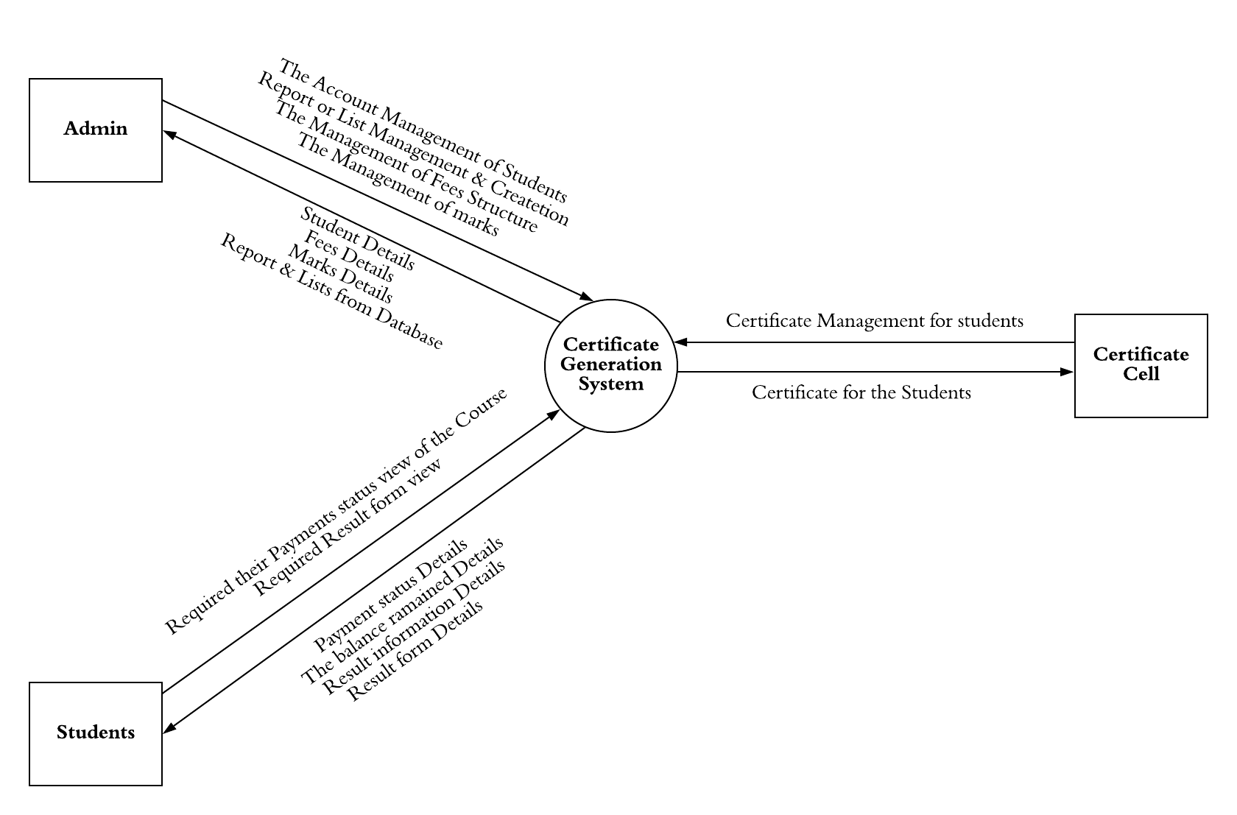

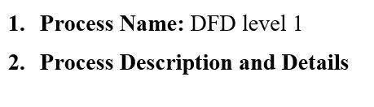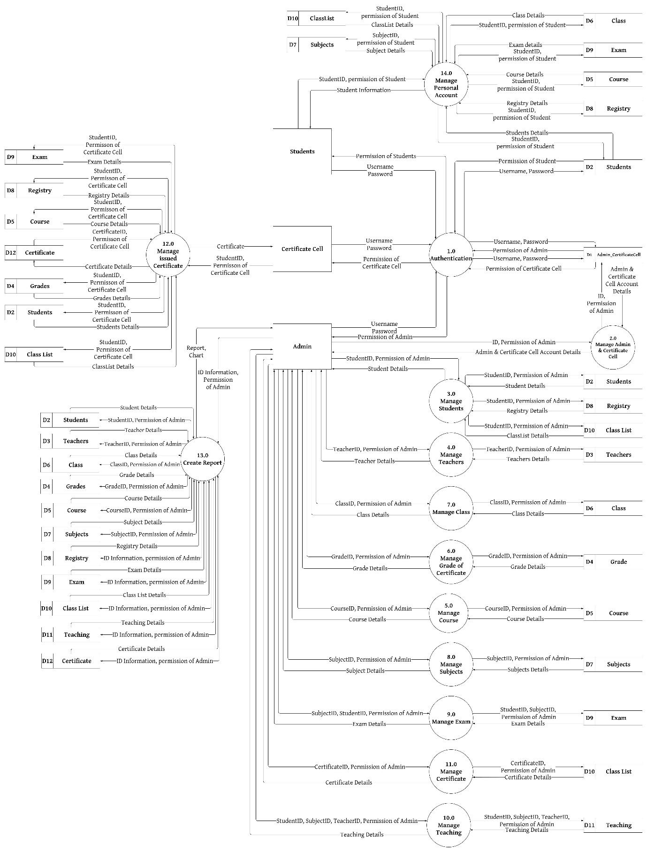

1. **Process Name:** Manage Admin & Certificate Cell Account
2. **Process Description and Details**

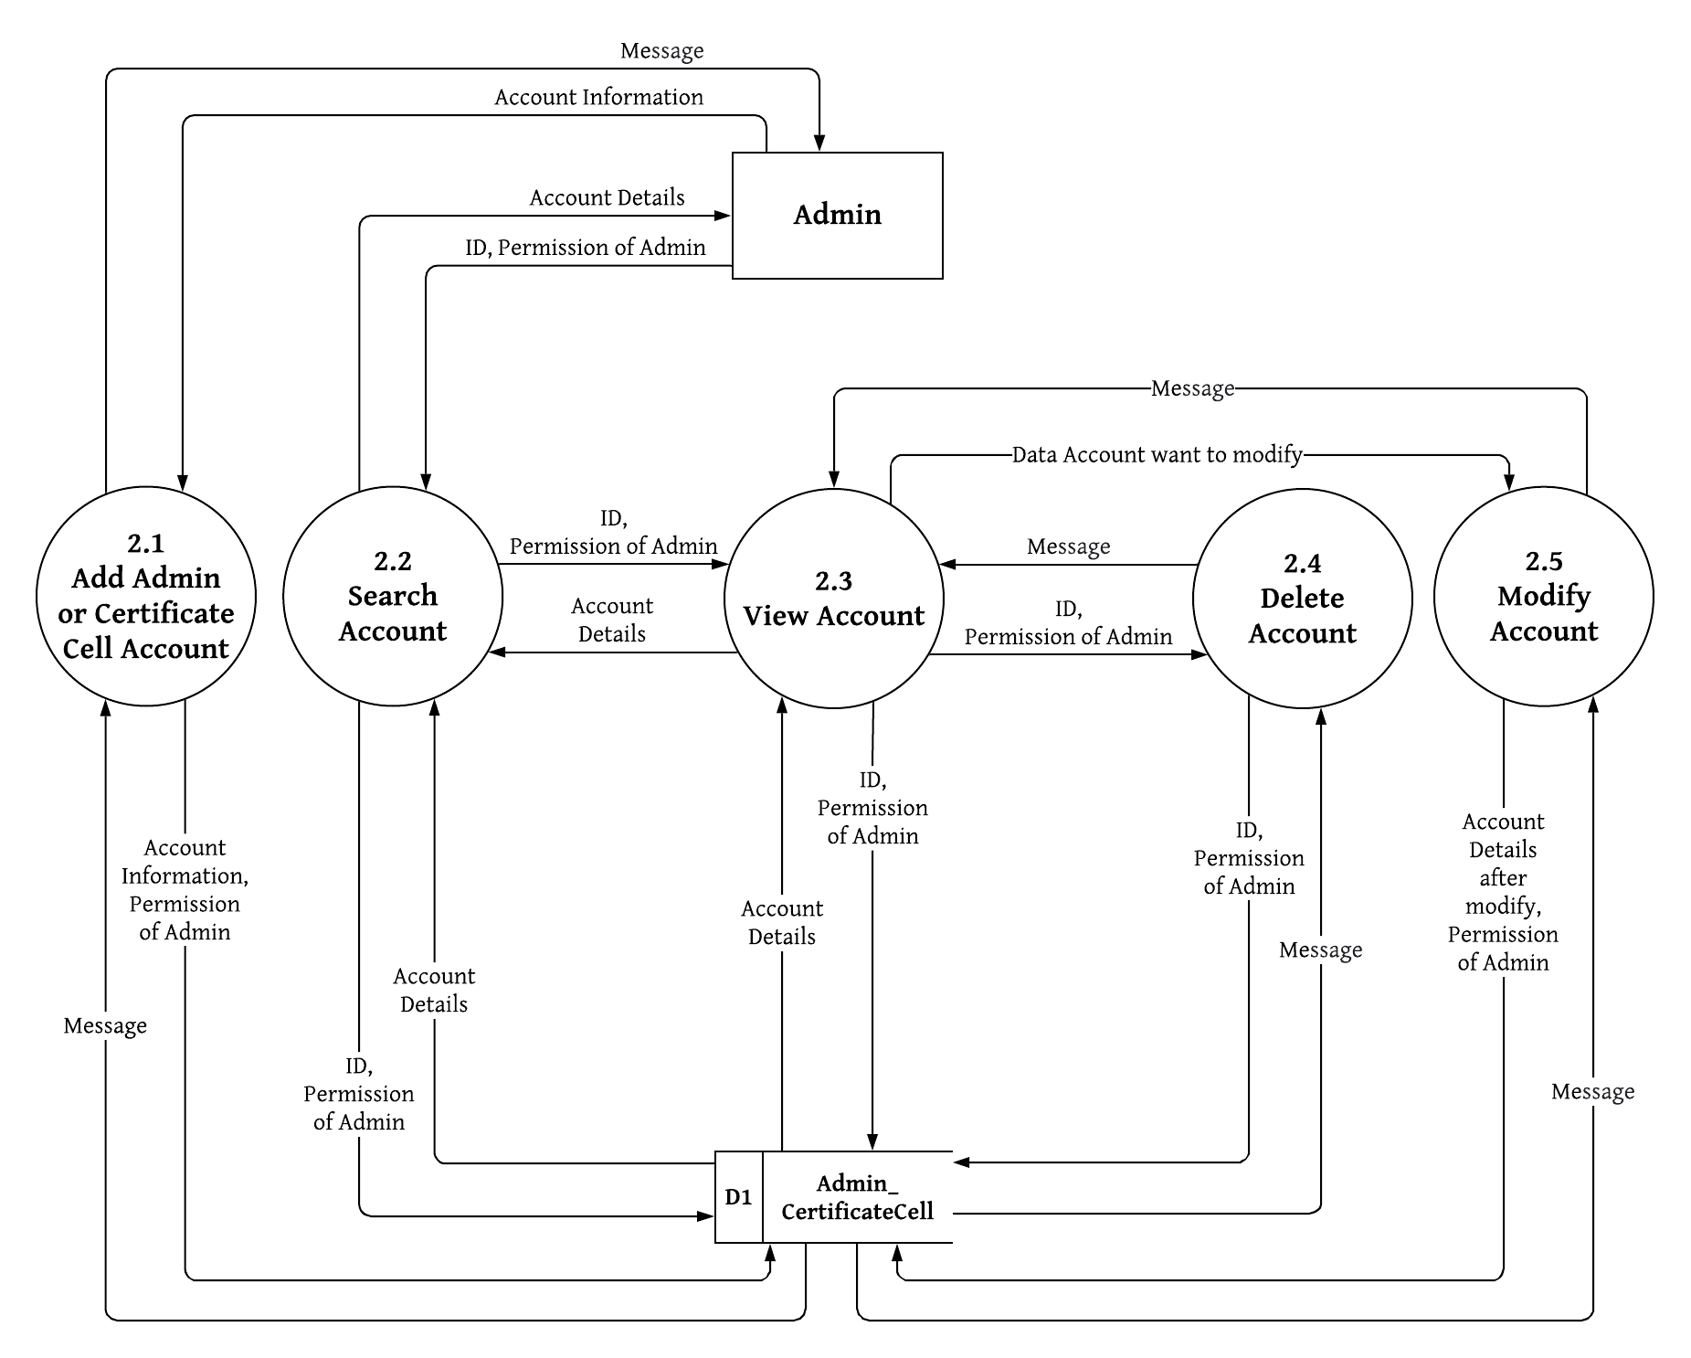

1. **Process Name:** Manage Student
2. **Process Description and Details**

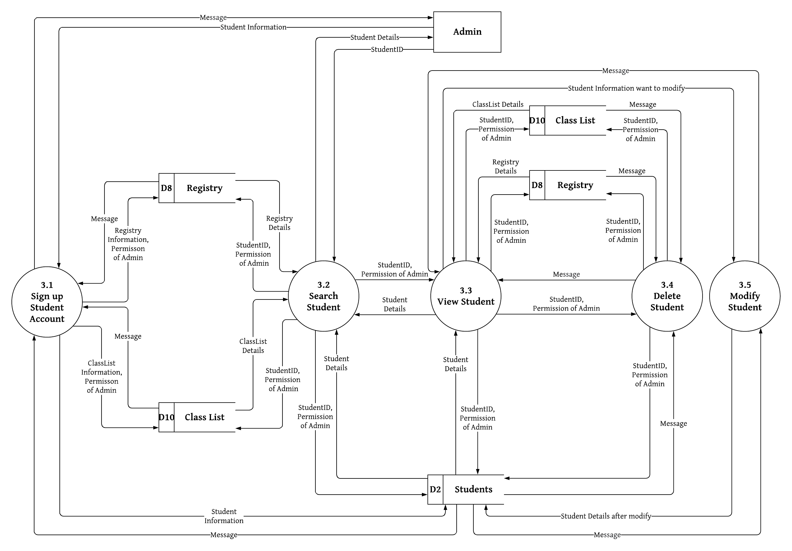

1. **Process Name:** Manage Teachers
2. **Process Description and Details**

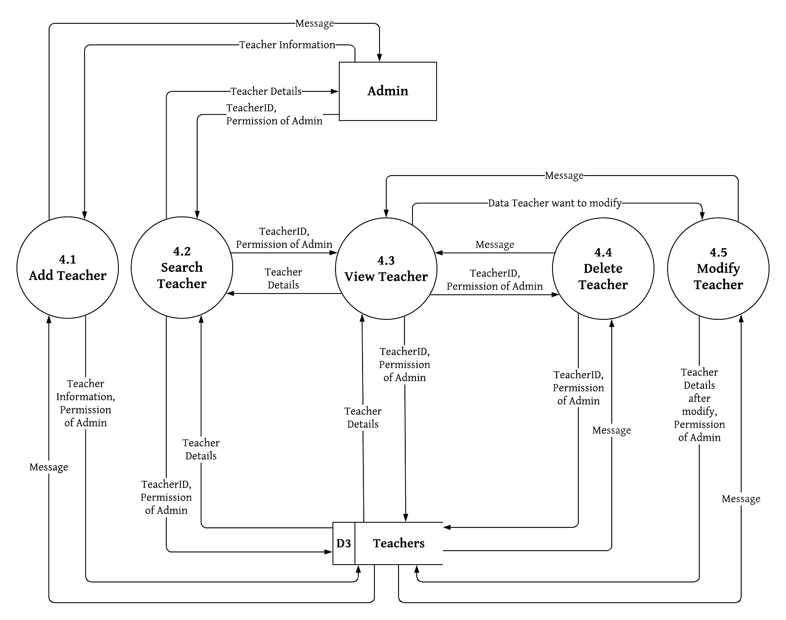

1. **Process Name:** Manage Course
2. **Process Description and Details**

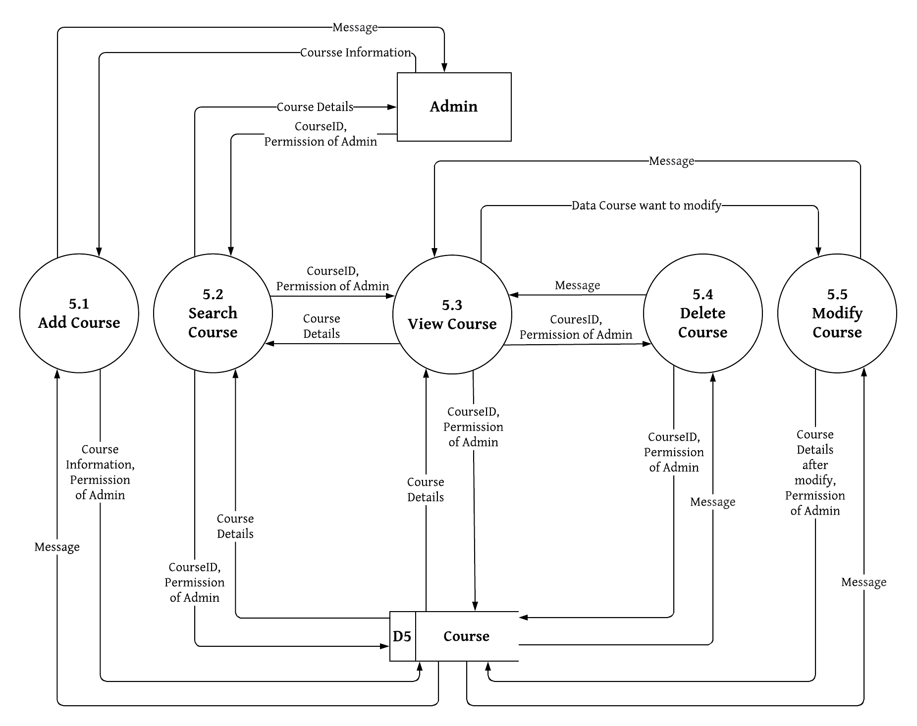

1. **Process Name:** Manage Grade of Certificate
2. **Process Description and Details**

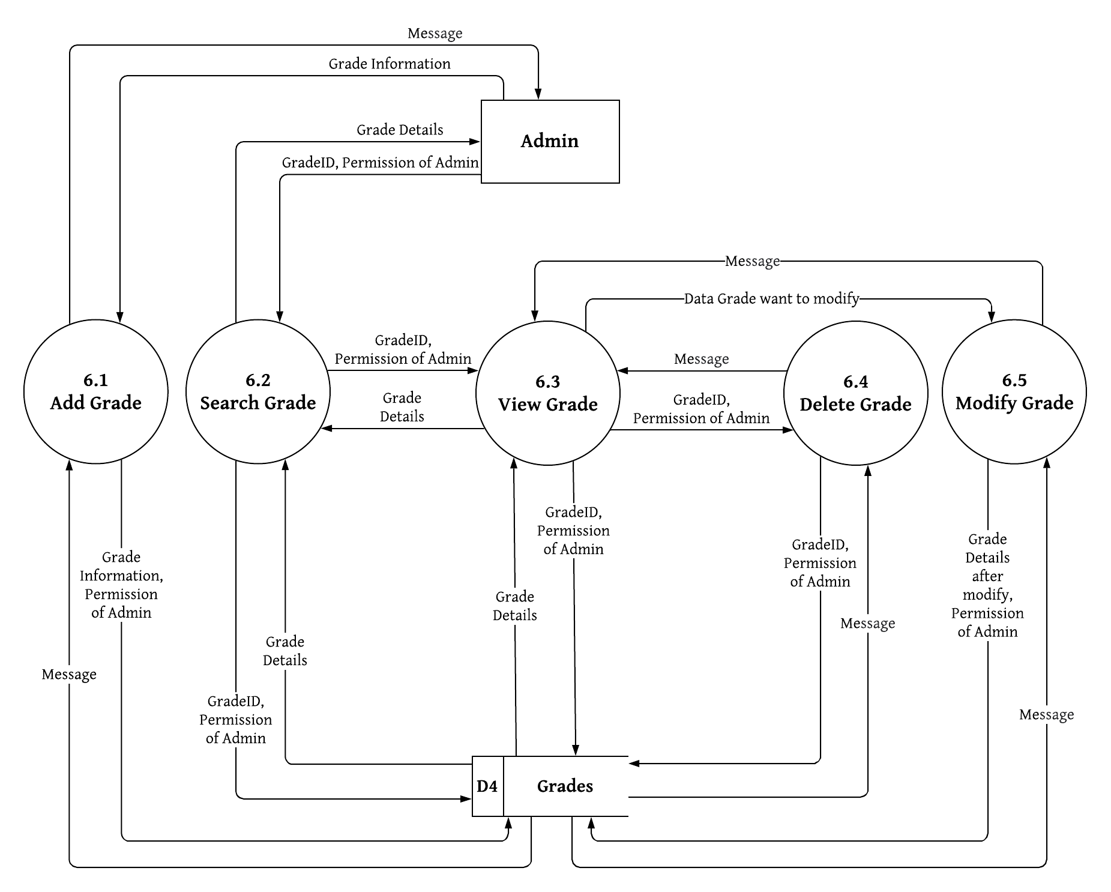

1. **Process Name:** Manage Class
2. **Process Description and Details**

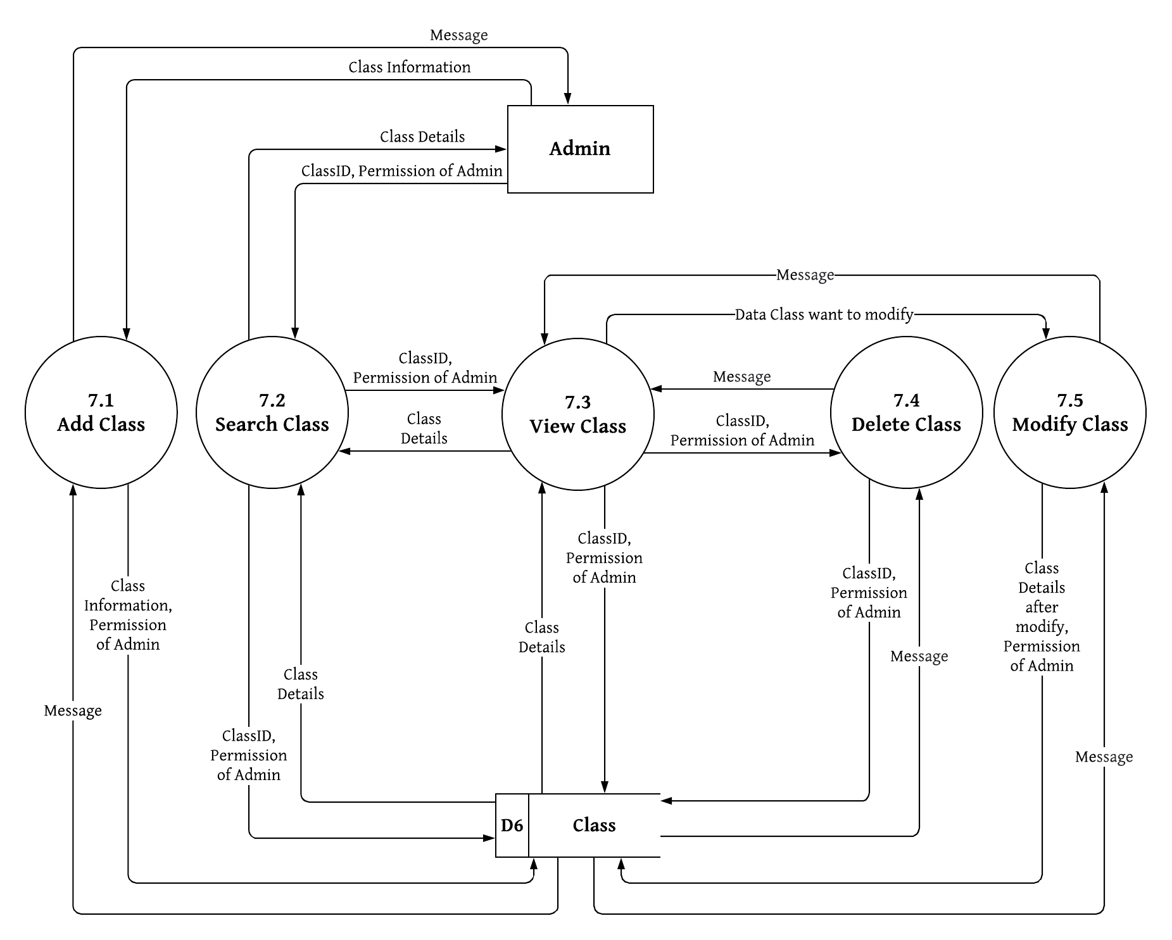

1. **Process Name:** Manage Subject
2. **Process Description and Details**

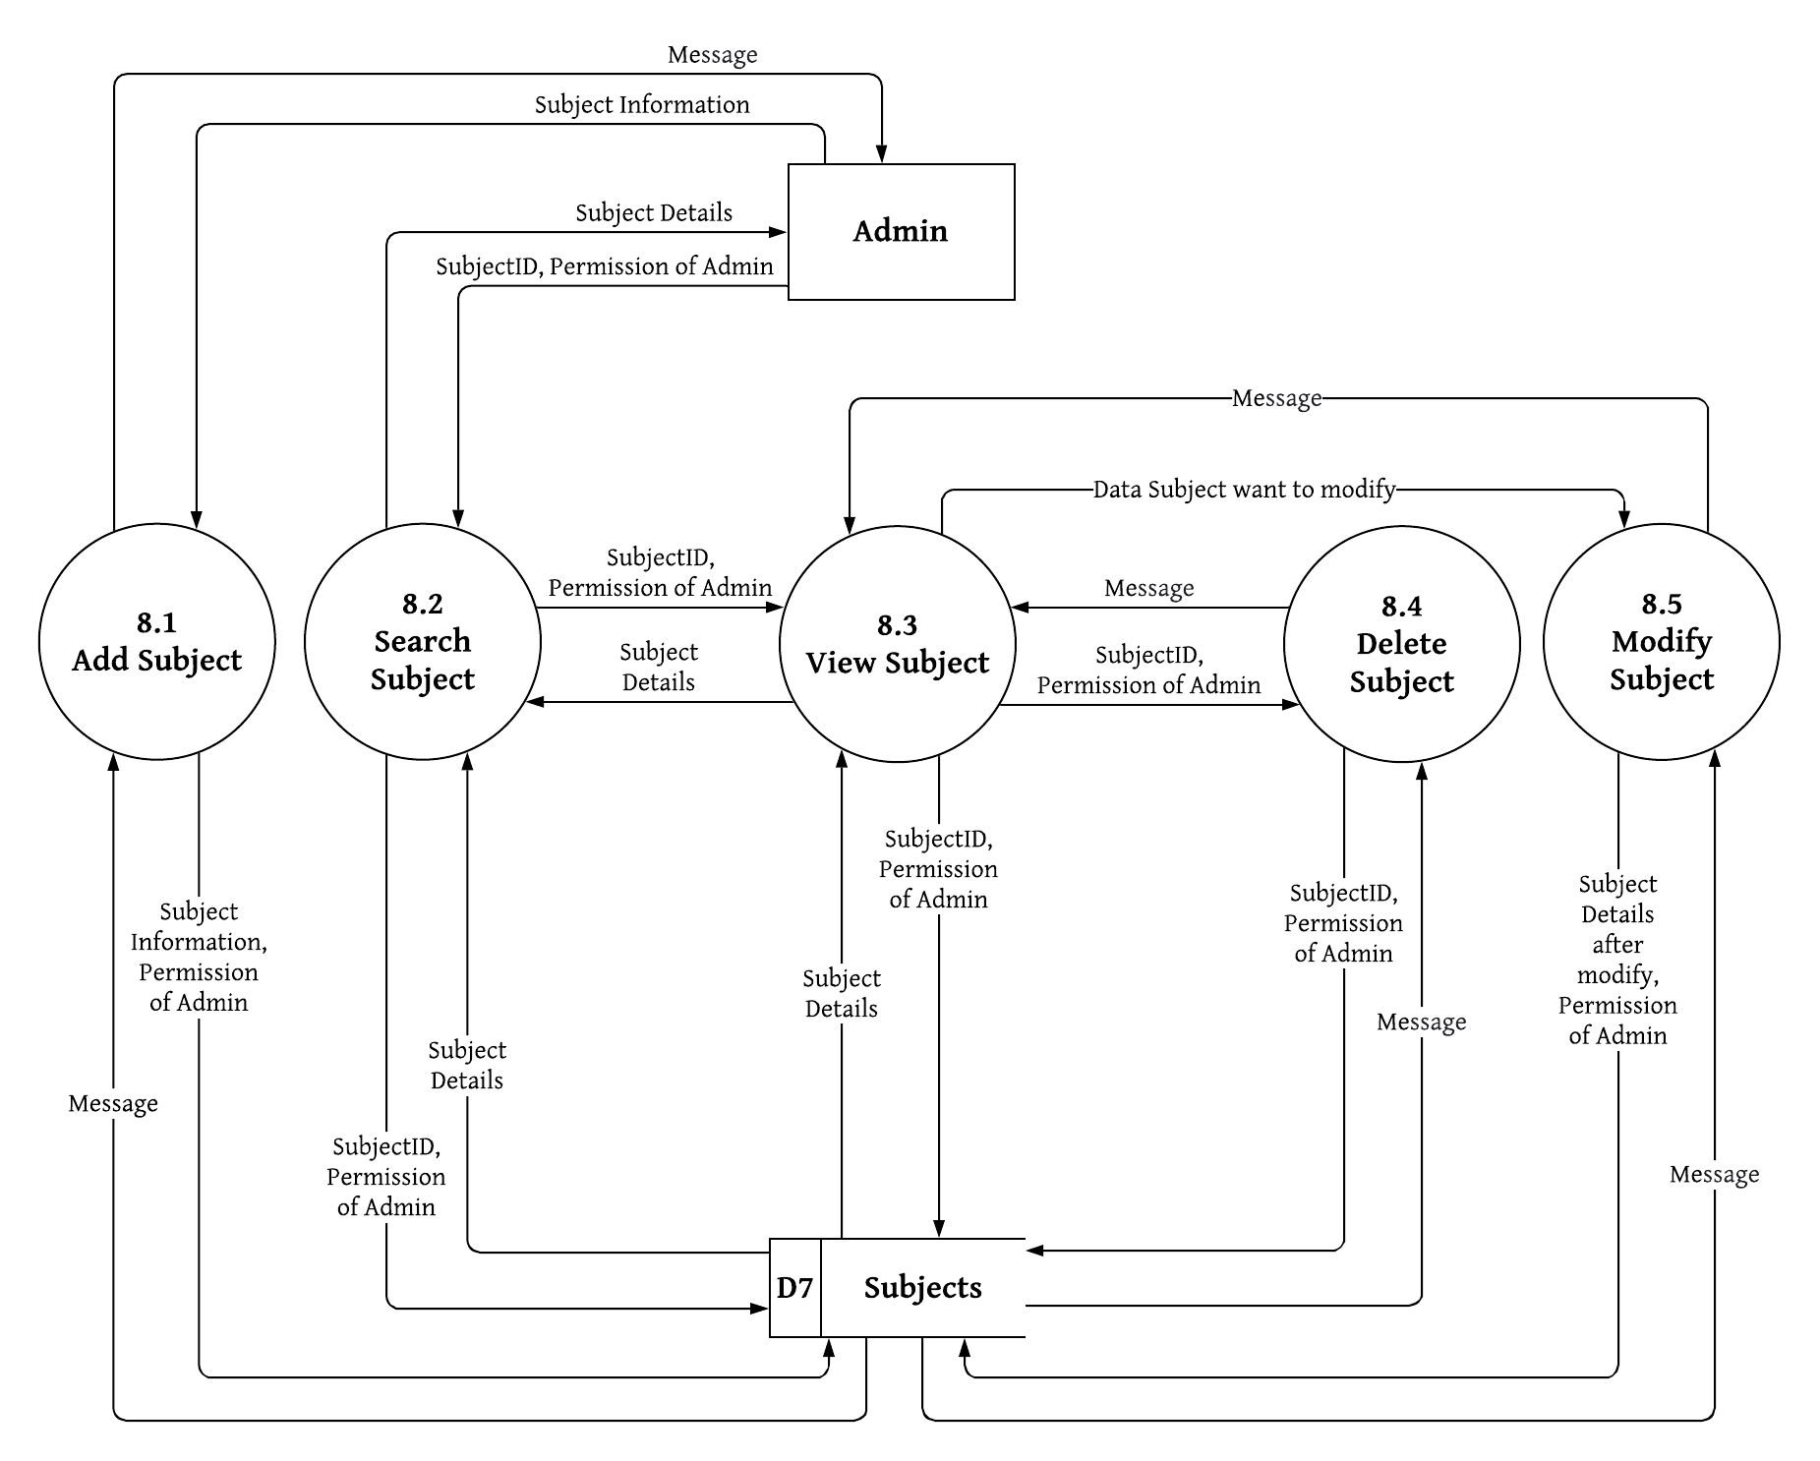

1. **Process Name:** Manage Exam
2. **Process Description and Details**

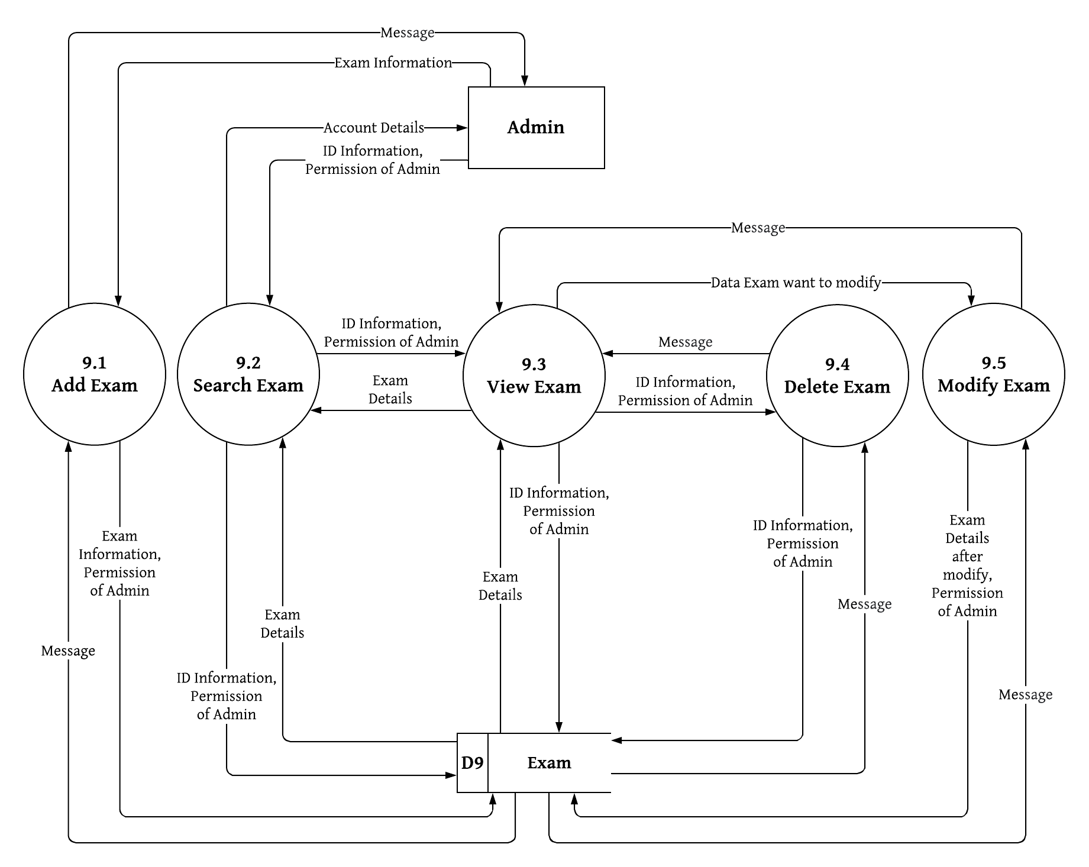

1. **Process Name:** Manage Teaching
2. **Process Description and Details**

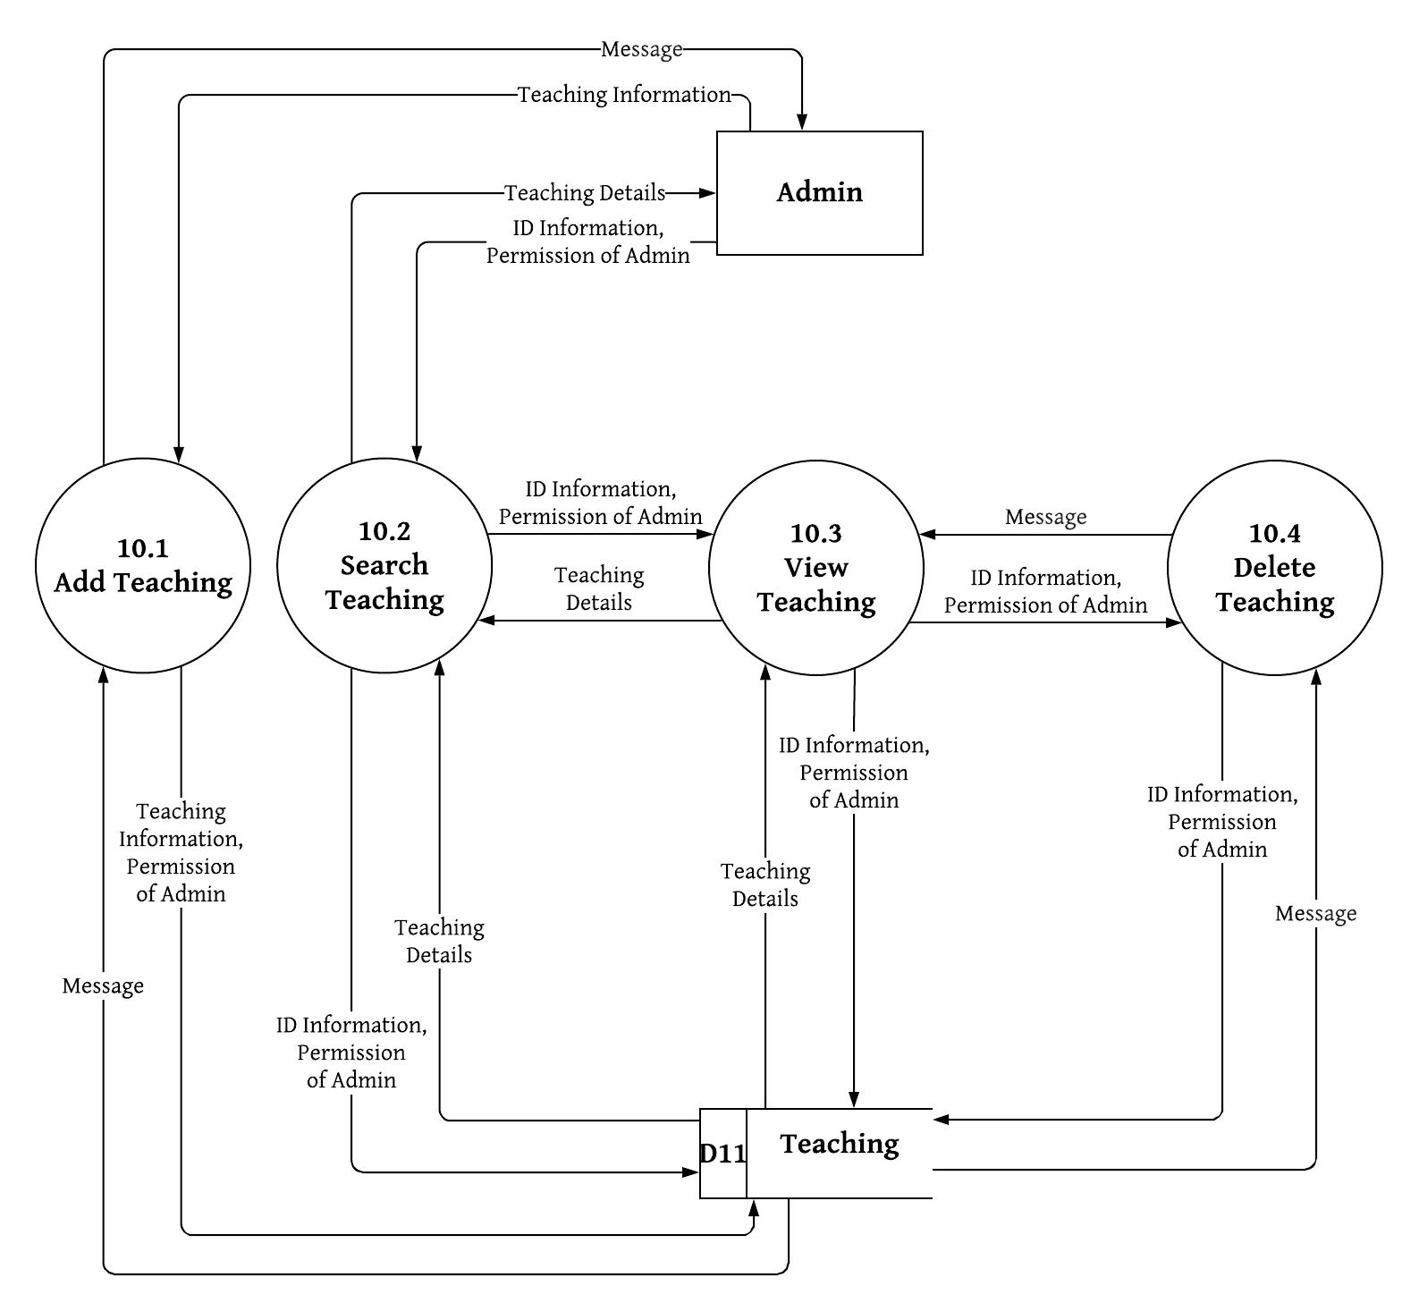

1. **Process Name:** Manage Certificate
2. **Process Description and Details**

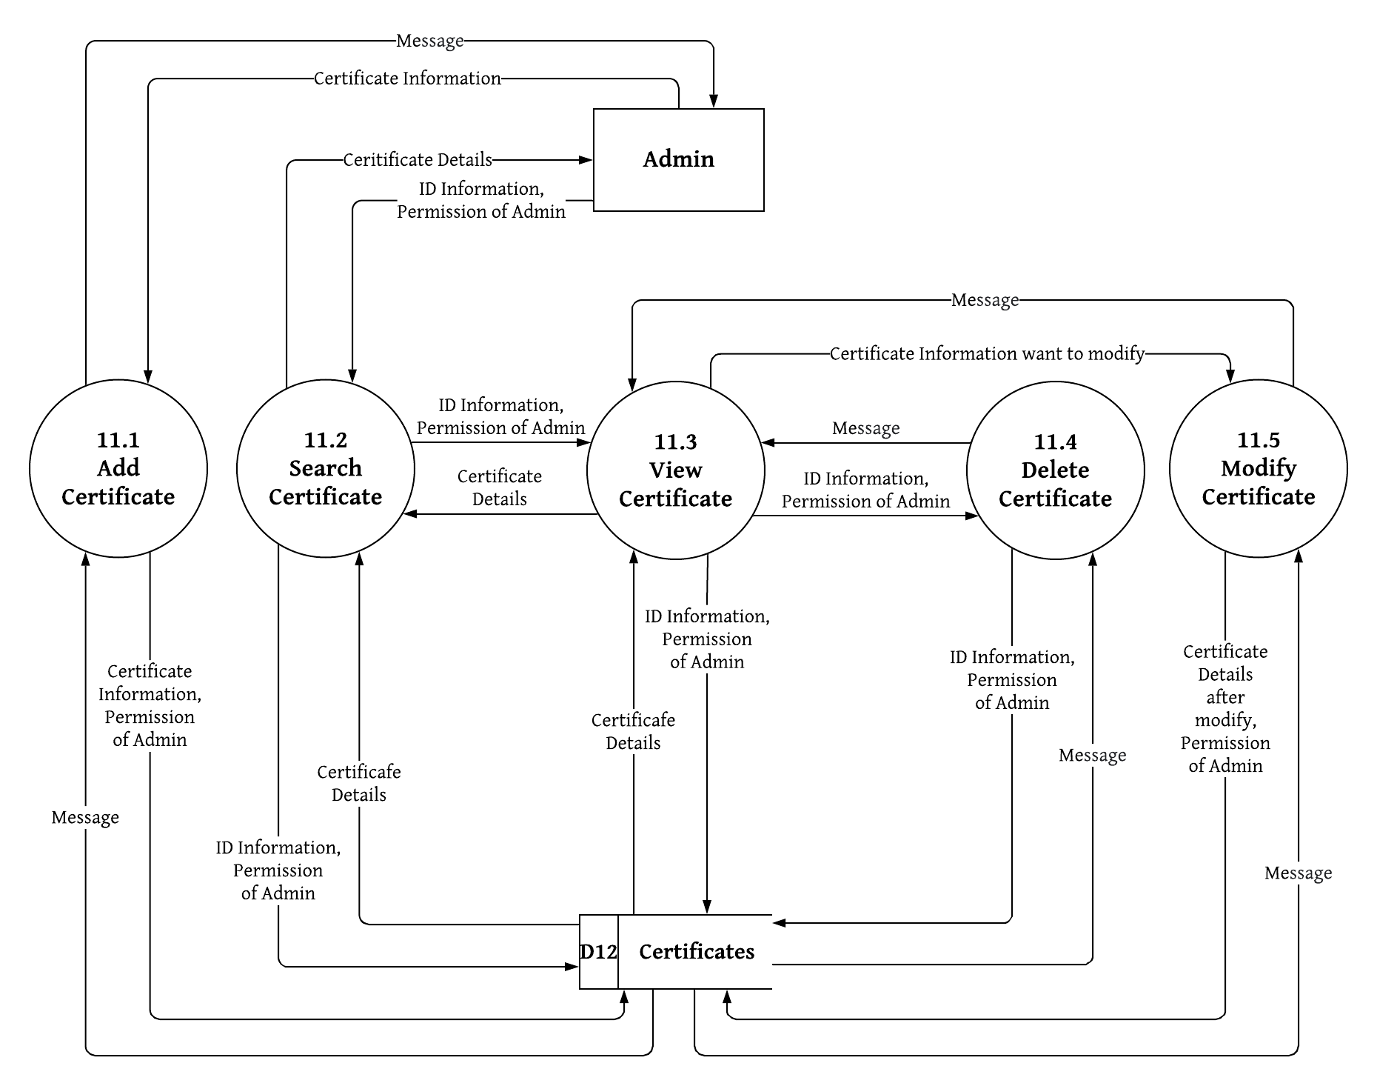

1. **Process Name:** Manage issued Certificate
2. **Process Description and Details**

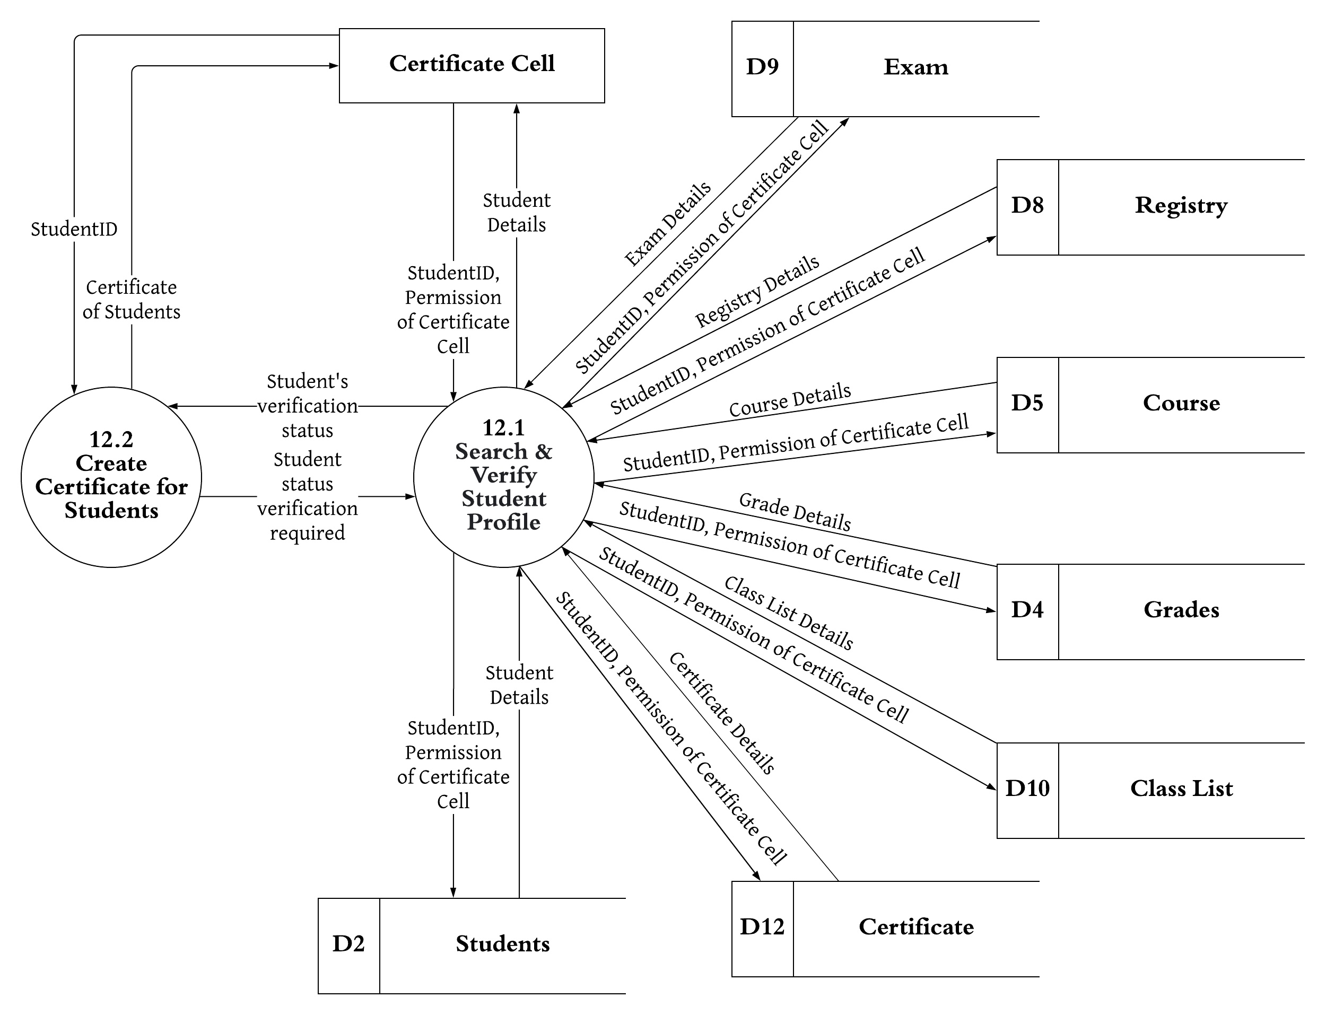

1. **Process Name:** Create Report
2. **Process Description and Details**

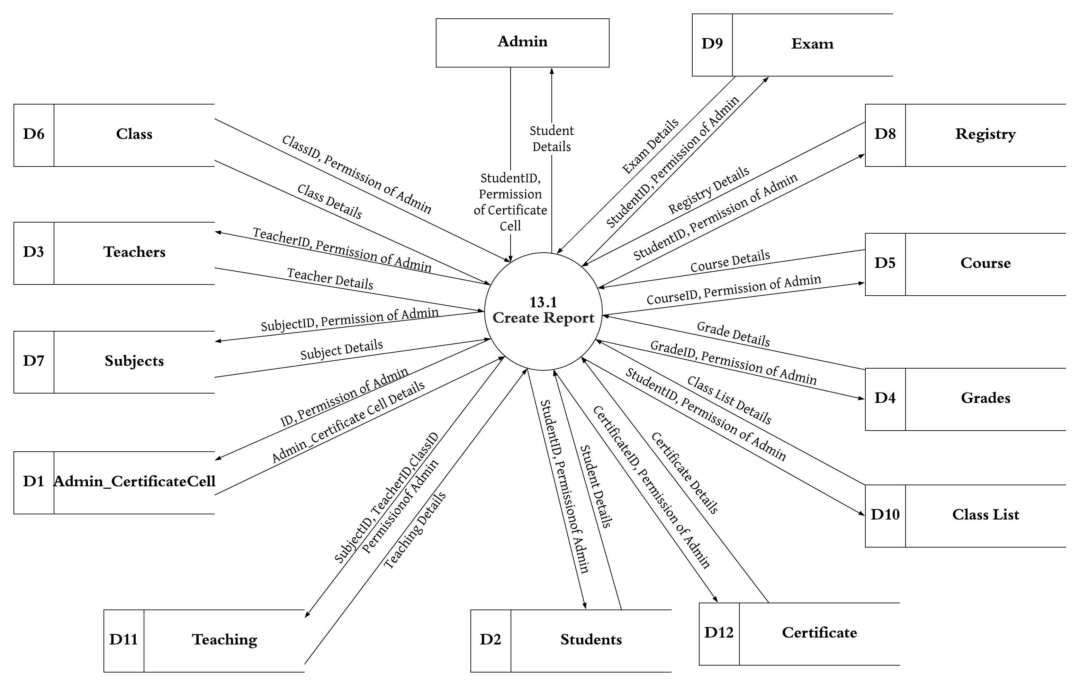

1. **Process Name:** Manage Personal Account
2. **Process Description and Details**

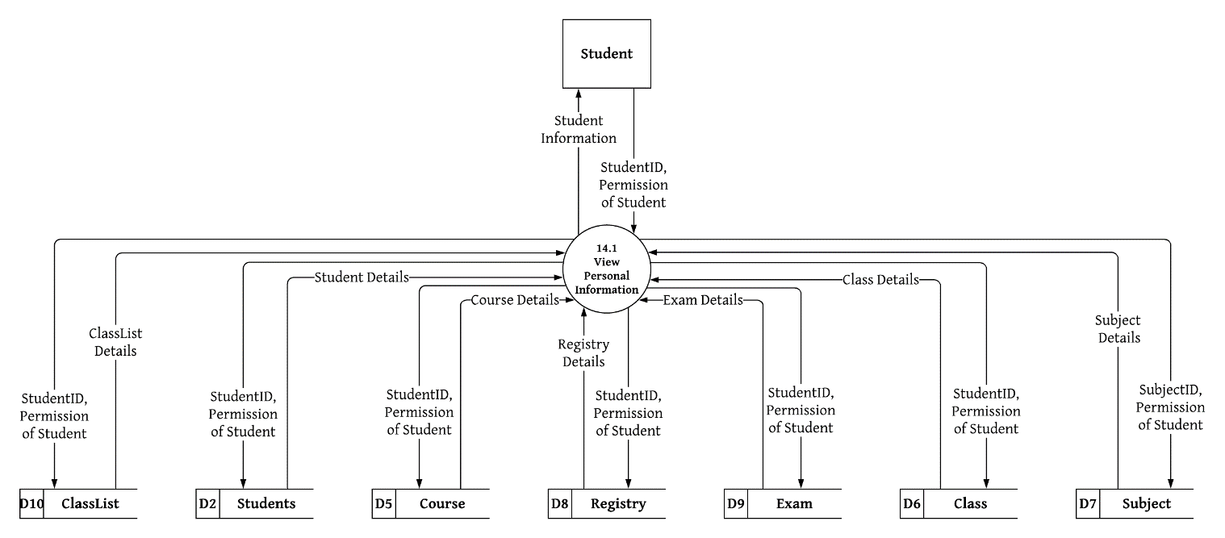

1. **Process Name:** Log In
2. **Process Description and Details**

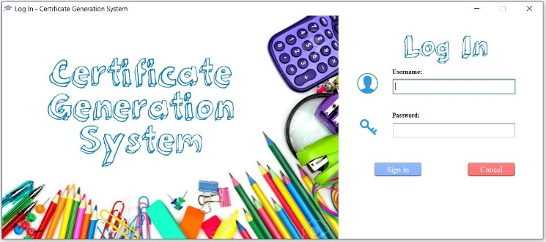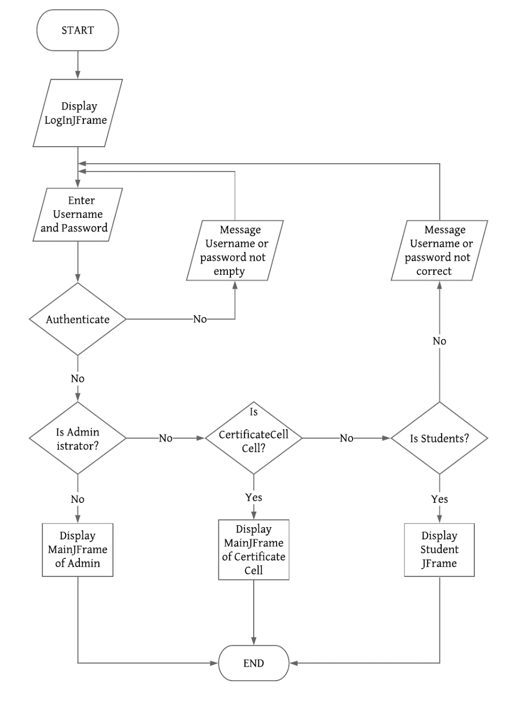

1. **Process Name:** Manage Admin and Certificate Cell
2. **Process Description and Detail**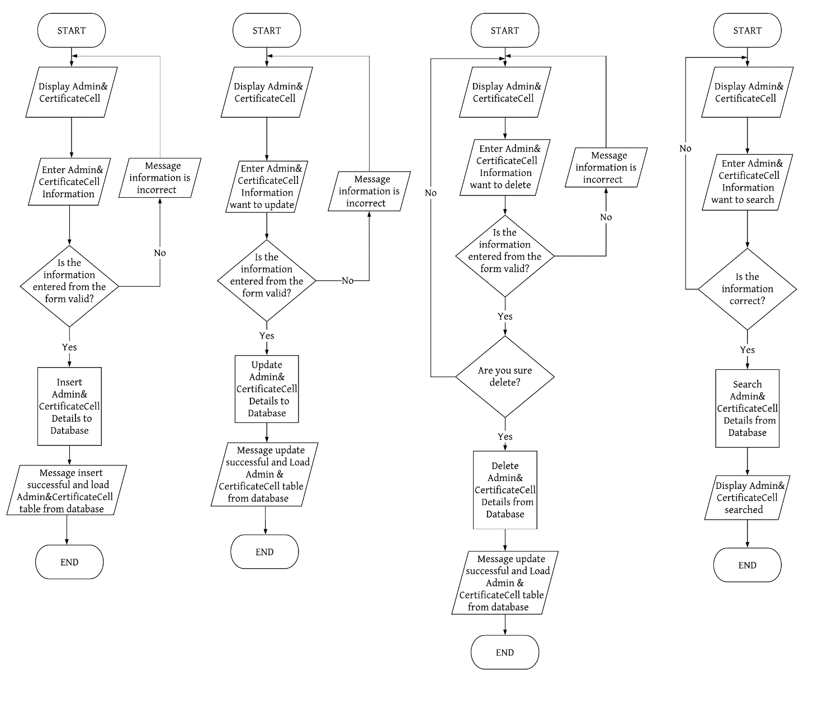

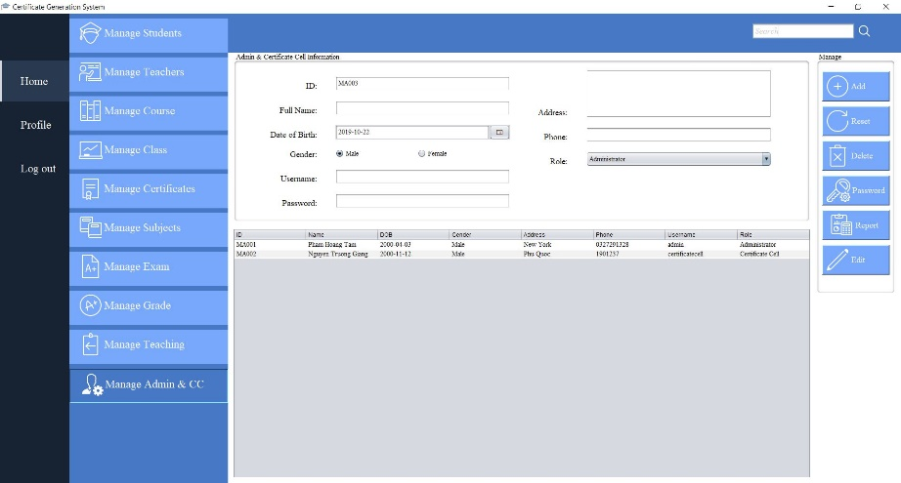

1. **Process Name:** Manage Students
2. **Process Description and Details**

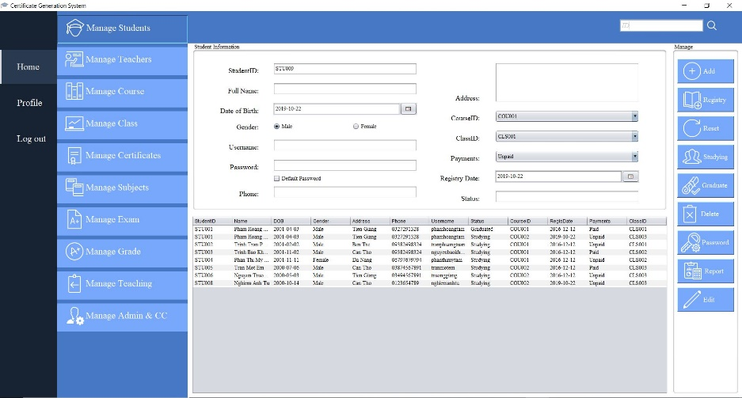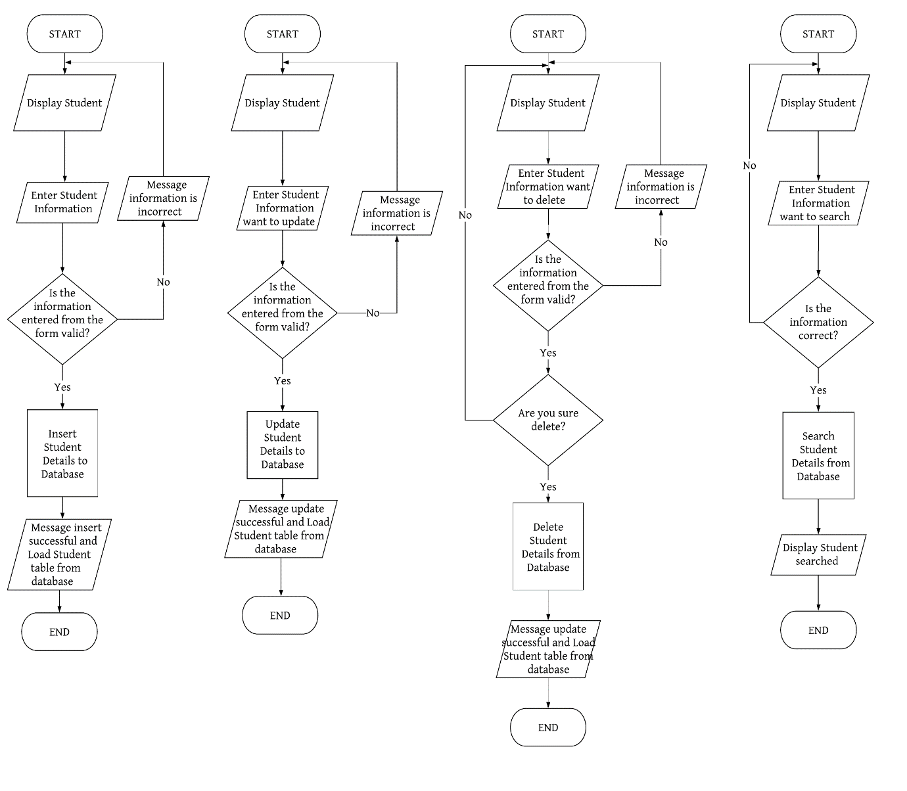

1. **Process Name:** Manage Teachers
2. **Process Description and Details**

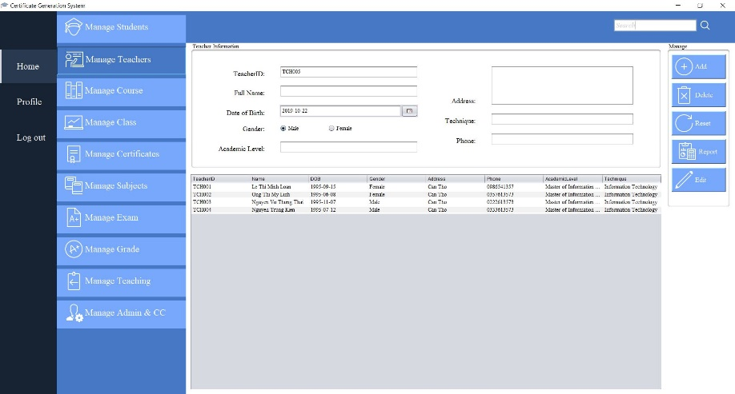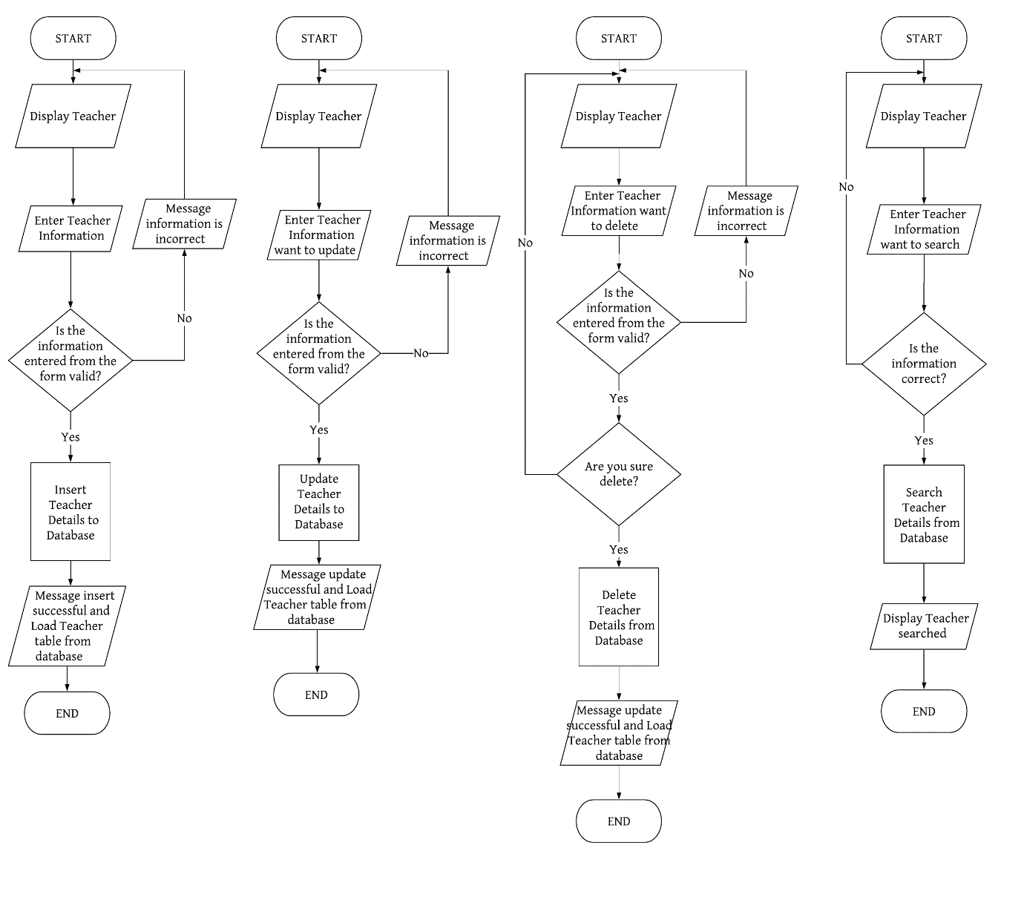

1. **Process Name:** Manage Course
2. **Process Description and Details**

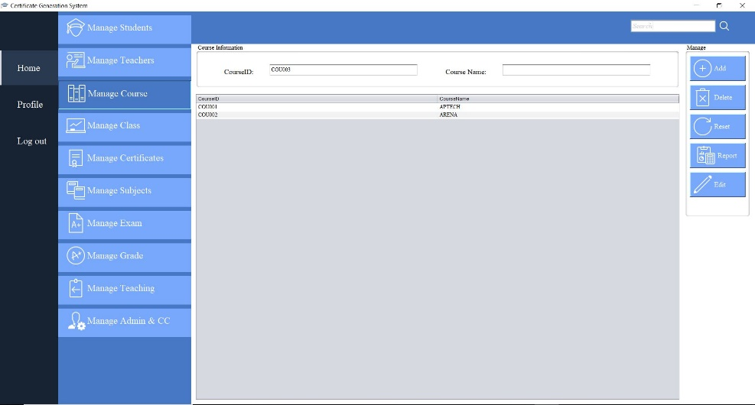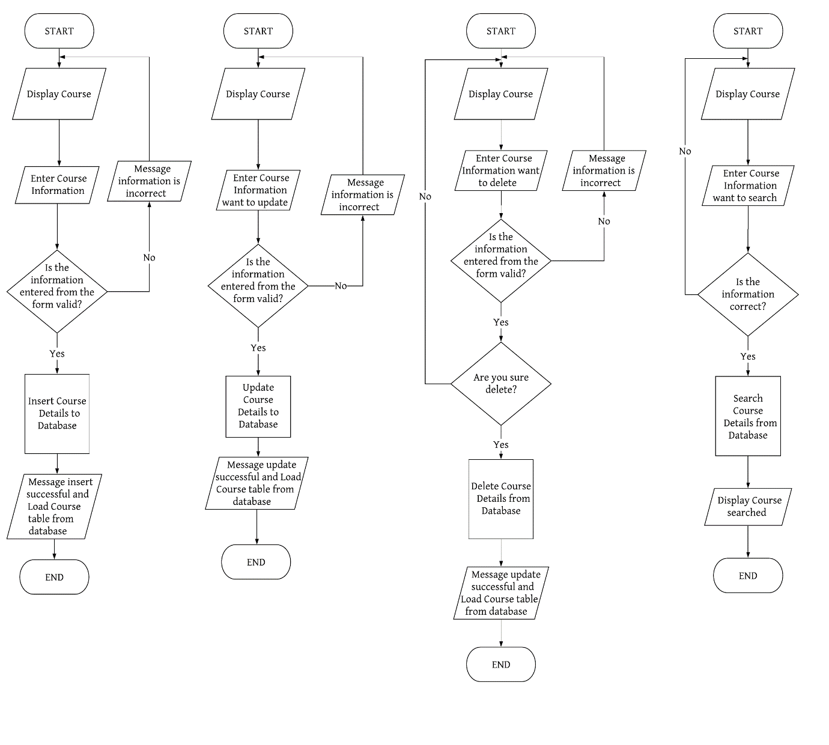

1. **Process Name:** Manage Grade
2. **Process Description and Details**

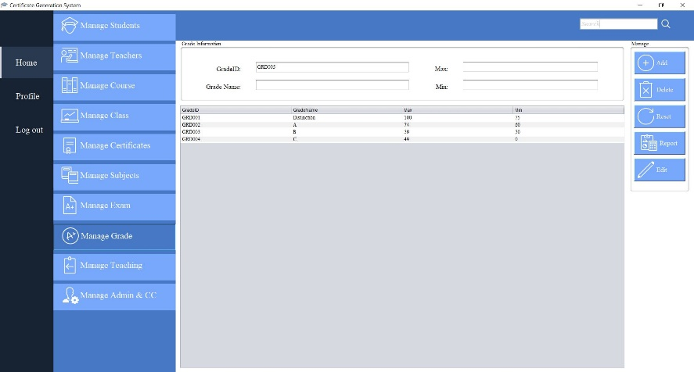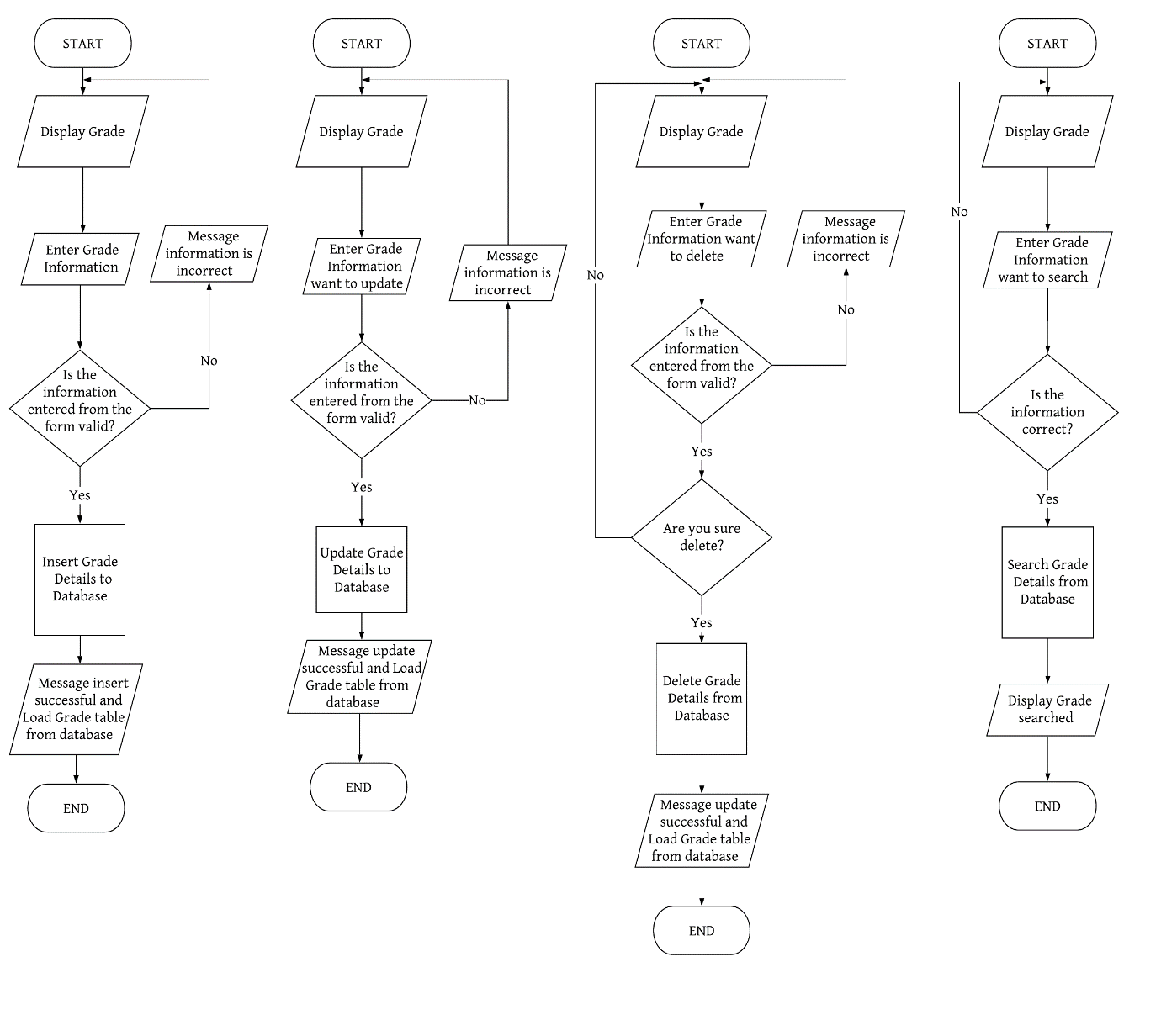

1. **Process Name:** Manage Class
2. **Process Description and Details**

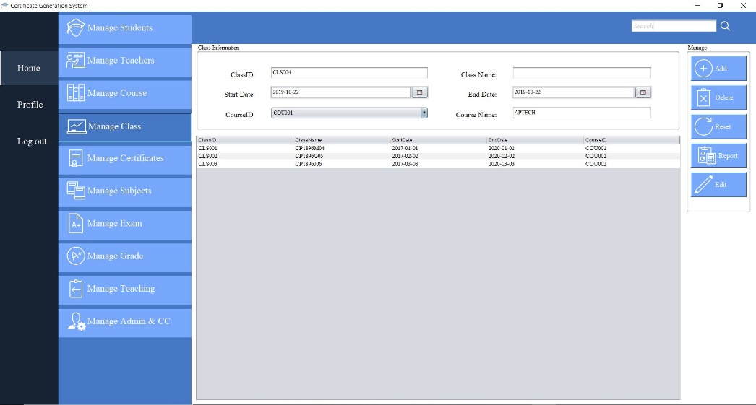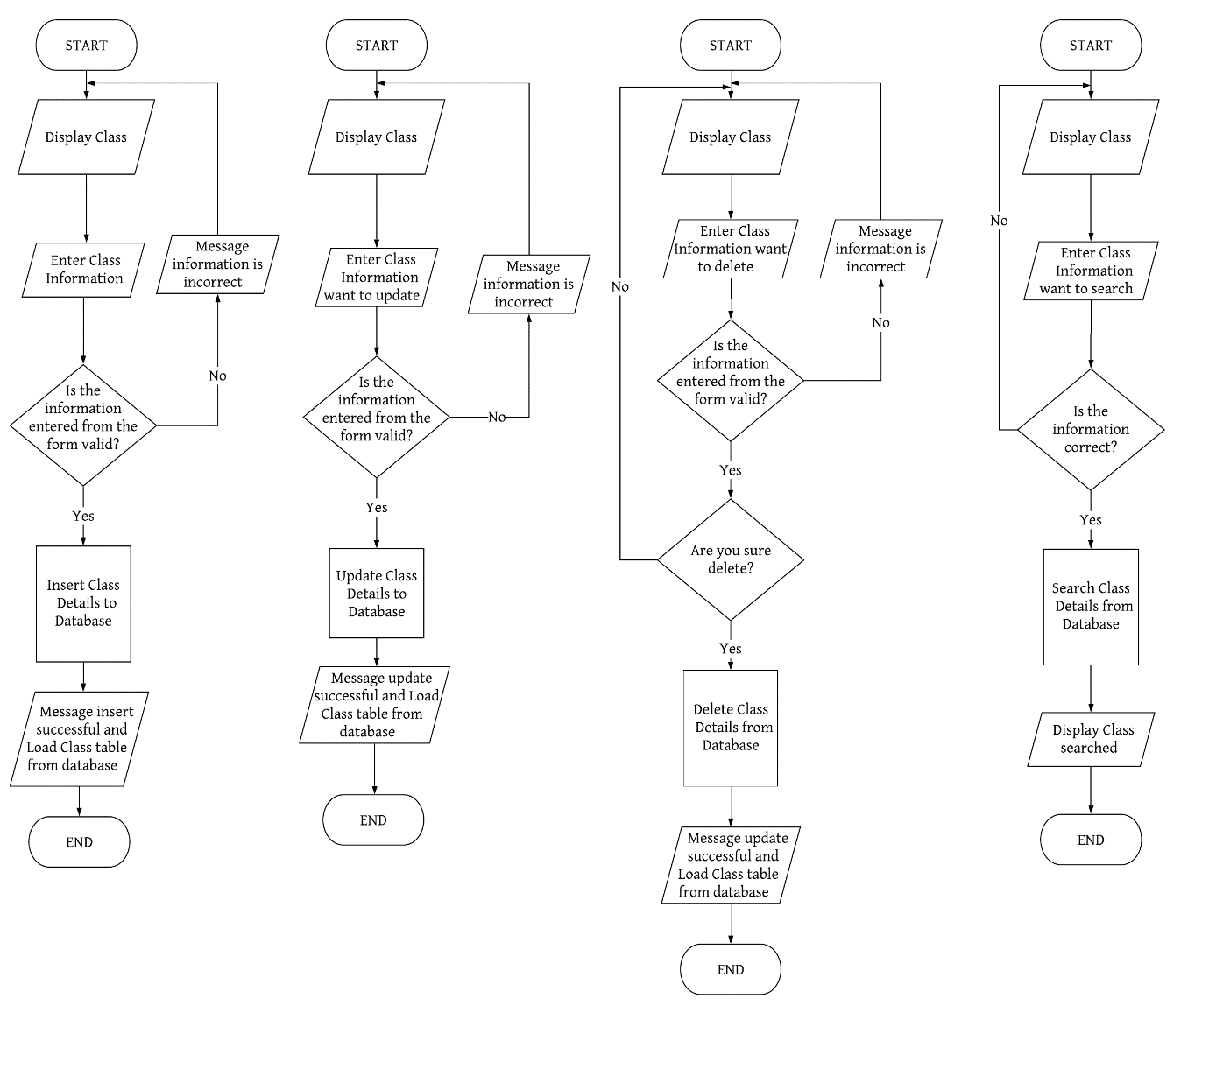

1. **Process Name:** Manage Subjects
2. **Process Description and Details**

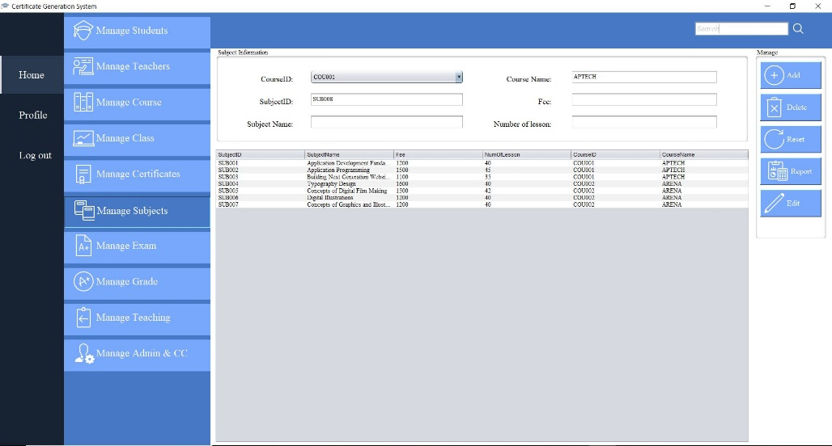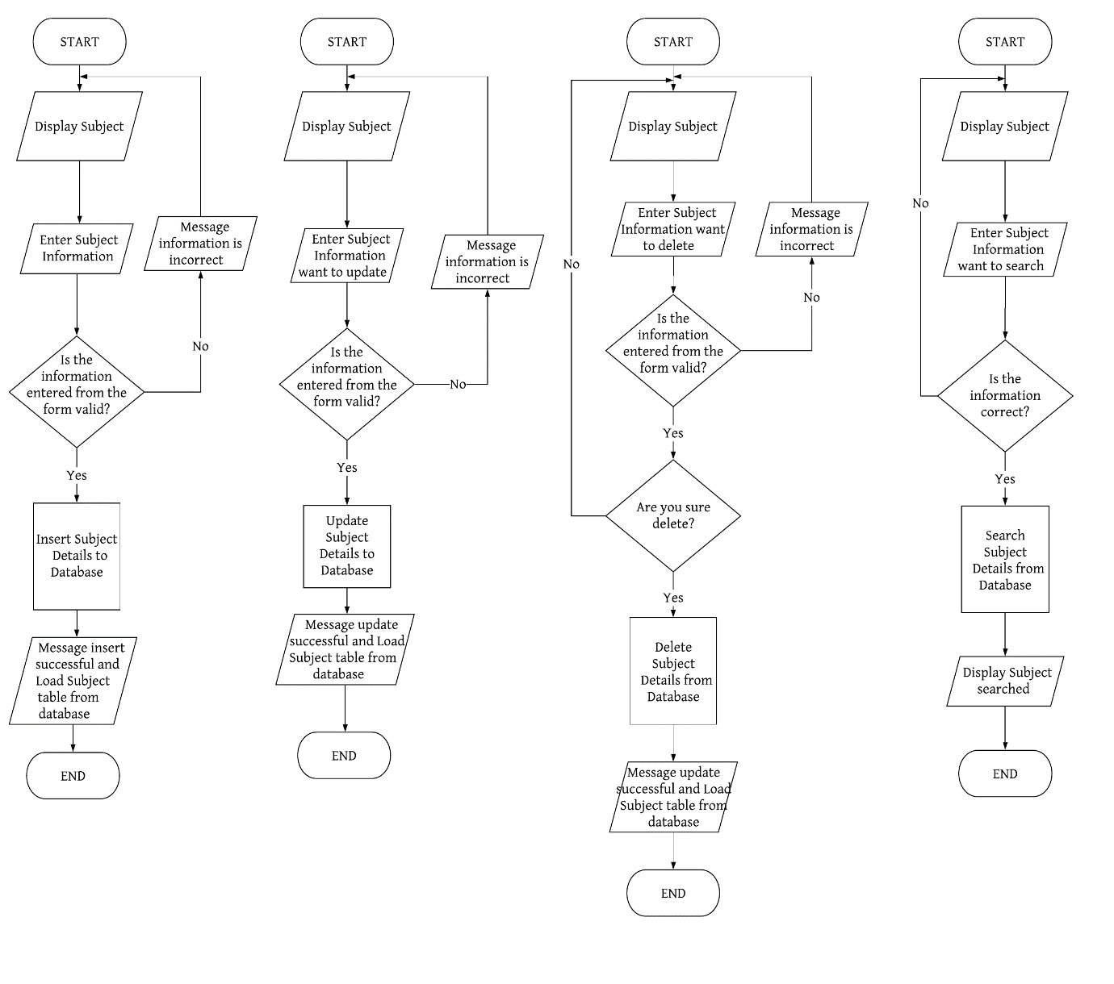

1. **Process Name:** Manage Exam
2. **Process Description and Details**

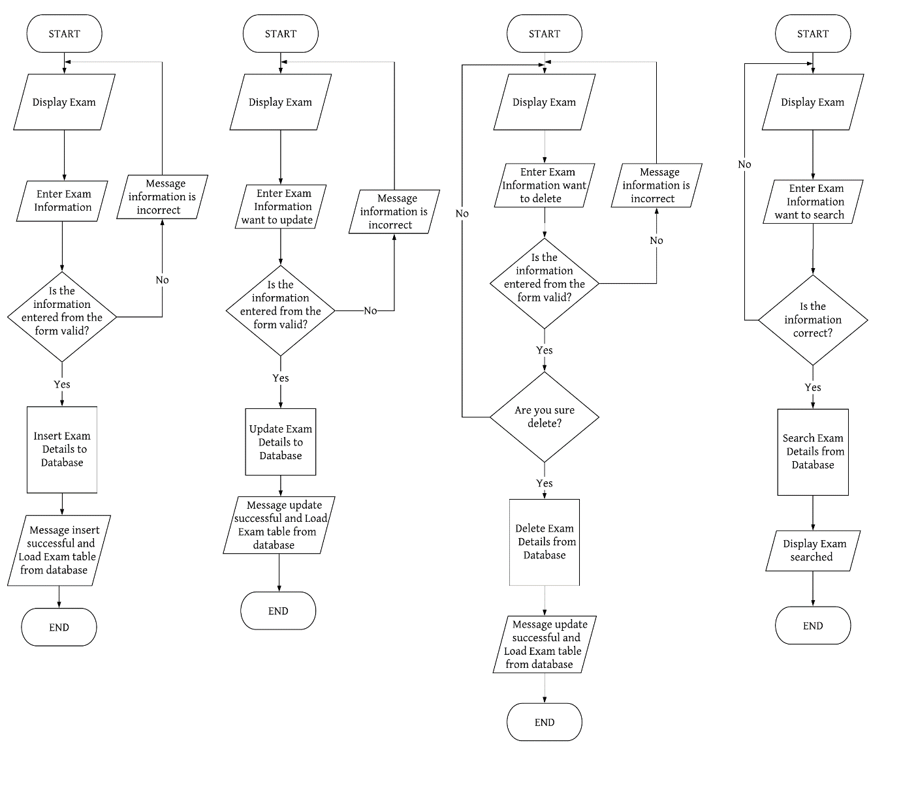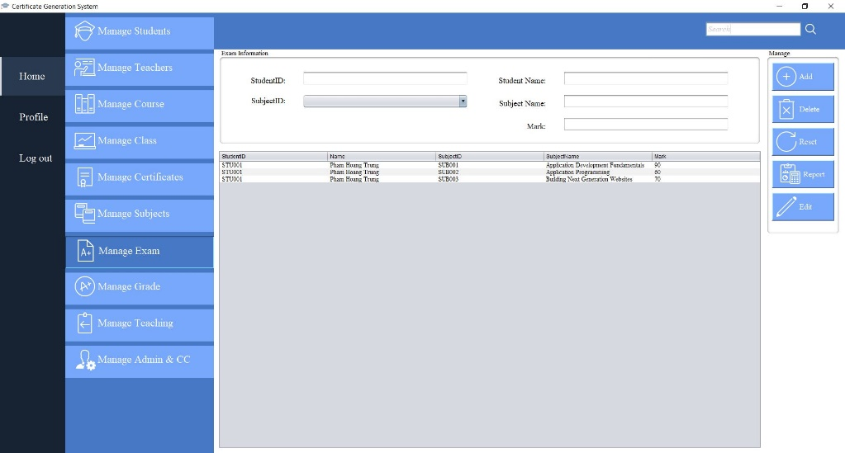

1. **Process Name:** Manage Teaching
2. **Process Description and Details**

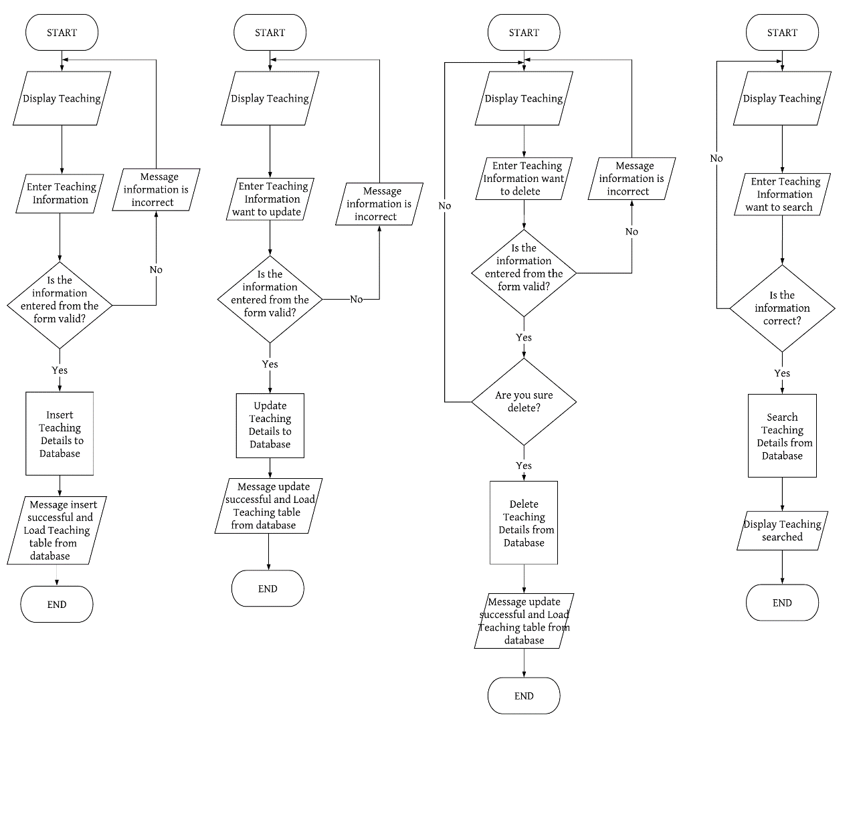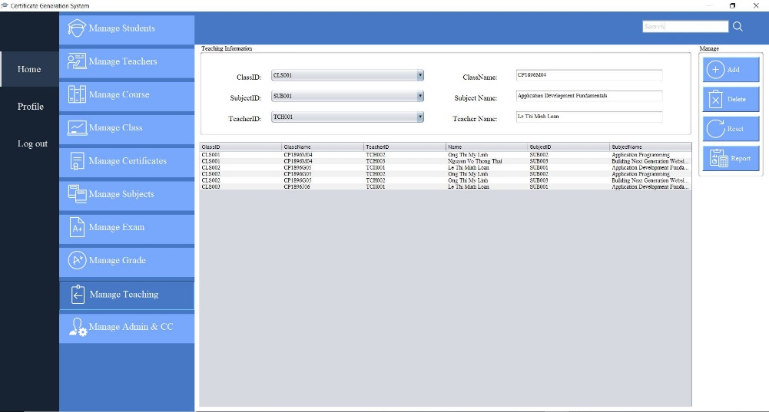

1. **Process Name:** Manage Certifcate
2. **Process Description and Details**

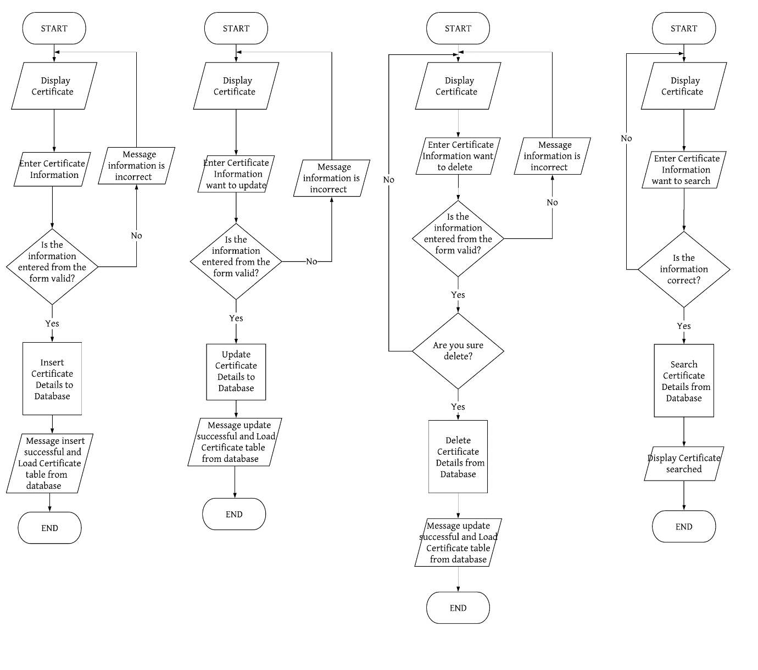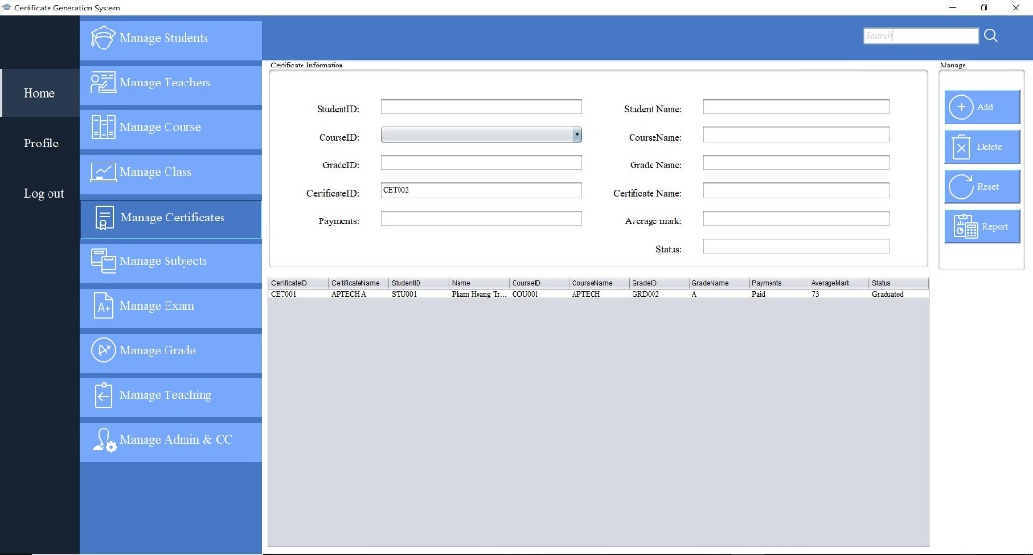

1. **Process Name:** Manage issued Certifcate
2. **Process Description and Details**

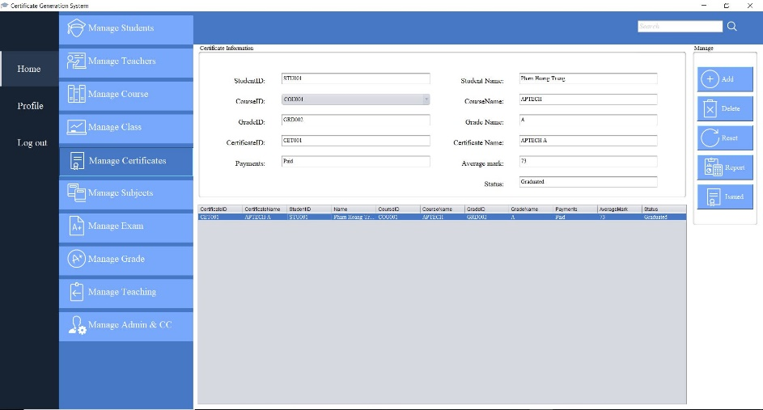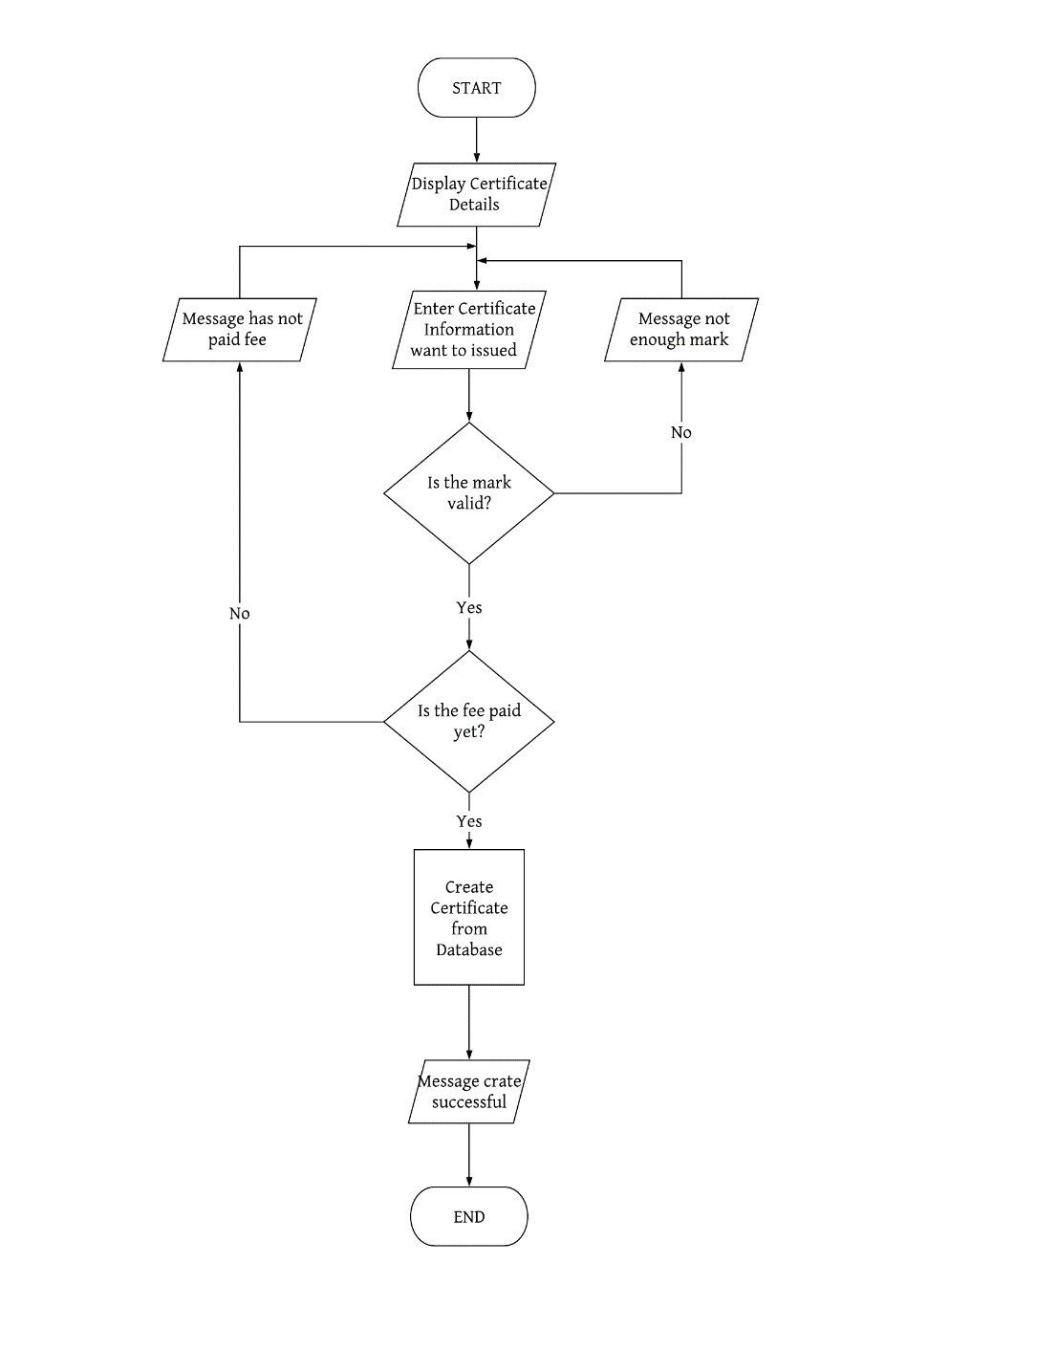

1. **Process Name:** Create Report
2. **Process Description and Details**

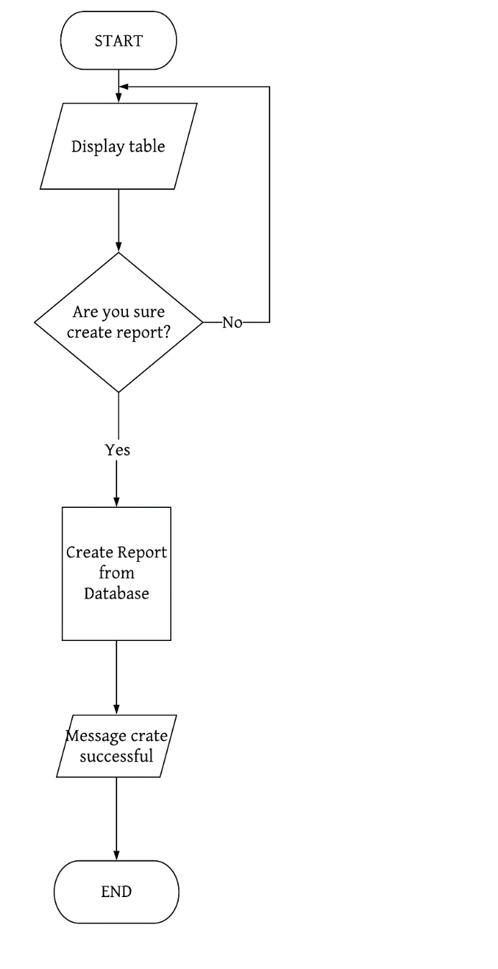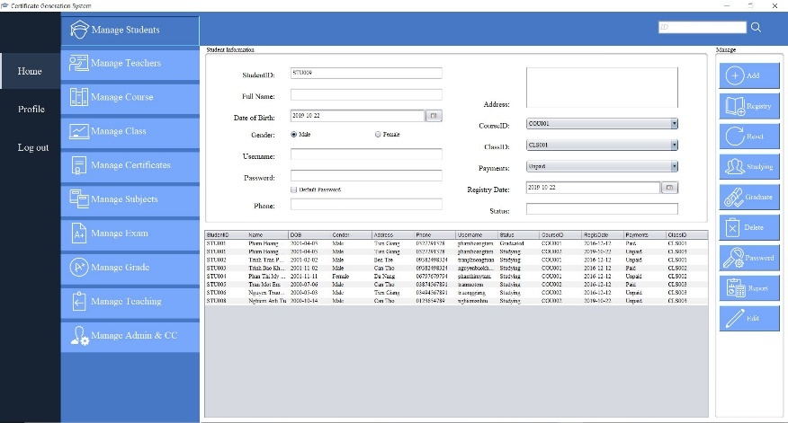

1. **Process Name:** Verify Student Profile
2. **Process Description and Details**

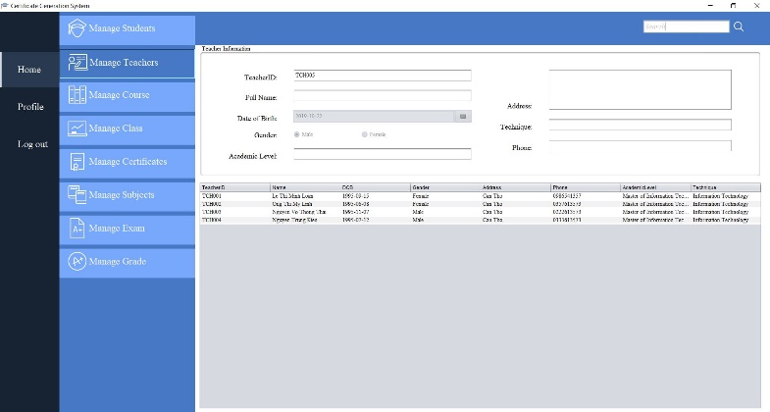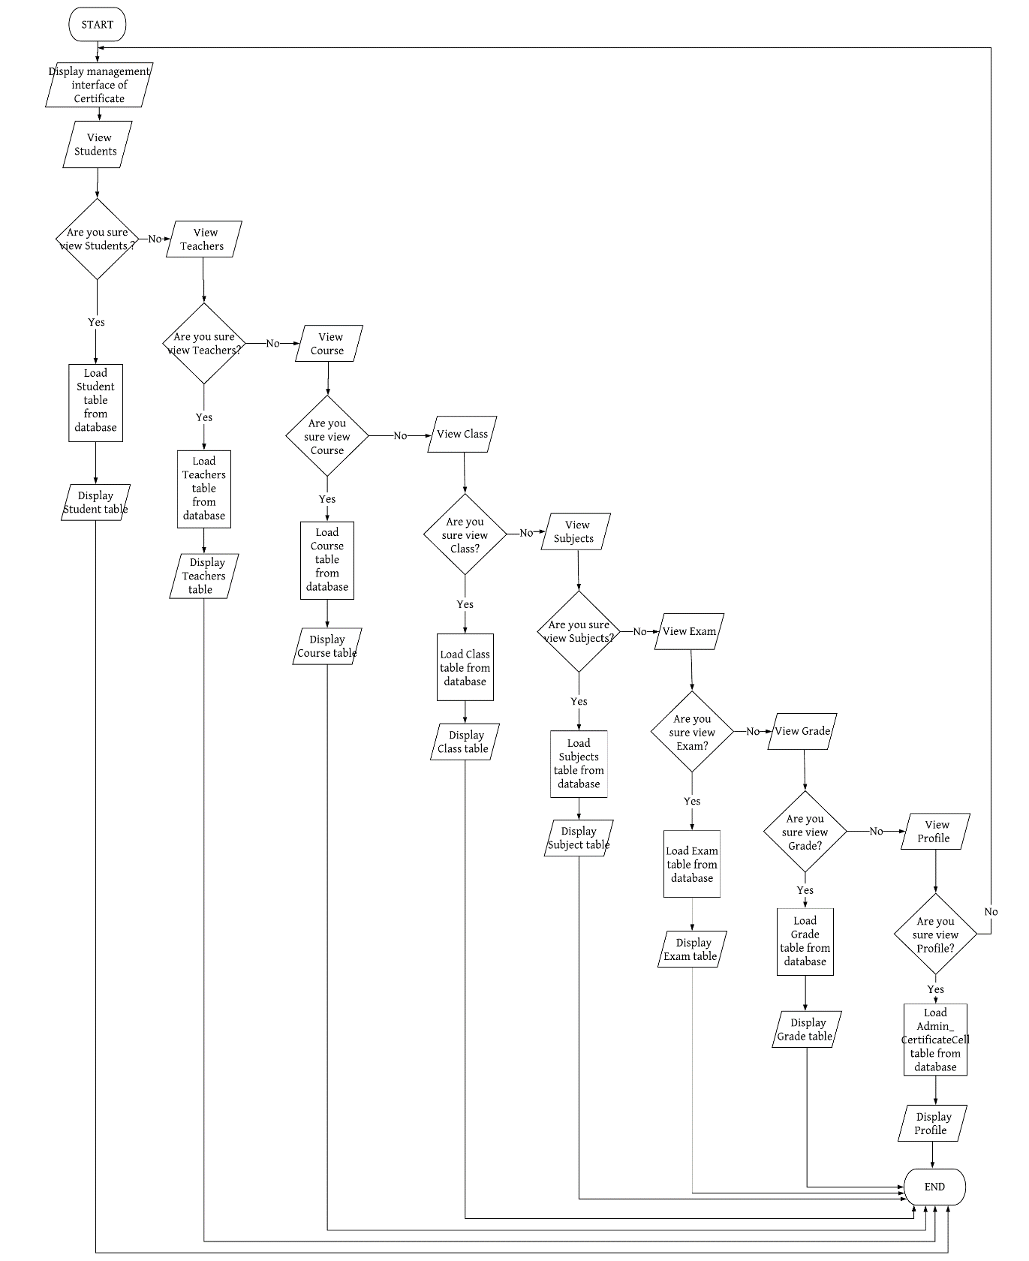

1. **Process Name:** View Personal Information
2. **Process Description and Details**

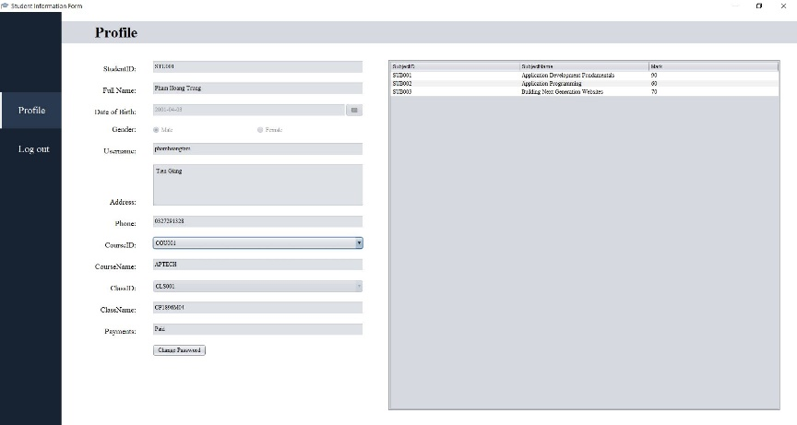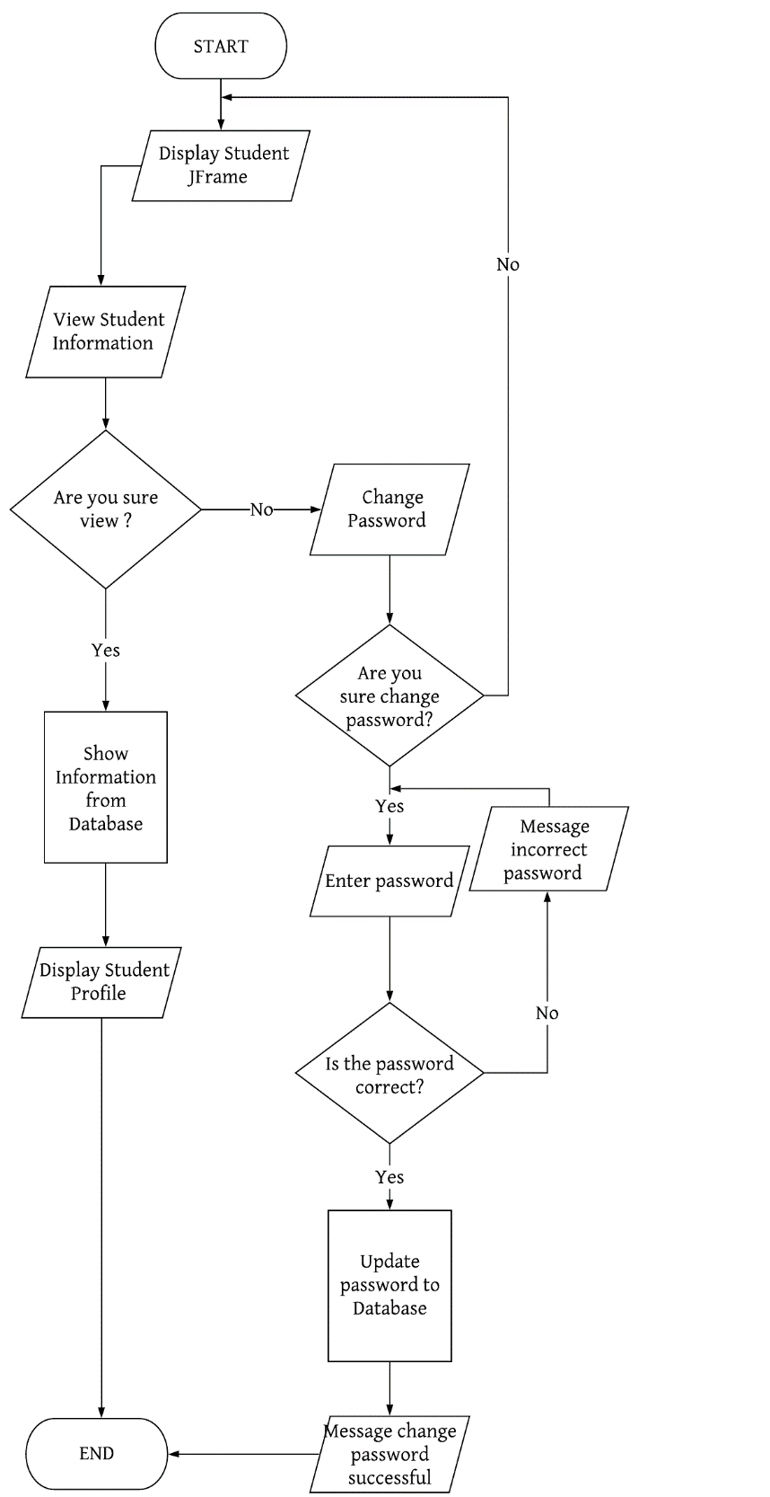

1. **File Names**This section lists commonly used file suffixes and name
   1. **File Suffixes**JavaSoft uses the following file suffixes:

|  |  |
| --- | --- |
| **File Type** | **Suffix** |
| Java source  Java bytecode | .java .class |

* 1. **Common File Names**Frequently used file names include:

|  |  |
| --- | --- |
| **File Name** | **Use** |
| GNUmakefile  README | The preferred name for makefiles. We use gnumake to build our software. The preferred name for the file that summarizes the contents of a particular directory. |

1. **File Organization**A file consists of sections that should be separated by blank lines and an optional comment identifying each section.  
   Files longer than 2000 lines are cumbersome and should be avoided.
   1. **Java Source Files**Each Java source file contains a single public class or interface. When private classes and interfaces are associated with a public class, you can put them in the same source file as the public class. The public class should be the first class or interface in the file.  
      Java source files have the following ordering:  
      • Beginning comments (see “Beginning Comments” on page 4)  
      • Package and Import statements; for example:  
      import java.applet.Applet;  
      import java.awt.*;  
      import java.net.*;  
      • Class and interface declarations
      1. *Beginning Comments*All source files should begin with a c-style comment that lists the programmer(s), the date, a copyright notice, and also a brief description of the purpose of the program. For example:  
         /*  
         * *Classname*\*  
         * *Version info*\*

* *Copyright notice*\*/

* + 1. *Package and Import Statements*The first non-comment line of most Java source files is a package statement. After that, import statements can follow. For example:  
       package java.awt;  
       import java.awt.peer.CanvasPeer;
    2. *Class and Interface Declarations*The following table describes the parts of a class or interface declaration, in the order that they should appear.

|  |  |  |
| --- | --- | --- |
|  | **Part of Class/Interface Declaration** | **Notes** |
| 1 | Class/interface documentation comment (/**...*/) | See “Documentation Comments” on page 9 for information on what should be in this comment |
| 2 | class or interface statement |  |
| 3 | Class/interface implementation comment (/*...*/), if necessary | This comment should contain any class-wide or interface-wide information that wasn’t appropriate for the class/interface documentation comment |
| 4 | Class (static) variables | First the public class variables, then the pro tected, and then the private |
| 5 | Instance variables | First public, then protected, and then pri vate. |
| 6 | Constructors |  |
| 7 | Methods | These methods should be grouped by functional-ity rather than by scope or accessibility. Forexample, a private class method can be in between two public instance methods. The goal is to make reading and understanding the code eas-ier. |

1. **Indentation**Four spaces should be used as the unit of indentation. The exact construction of the indentation (spaces vs. tabs) is unspecified. Tabs must be set exactly every 8 spaces (not 4).
   1. **Line Length**Avoid lines longer than 80 characters, since they’re not handled well by many terminals and tools.

**Note:** Examples for use in documentation should have a shorter line length—generally no more than 70 characters.

* 1. **Wrapping Lines**When an expression will not fit on a single line, break it according to these general principles:  
     • Break after a comma.  
     • Break before an operator.  
     • Prefer higher-level breaks to lower-level breaks.  
     • Align the new line with the beginning of the expression at the same level on the previous line.  
     • If the above rules lead to confusing code or to code that’s squished up against the right margin, just indent 8 spaces instead. Here are some examples of breaking method calls:  
     function(longExpression1, longExpression2, longExpression3,  
     longExpression4, longExpression5);  
     var = function1(longExpression1,  
     function2(longExpression2,  
     longExpression3));

1. **Comments**Java programs can have two kinds of comments: implementation comments and documentation comments. Implementation comments are those found in C++, which are delimited by /*...*/, and //. Documentation comments (known as “doc comments”) are Java-only, and are delimited by /**...*/. Doc comments can be extracted to HTML files using the javadoc tool.  
   Implementation comments are mean for commenting out code or for comments about the particular implementation. Doc comments are meant to describe the specification of the code, from an implementation-free perspective. to be read by developers who might not necessarily have the source code at hand.  
   Comments should be used to give overviews of code and provide additional information that is not readily available in the code itself. Comments should contain only information that is relevant to reading and understanding the program. For example, information about how the corresponding package is built or in what directory it resides should not be included as a comment.  
   Discussion of nontrivial or nonobvious design decisions is appropriate, but avoid duplicating information that is present in (and clear from) the code. It is too easy for redundant comments to get out of date. In general, avoid any comments that are likely to get out of date as the code evolves.  
   **Note:** The frequency of comments sometimes reflects poor quality of code. When you feel compelled to add a comment, consider rewriting the code to make it clearer.

Comments should not be enclosed in large boxes drawn with asterisks or other characters.  
Comments should never include special characters such as form-feed and backspace.

* 1. **Implementation Comment Formats**Programs can have four styles of implementation comments: block, single-line, trailing and end-of-line.
     1. *Block Comments*Block comments are used to provide descriptions of files, methods, data structures and algorithms. Block comments should be used at the beginning of each file and before each method. They can also be used in other places, such as within methods. Block comments inside a function or method should be indented to the same level as the code they describe. A block comment should be preceded by a blank line to set it apart from the rest of the code. Block comments have an asterisk “*” at the beginning of each line except the first.  
        /*  
        * Here is a block comment.  
        */

Block comments can start with /*-, which is recognized by **indent**(1) as the beginning of a block comment that should not reformatted. Example:  
/*  
* Here is a block comment with some very special  
* formatting that I want indent(1) to ignore.  
*  
* one  
* two  
* three  
*/  
**Note:** If you don’t use **indent**(1), you don’t have to use /*- in your code or make any other concessions to the possibility that someone else might run **indent**(1) on your code.

* + 1. *Single-Line Comments*Short comments can appear on a single line indented to the level of the code that follows. If a comment can’t be written in a single line, it should follow the block comment format (see section 4.1.1). A single-line comment should be preceded by a blank line. Here’s an example of a single-line comment in Java code :  
       if (condition) {  
       /* Handle the condition. */

...  
}

* + 1. *Trailing Comments*Very short comments can appear on the same line as the code they describe, but should be shifted far enough to separate them from the statements. If more than one short comment appears in a chunk of code, they should all be indented to the same tab setting. Avoid the assembly language style of commenting every line of executable code with a trailing comment.  
       Here’s an example of a trailing comment in Java code (also see “Documentation Comments”  
       on page 9):  
       if (a == 2) {  
       return TRUE; /* special case */  
       } else {  
       return isprime(a); /* works only for odd a */  
       }
    2. *End-Of-Line Comments*The // comment delimiter begins a comment that continues to the newline. It can comment out a complete line or only a partial line. It shouldn’t be used on consecutive multiple lines for text comments; however, it can be used in consecutive multiple lines for commenting out sections of code. Examples of all three styles follow:

if (foo > 1) {  
// Do a double-flip.  
...  
}  
else  
return false; // Explain why here.  
//if (bar > 1) {  
//  
// // Do a triple-flip.  
// ...  
//}  
//else  
// return false;

* 1. **Documentation Comments  
     Note:** See “Java Source File Example” on page 19 for examples of the comment formats described here.  
     For further details, see “How to Write Doc Comments for Javadoc” which includes information on the doc comment tags (@return, @param, @see):

http://java.sun.com/products/jdk/javadoc/writingdoccomments.html  
For further details about doc comments and javadoc, see the javadoc home page at:  
http://java.sun.com/products/jdk/javadoc/  
Doc comments describe Java classes, interfaces, constructors, methods, and fields. Each doc comment is set inside the comment delimiters /**...*/, with one comment per API. This comment should appear just before the declaration:  
/**  
* The Example class provides ...  
*/  
class Example { ...  
Notice that classes and interfaces are not indented, while their members are. The first line of doc comment (/**) for classes and interfaces is not indented; subsequent doc comment lines each have 1 space of indentation (to vertically align the asterisks). Members, including constructors, have 4 spaces for the first doc comment line and 5 spaces thereafter.  
If you need to give information about a class, interface, variable, or method that isn’t appropriate for documentation, use an implementation block comment (see section 4.1.1) or single-line (see section 4.1.2) comment immediately *after* the declaration. For example, details about the implementation of a class should go in in such an implementation block comment *following* the class statement, not in the class doc comment.  
Doc comments should not be positioned inside a method or constructor definition block, because Java associates documentation comments with the first declaration *after* the comment.

1. **Declarations**
   1. **Number Per Line**One declaration per line is recommended since it encourages commenting. In other words,  
      int level; // indentation level  
      int size; // size of table  
      is preferred over  
      int level, size;  
      In absolutely no case should variables and functions be declared on the same line. Example:  
      long dbaddr, getDbaddr(); // WRONG!  
      Do not put different types on the same line. Example:  
      int foo, fooarray[]; //WRONG!

**Note:** The examples above use one space between the type and the identifier. Another acceptable alternative is to use tabs, e.g.:

|  |  |
| --- | --- |
| int  int  Object | level; // indentation level size; // size of table currentEntry; // currently selected table entry |

* 1. **Placement**Put declarations only at the beginning of blocks. (A block is any code surrounded by curly braces “{” and “}”.) Don’t wait to declare variables until their first use; it can confuse the unwary programmer and hamper code portability within the scope.  
     void MyMethod() {  
     int int1; // beginning of method block  
     if (condition) {  
     int int2; // beginning of "if" block  
     ...  
     }  
     }  
     The one exception to the rule is indexes of for loops, which in Java can be declared in the for statement:  
     for (int i = 0; i < maxLoops; i++) { ...  
     Avoid local declarations that hide declarations at higher levels. For example, do not declare the same variable name in an inner block:

int count;  
...  
func() {  
if (condition) {  
int count; // AVOID!  
...  
}  
...  
}

* 1. **Initialization**Try to initialize local variables where they’re declared. The only reason not to initialize a variable where it’s declared is if the initial value depends on some computation occurring first.
  2. **Class and Interface Declarations**When coding Java classes and interfaces, the following formatting rules

should be followed:  
• No space between a method name and the parenthesis “(“ starting its parameter list  
• Open brace “{” appears at the end of the same line as the declaration statement  
• Closing brace “}” starts a line by itself indented to match its corresponding opening statement, except when it is a null statement the “}” should appear immediately after the  
“{“  
class Sample extends Object {  
int ivar1;  
int ivar2;  
Sample(int i, int j) {  
ivar1 = i;  
ivar2 = j;  
}  
int emptyMethod() {}  
...  
}  
• Methods are separated by a blank line

1. **Statements**
   1. **Simple Statements**Each line should contain at most one statement. Example:  
      argv++; argc--; // AVOID!

Do not use the comma operator to group multiple statements unless it is for an obvious reason.  
Example:  
if (err) {  
Format.print(System.out, “error”), exit(1); //VERY WRONG!  
}

* 1. **Compound Statements**Compound statements are statements that contain lists of statements enclosed in braces “{ statements }”. See the following sections for examples.  
     • The enclosed statements should be indented one more level than the compound statement.  
     • The opening brace should be at the end of the line that begins the compound statement; the closing brace should begin a line and be indented to the beginning of the compound statement.  
     • Braces are used around all statements, even singletons, when they are part

of a control structure, such as a if-else or for statement. This makes it easier to add statements without accidentally introducing bugs due to forgetting to add braces.

* 1. **return Statements**A return statement with a value should not use parentheses unless they make the return value more obvious in some way. Example:  
     return;  
     return myDisk.size();  
     return (size ? size : defaultSize);
  2. **if, if-else, if-else-if-else Statements**The if-else class of statements should have the following form:  
     if (*condition*) {  
     *statements*;  
     }  
     if (*condition*) {  
     *statements*;  
     } else {  
     *statements*;  
     }  
     if (*condition*) {  
     *statements*;  
     } else if (*condition*) {  
     *statements*;  
     } else if (*condition*) {  
     *statements*;  
     }

**Note:** if statements always use braces {}. Avoid the following error-prone form:  
if (*condition*) //AVOID! THIS OMITS THE BRACES {}!  
*statement*;

* 1. **for Statements**A for statement should have the following form:  
     for (*initialization*; *condition*; *update*) {  
     *statements*;  
     }  
     An empty for statement (one in which all the work is done in the initialization, condition, and update clauses) should have the following form:  
     for (*initialization*; *condition*; *update*);  
     When using the comma operator in the initialization or update clause of a for statement, avoid the complexity of using more than three variables. If needed,

use separate statements before the for loop (for the initialization clause) or at the end of the loop (for the update clause).

* 1. **while Statements**A while statement should have the following form:  
     while (*condition*) {  
     *statements*;  
     }  
     An empty while statement should have the following form:  
     while (*condition*);
  2. **do-while Statements**A do-while statement should have the following form:  
     do {  
     *statements*;  
     } while (*condition*);
  3. **switch Statements**A switch statement should have the following form:

switch (*condition*) {  
case ABC:  
*statements*;  
/* falls through */  
case DEF:  
*statements*;  
break;  
case XYZ:  
*statements*;  
break;  
default:  
*statements*;  
break;  
}  
Every time a case falls through (doesn’t include a break statement), add a comment where the  
break statement would normally be. This is shown in the preceding code example with the  
/* falls through */ comment.  
Every switch statement should include a default case. The break in the default case is  
redundant, but it prevents a fall-through error if later another case is added.

* 1. **try-catch Statements**A try-catch statement should have the following format:

try {  
*statements*;  
} catch (ExceptionClass e) {  
*statements*;  
}

**Installation Instructions**

* After downloading Source Code, please proceed to extract the .zip file
* Right-click on the .zip file

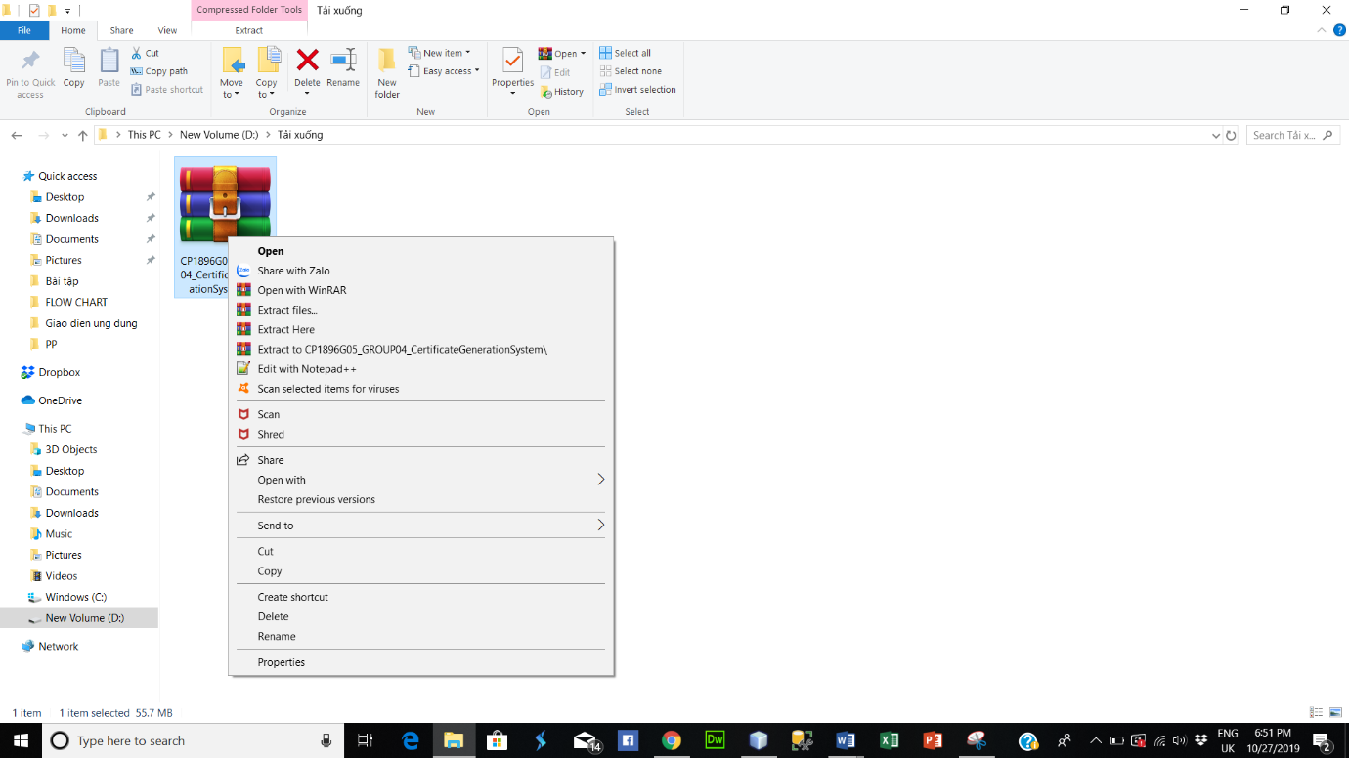

* Click “Extract files…” to display the dialog box “Extraction path and options”
* Then click “OK” to extract file
* 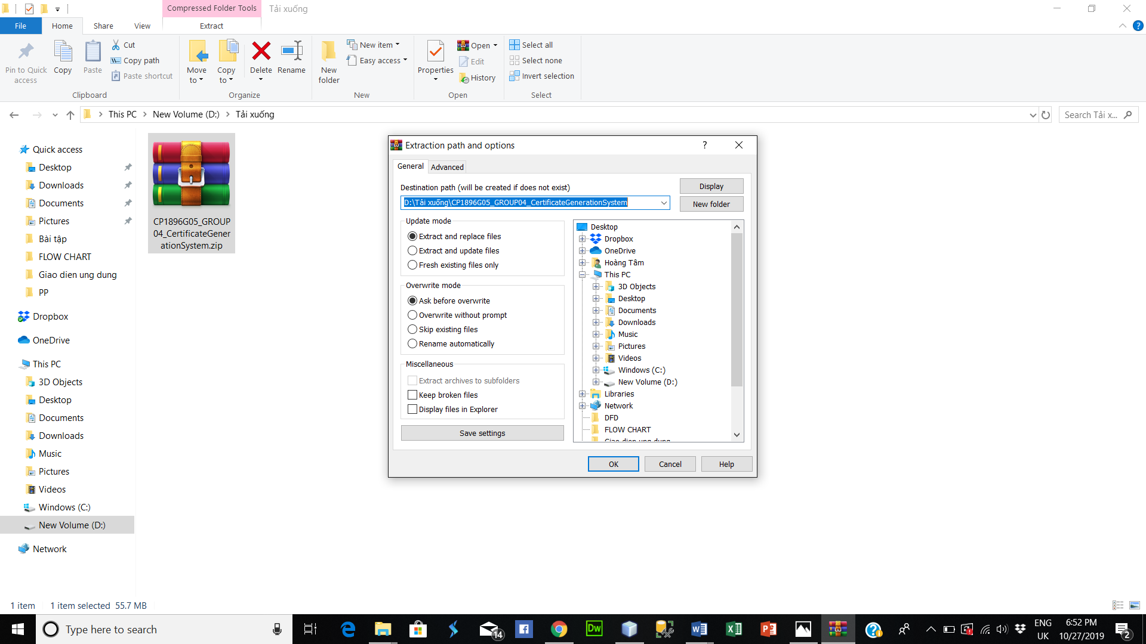

* After extracting you get a folder.

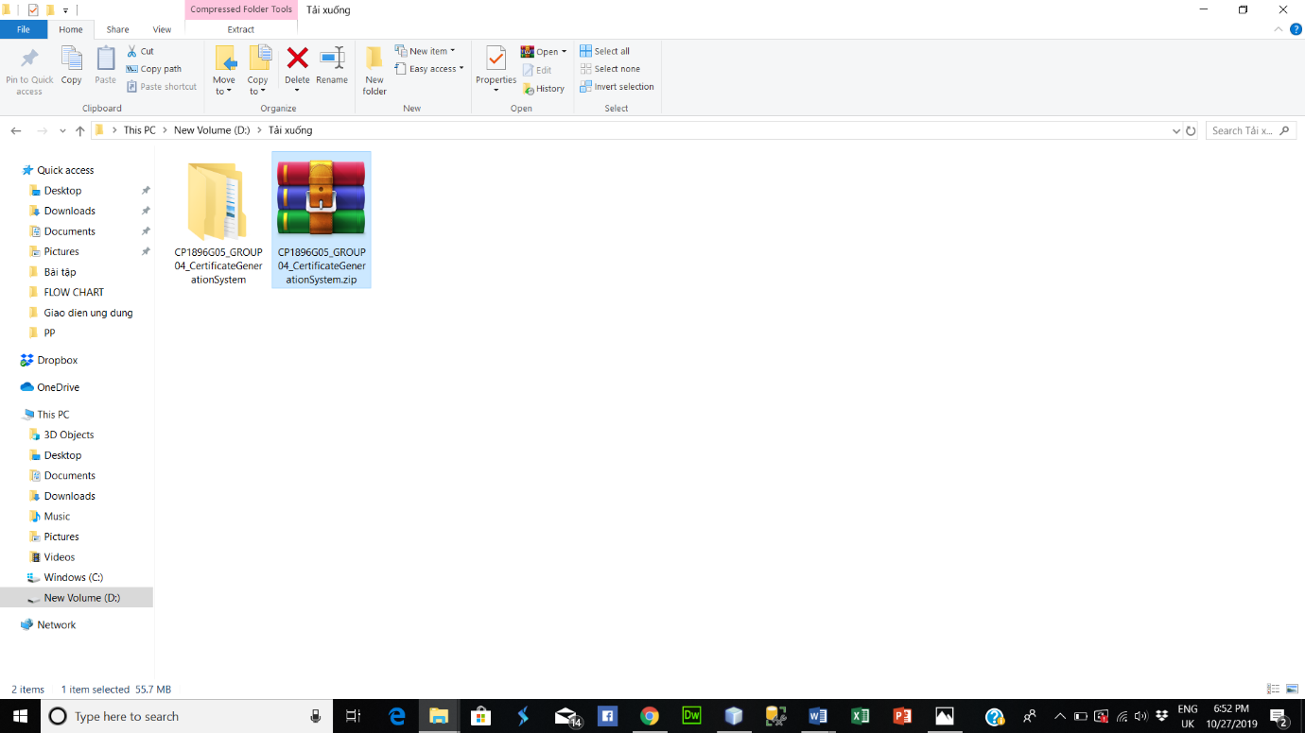

* Continue to open subfolder
* Open the folder you will see 3 subfolders. Inside,
  + Folder “CertificateGenerationSystem” is where the source code and the program (.jar file) are stored
  + Folder “DatabaseCertificateGenerationSystem” is where the database of system are stored
  + Folder “Documents” is where the document of system are stored

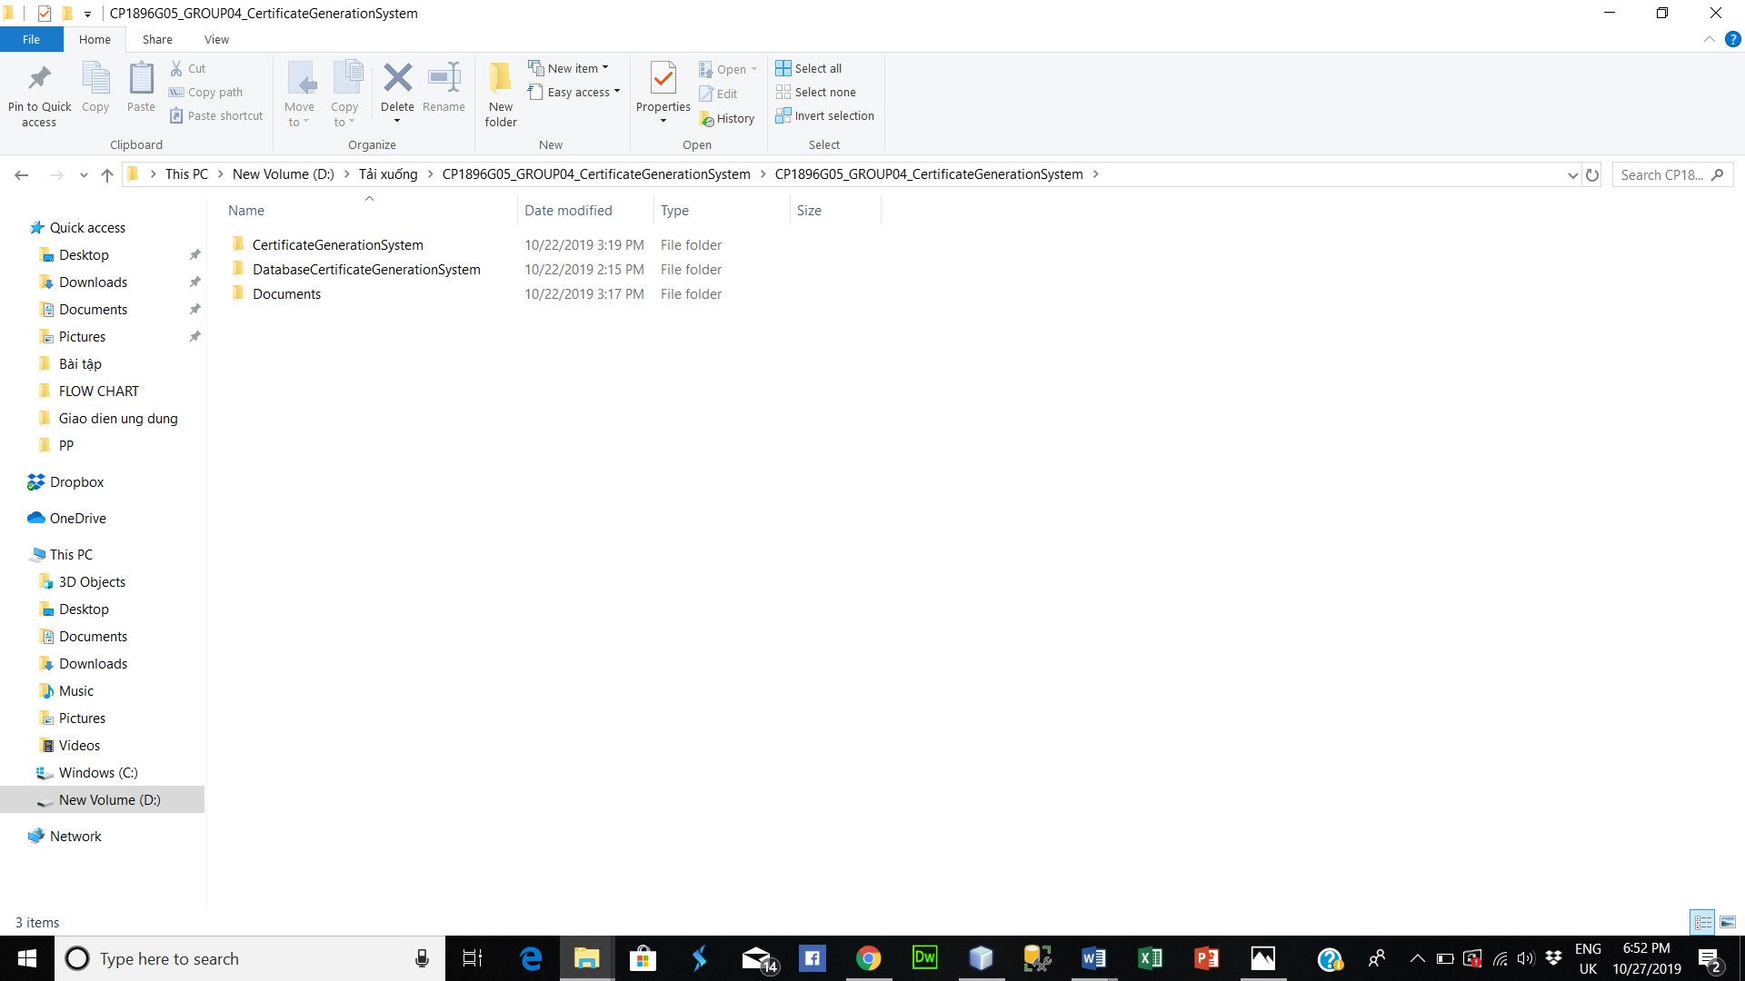

* Open folder “DatabaseCertificateGenerationSystem”
* Right-click on the “DBCertificateGenerationSystem.sql” file
* Click “Open with” then select “SSMS” (Or you can open it with a different database depending on your computer)

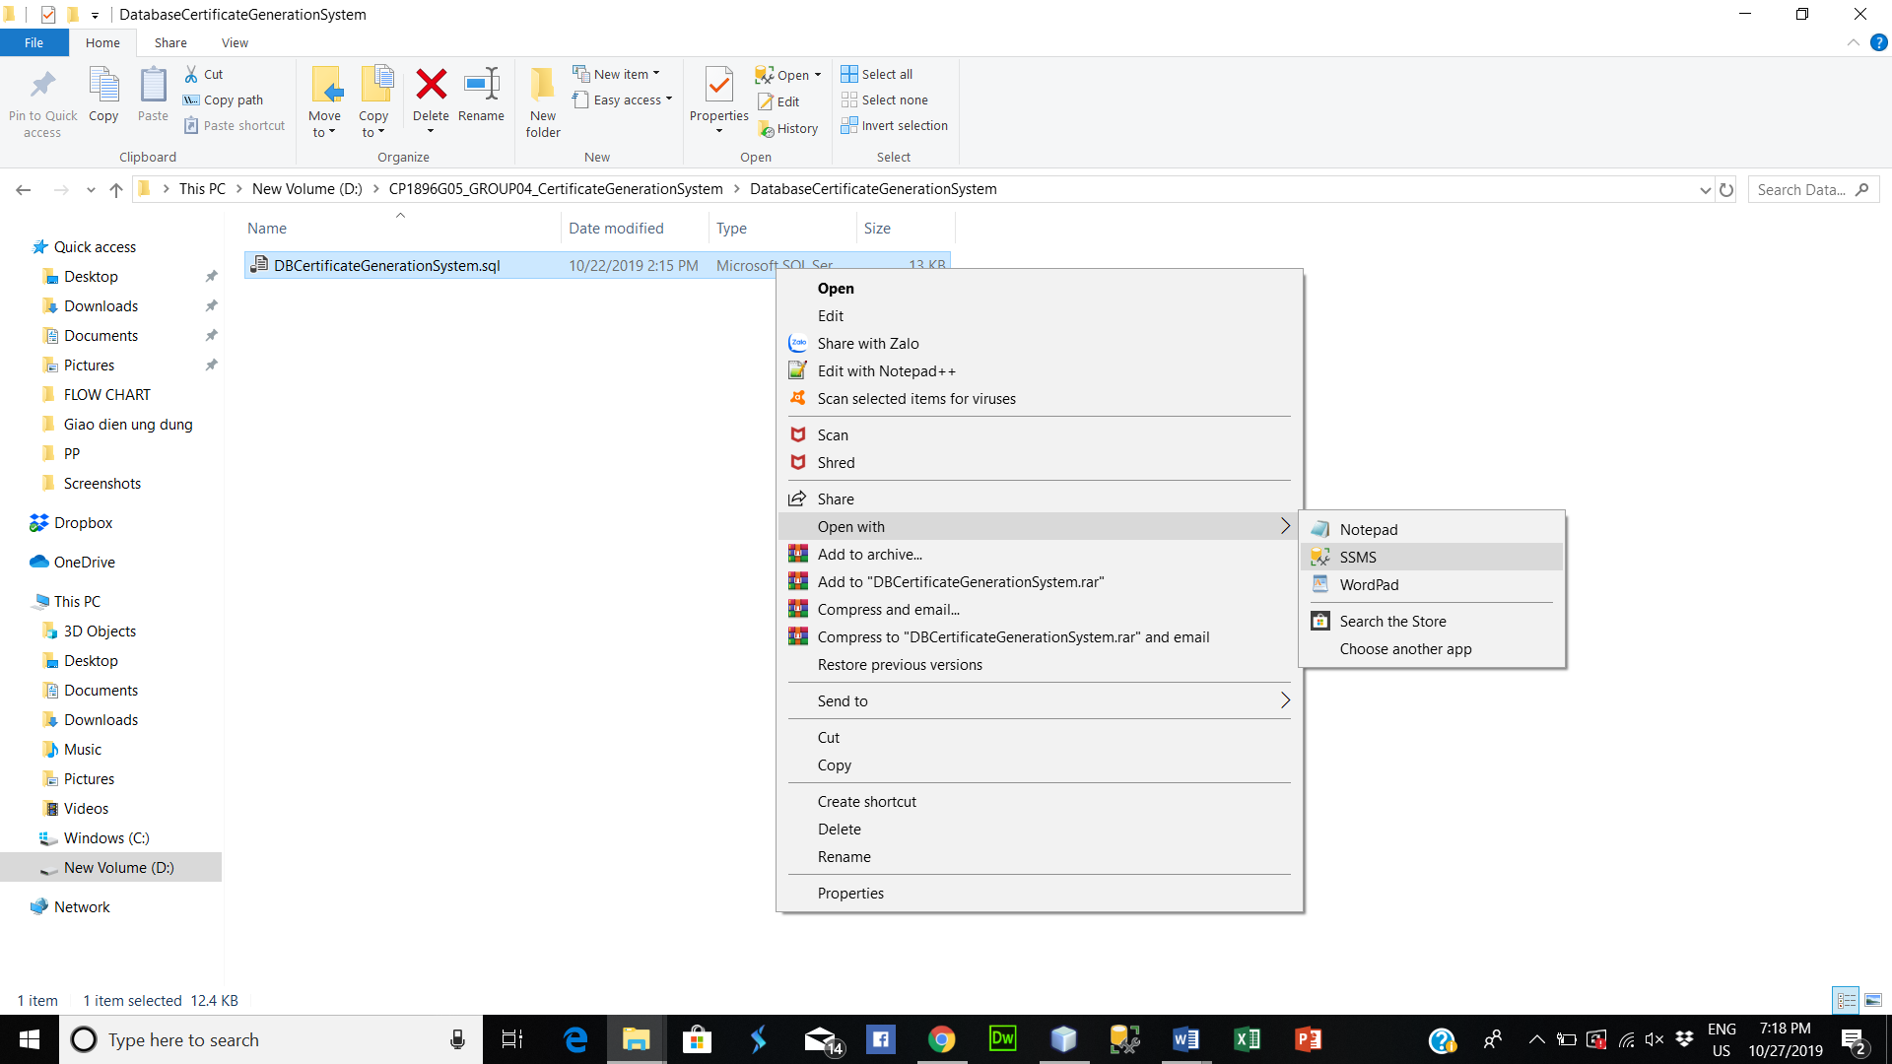

* Log in SQL Server, then click “Connect”

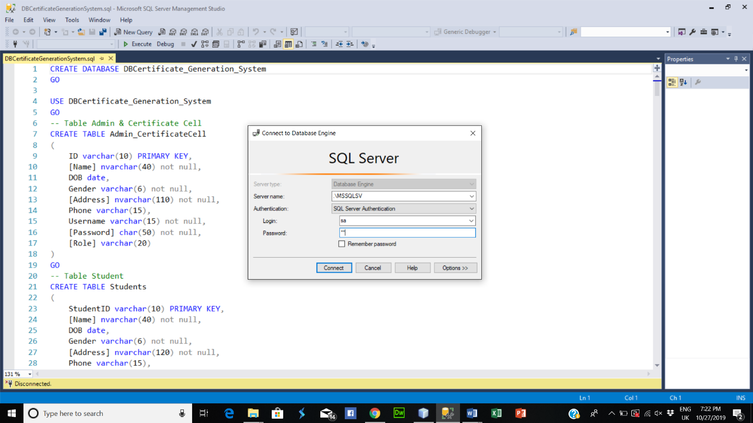

* After successful login. Click “Execute” to execute the file

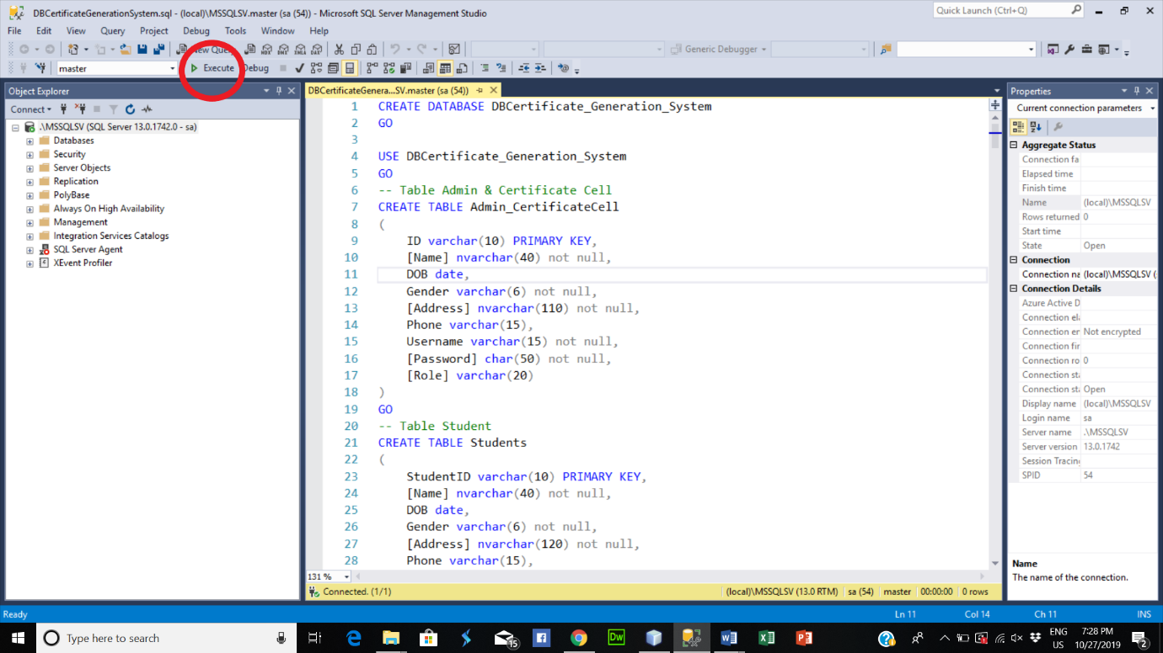

* Open folder “CertificateGenerationSystem”. Then open folder “dist”

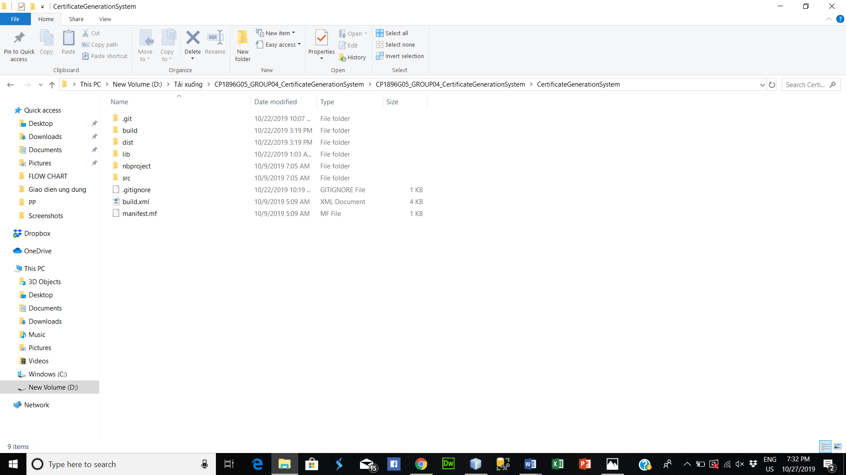

- Open file “CertificateGenerationSystem.jar” to start the application

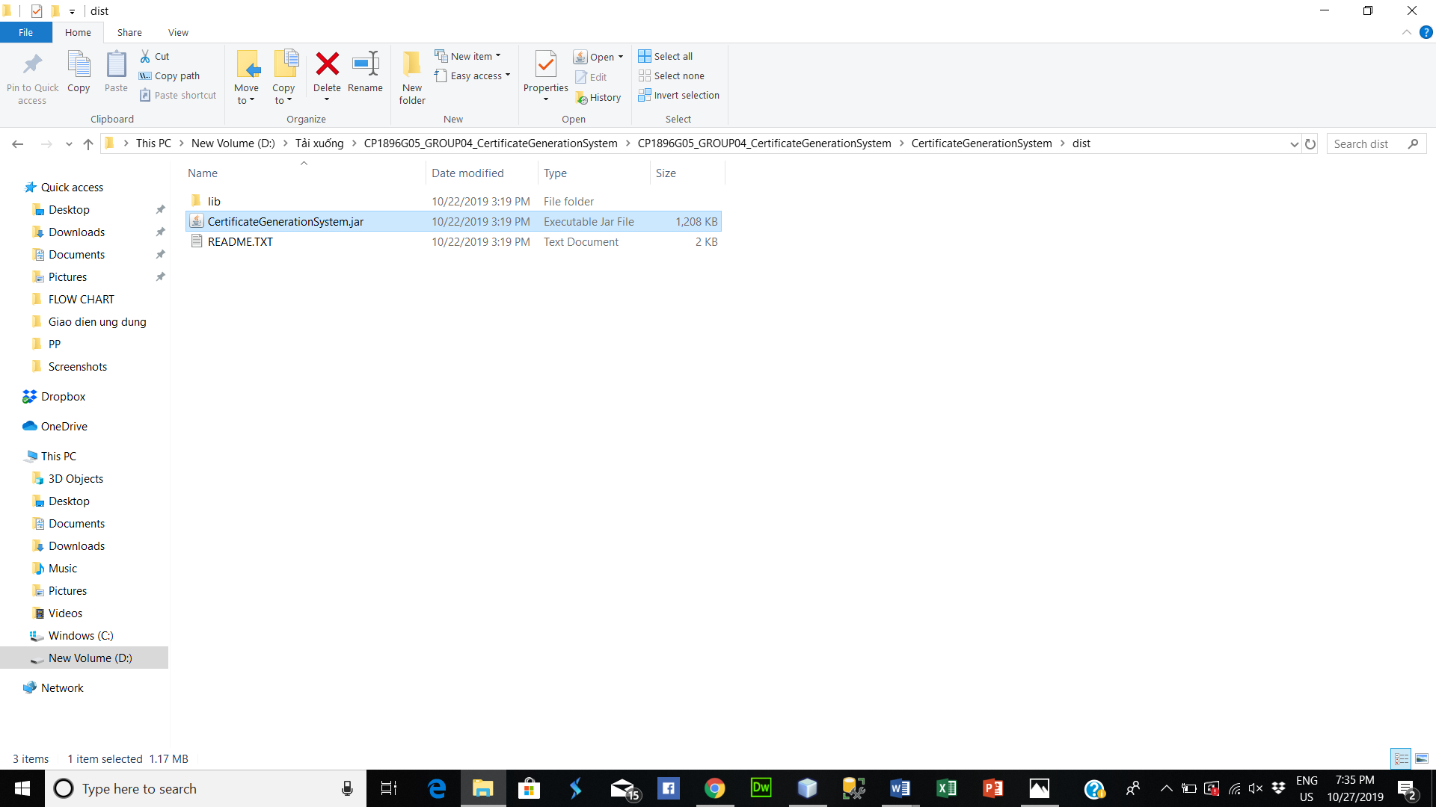

* Installation successful

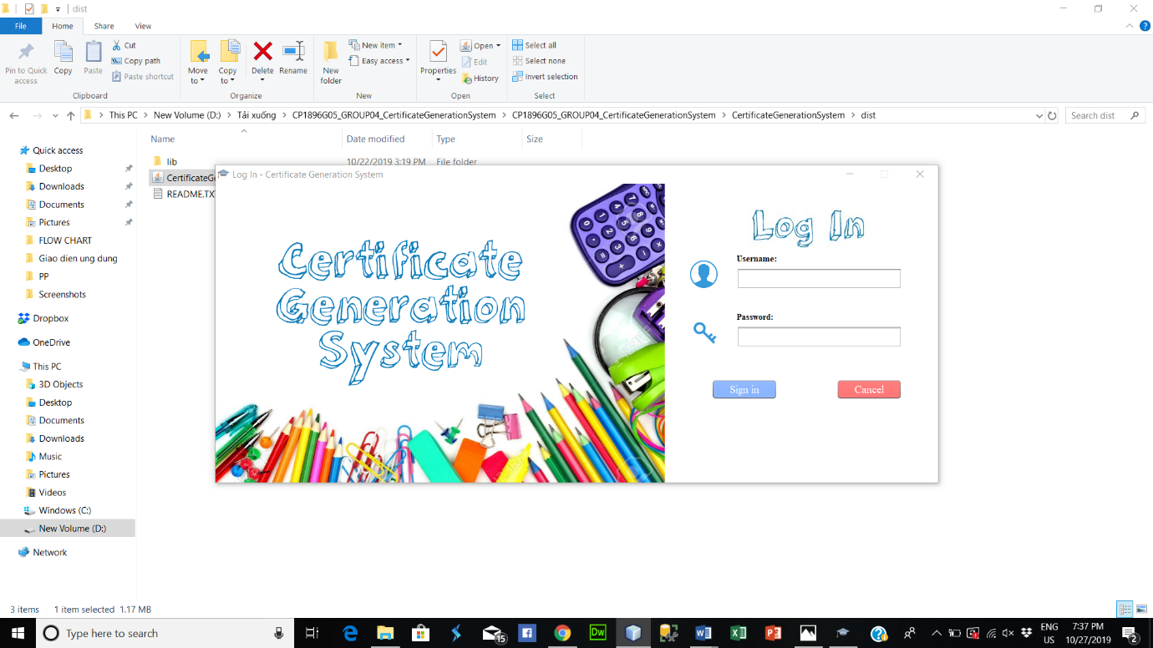

**User manual**

* Log in (with admin role). Enter the administrator's account information
* The interface after successful login with Administrator role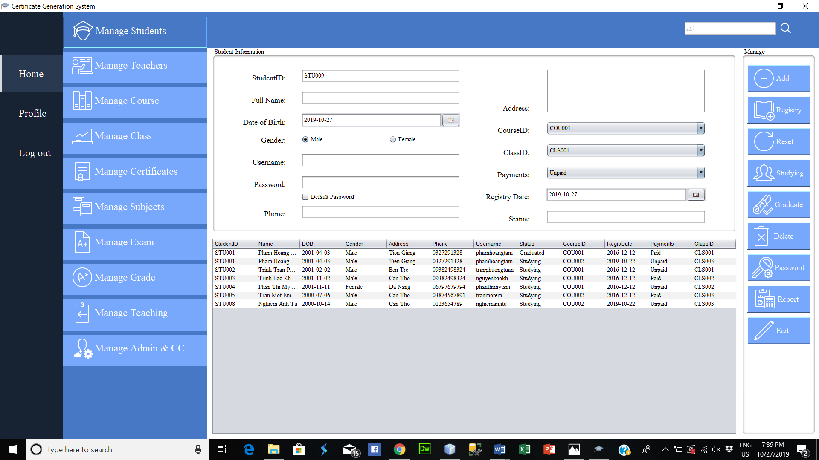
* Enter the information and click the “Add” button to register for a new student. After successful registration, you will receive a notification. If the information entered is not valid, a corresponding message will be sent to you

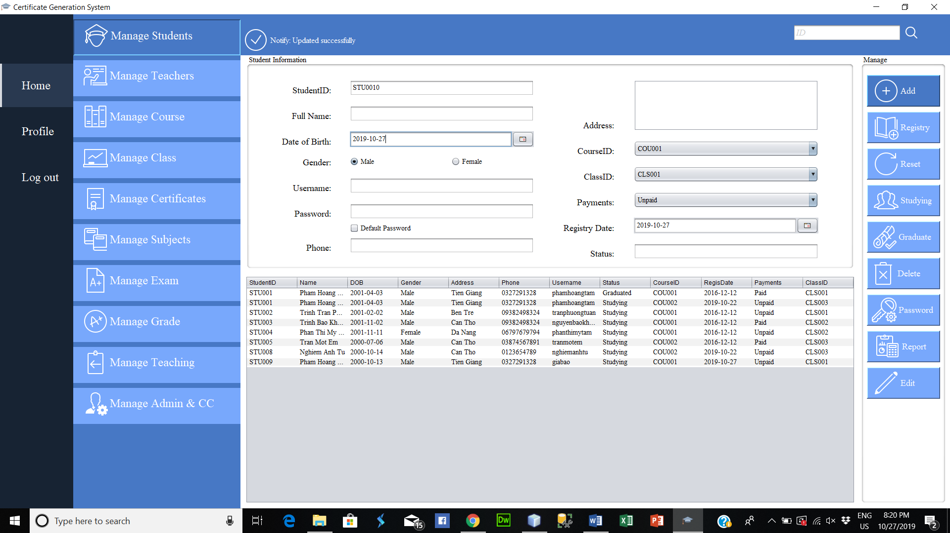

* Registry button to register for additional courses for students studying at the Academy. You only need to enter the student ID, student information will be displayed. Then choose the appropriate course and class. Click “Registry” to register or “Cancel” to close

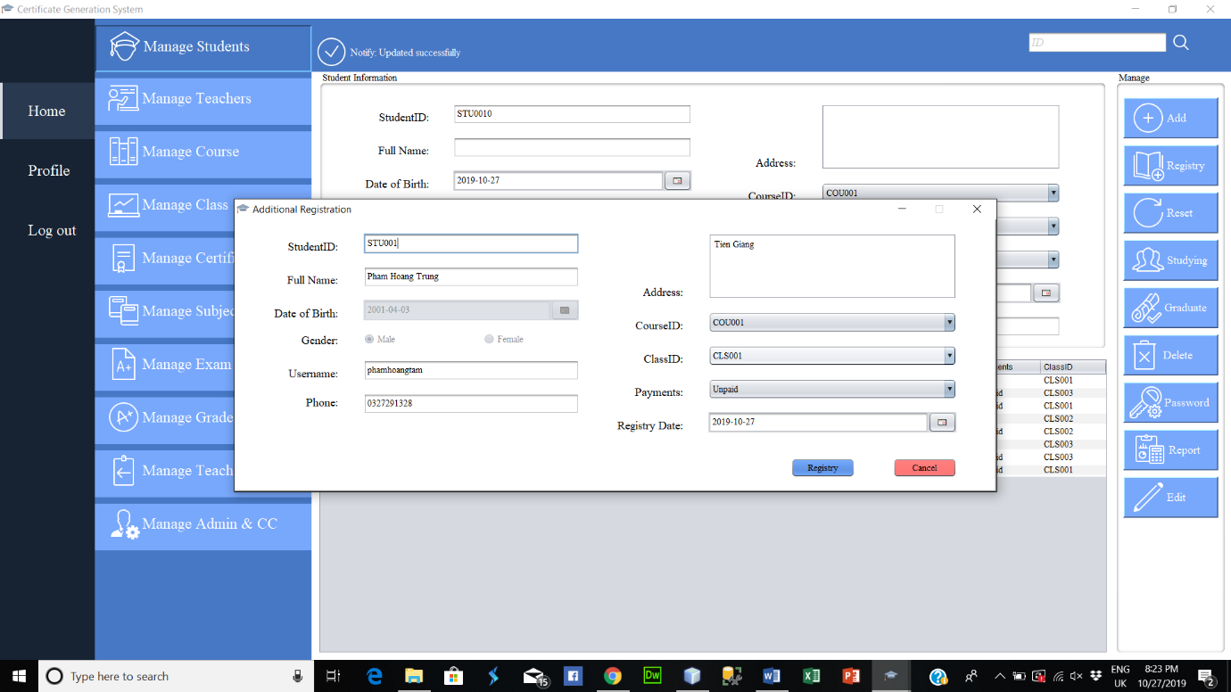

* Reset button to return form to default



* The 'Studying' button to view information about students studying at the Academy

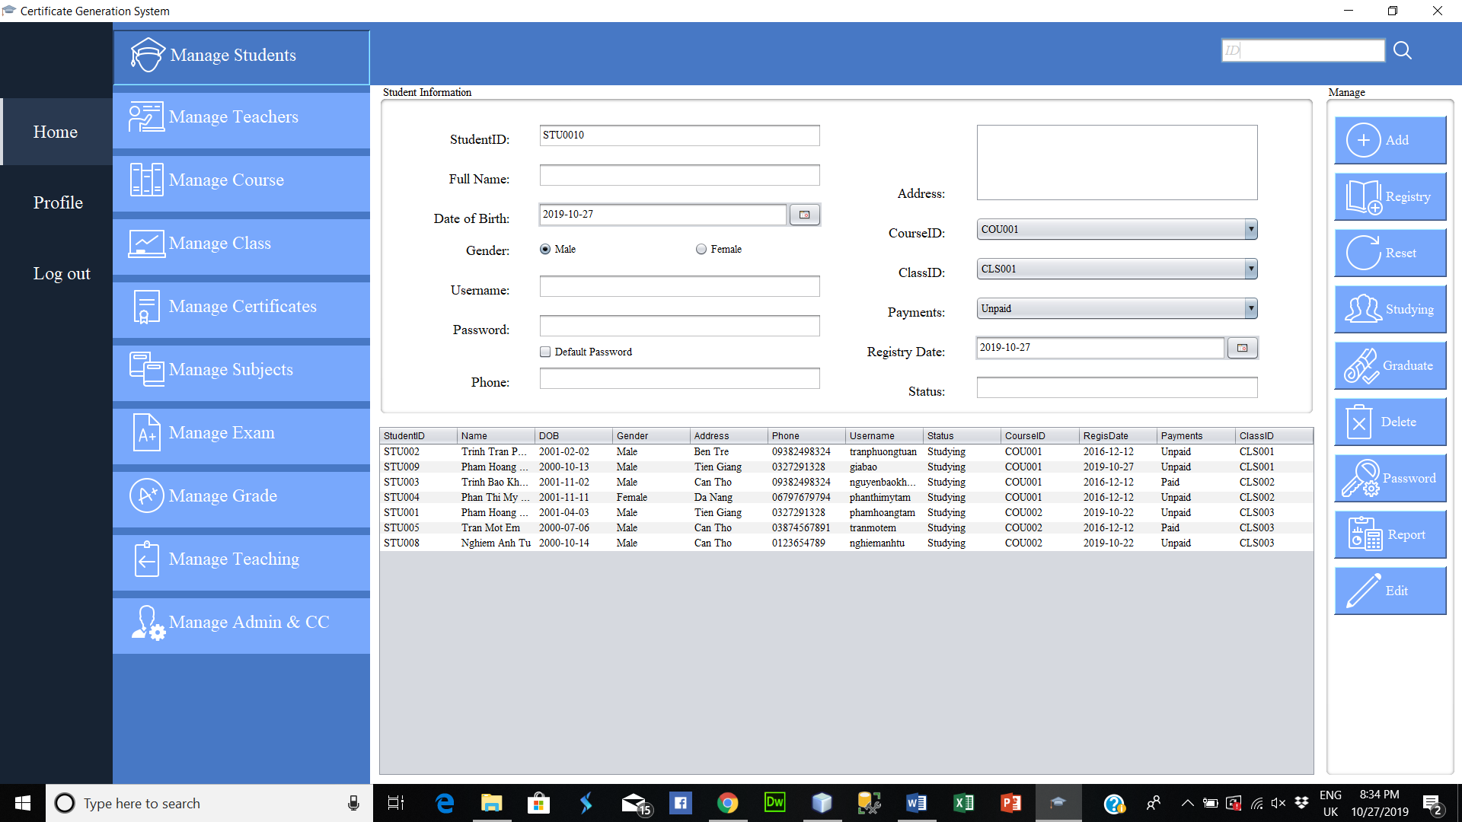

* The 'Graduate' button is used to view information about the graduates of the institute

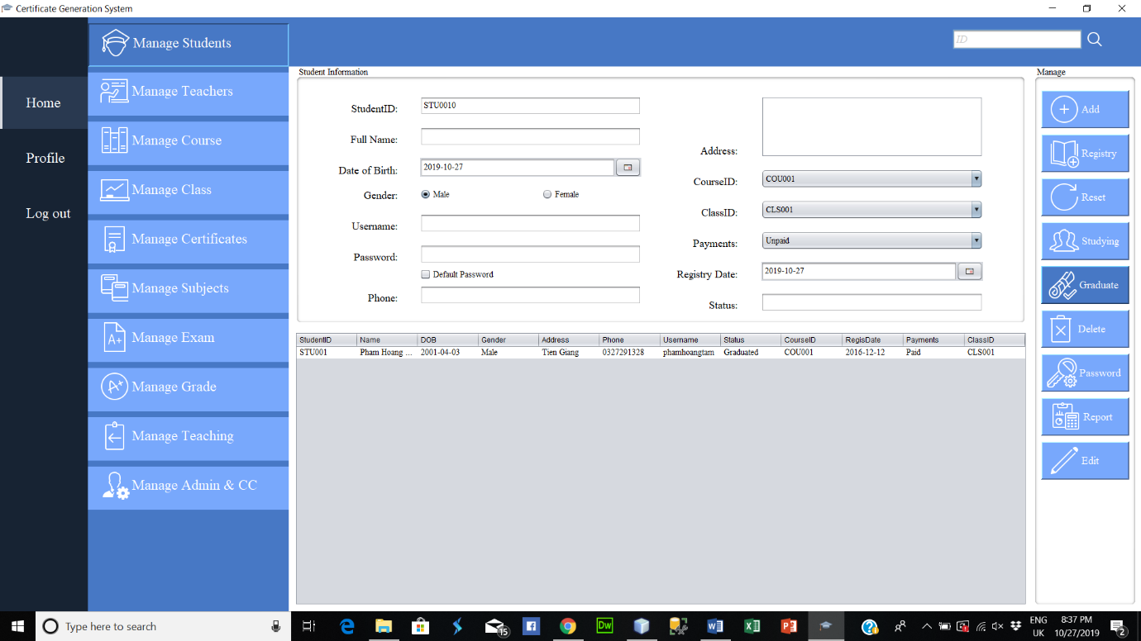

* Click on a student from the table (a row in the table)
  + Click “Edit” button to modify student information. Then, click “Update” button to update or click “Cancel” button to cancel
  + Click “Delete” button to delete student information. Then, click “Ok” if you are sure

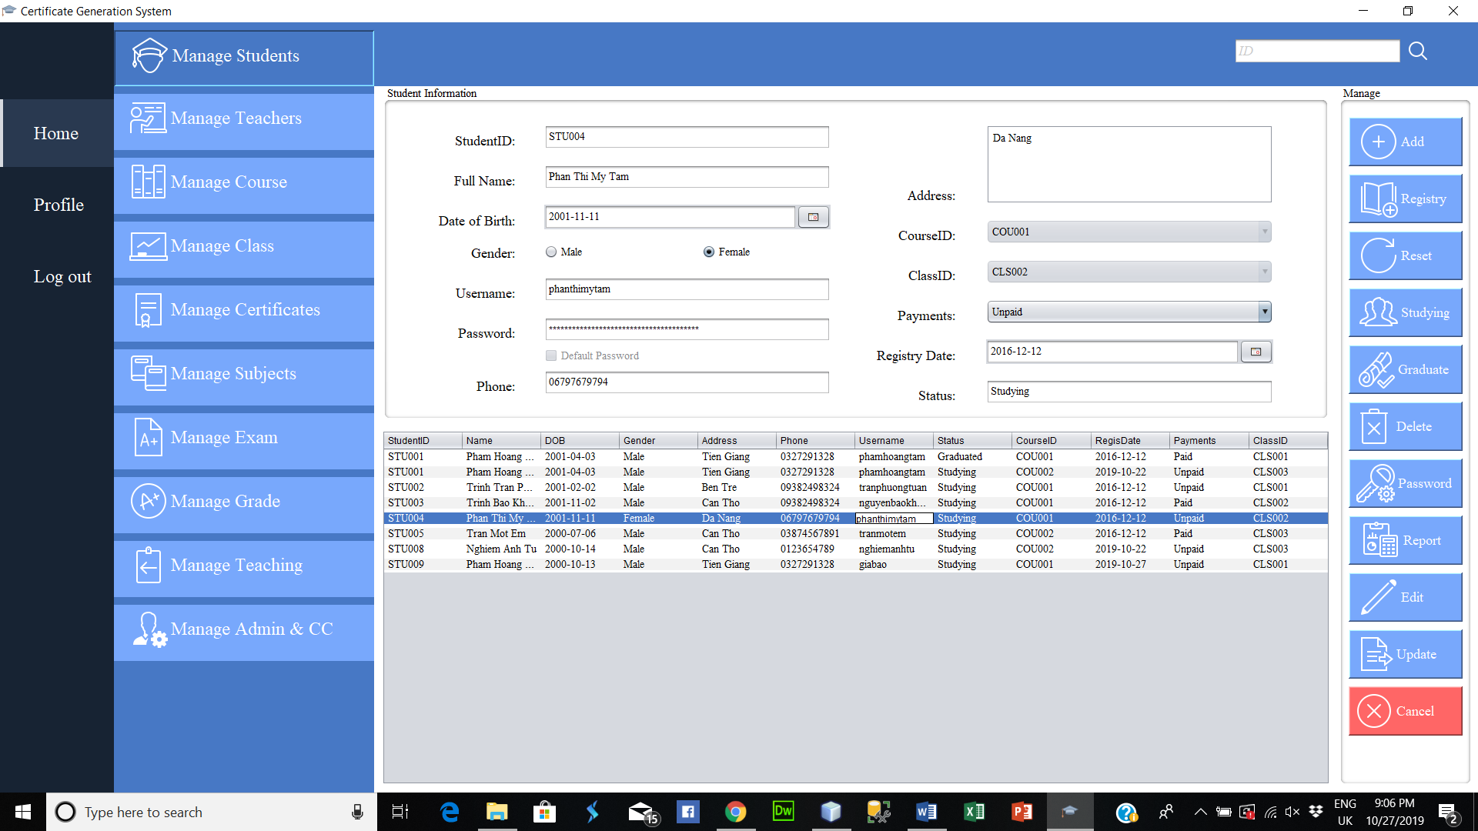

* Click “Password” button to change the password of the student account. Enter the information “Username” and “New password”. Then click “Change” button to change or “Cancel” to cancel.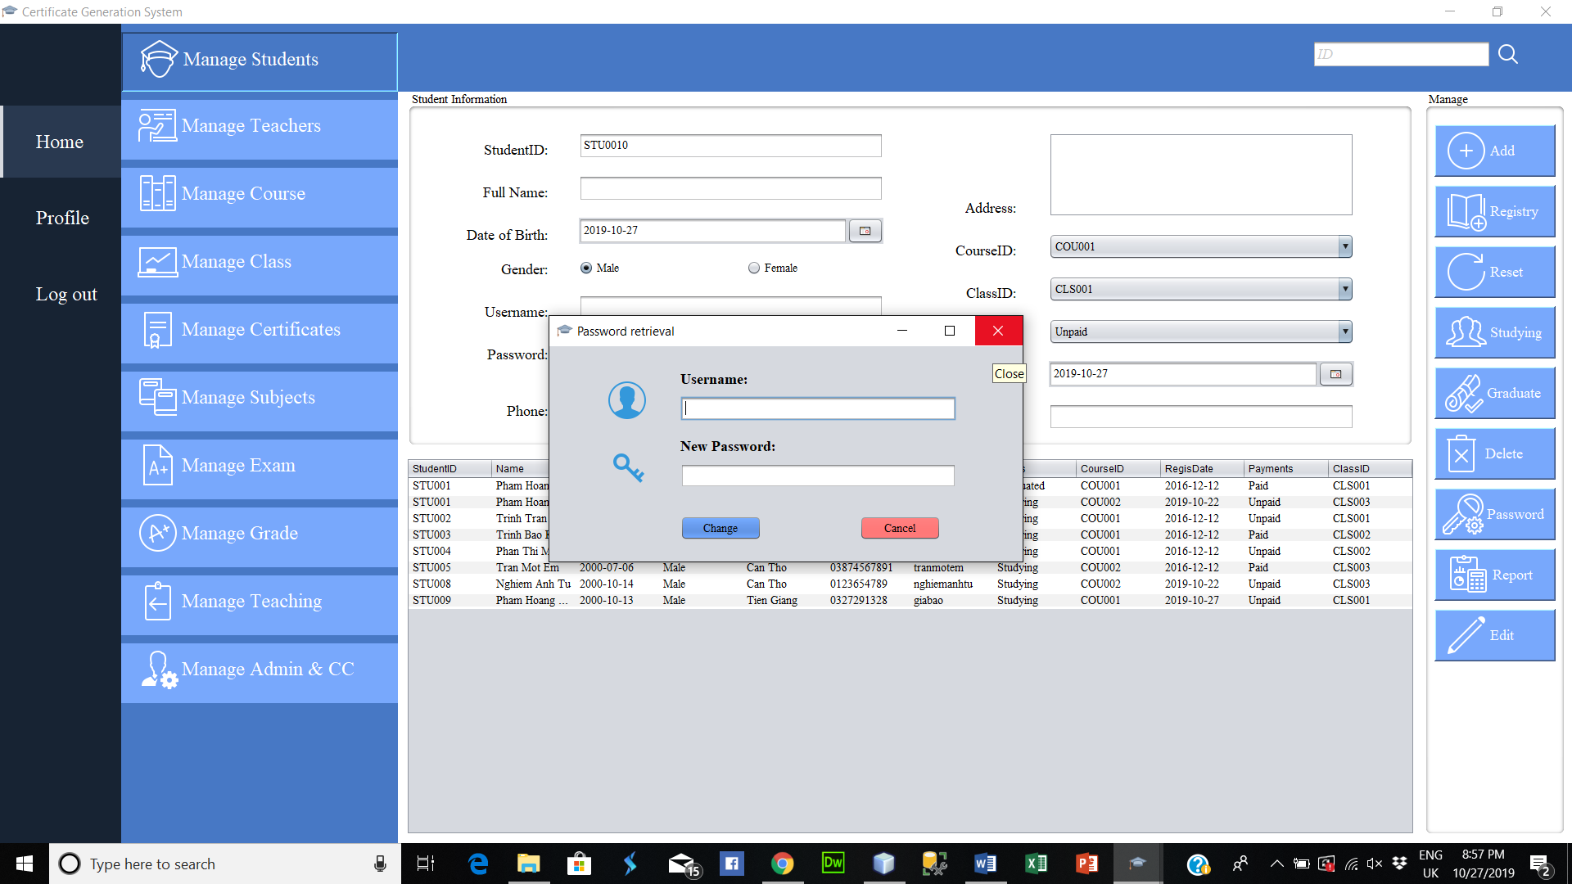
* Click “Report” to create a report with the extension .xlsx (Excel). Enter a name for the file (.xlsx). Select the appropriate path. Then click “Save”

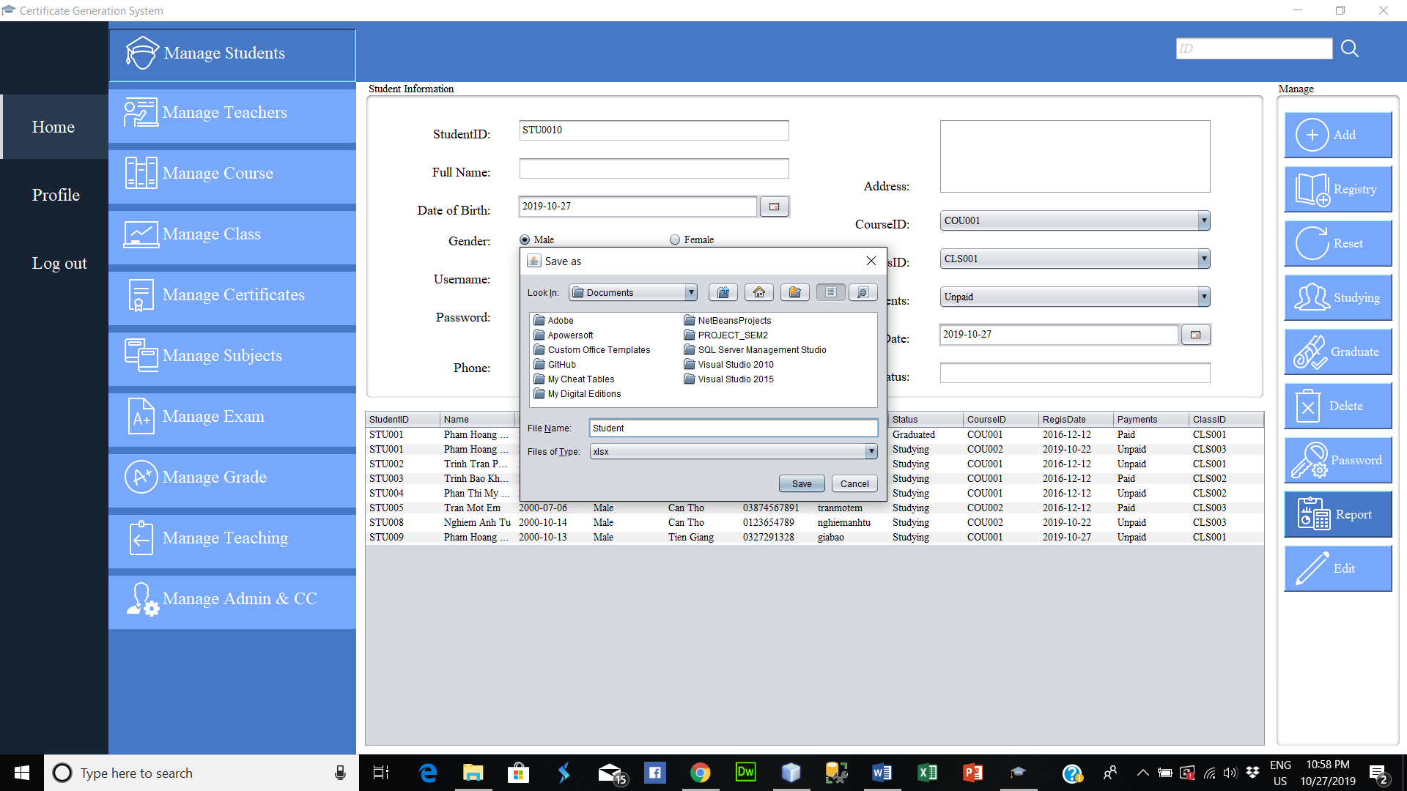

* Enter information in the search text field. The system will rely on the keyword entered to search for corresponding information

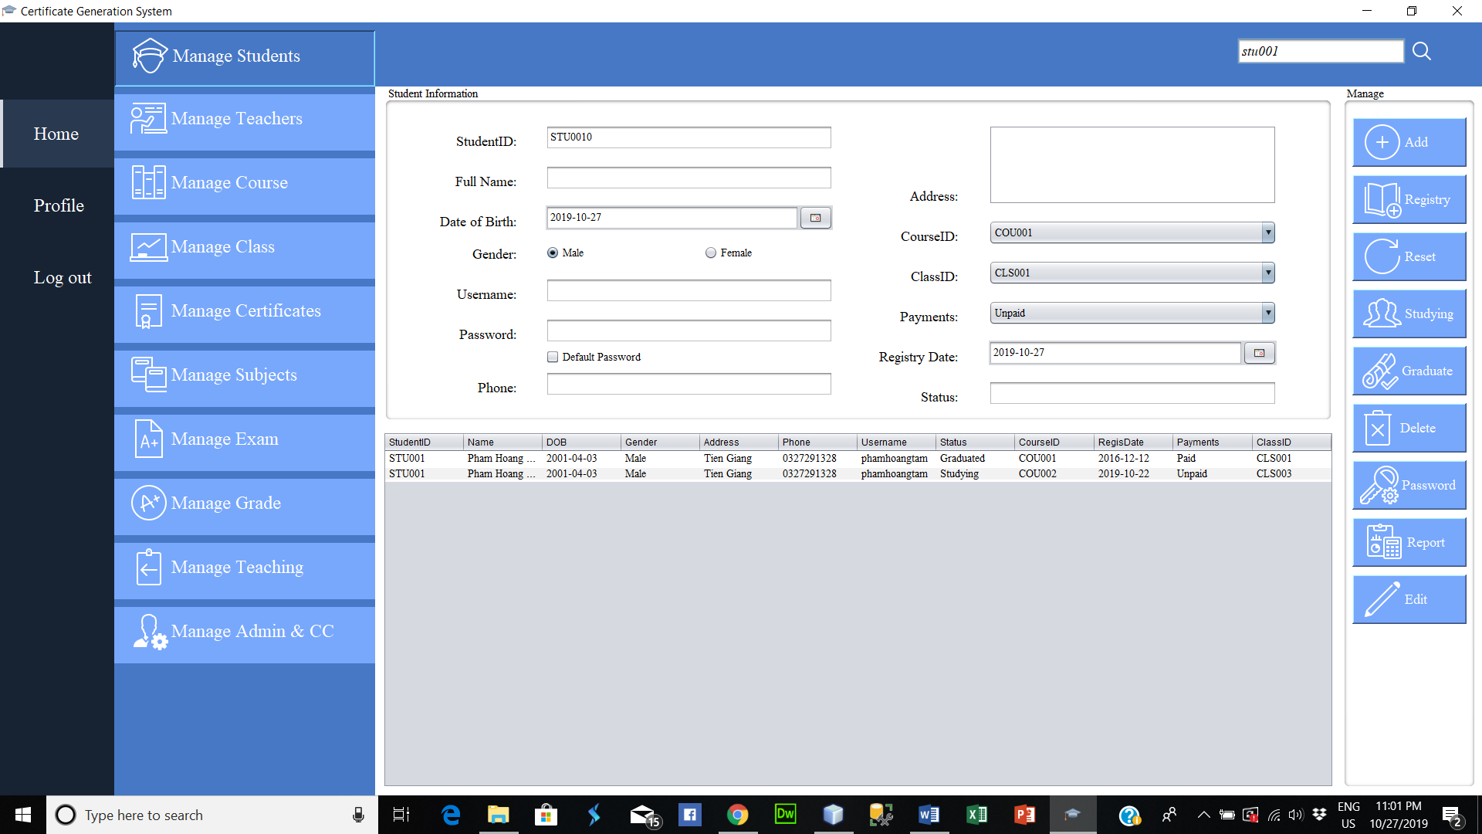

* Same with the buttons of “Manage Student”. Include “Manage Teacher”, “Manage Course”, “Manage Class”, “Manage Certificate”, “Manage Subjects”, “Manage Exam”, “Manage Grade”, “Manage Teaching”, “Manage Adminn & CC”.
* In particular, for the “Manage Certificate” function. Once a student is eligible to graduate (Students have to pay all fee, complete exams and grade above C) administrators and Certificate Cell will be allowed to create a certificate for that student.

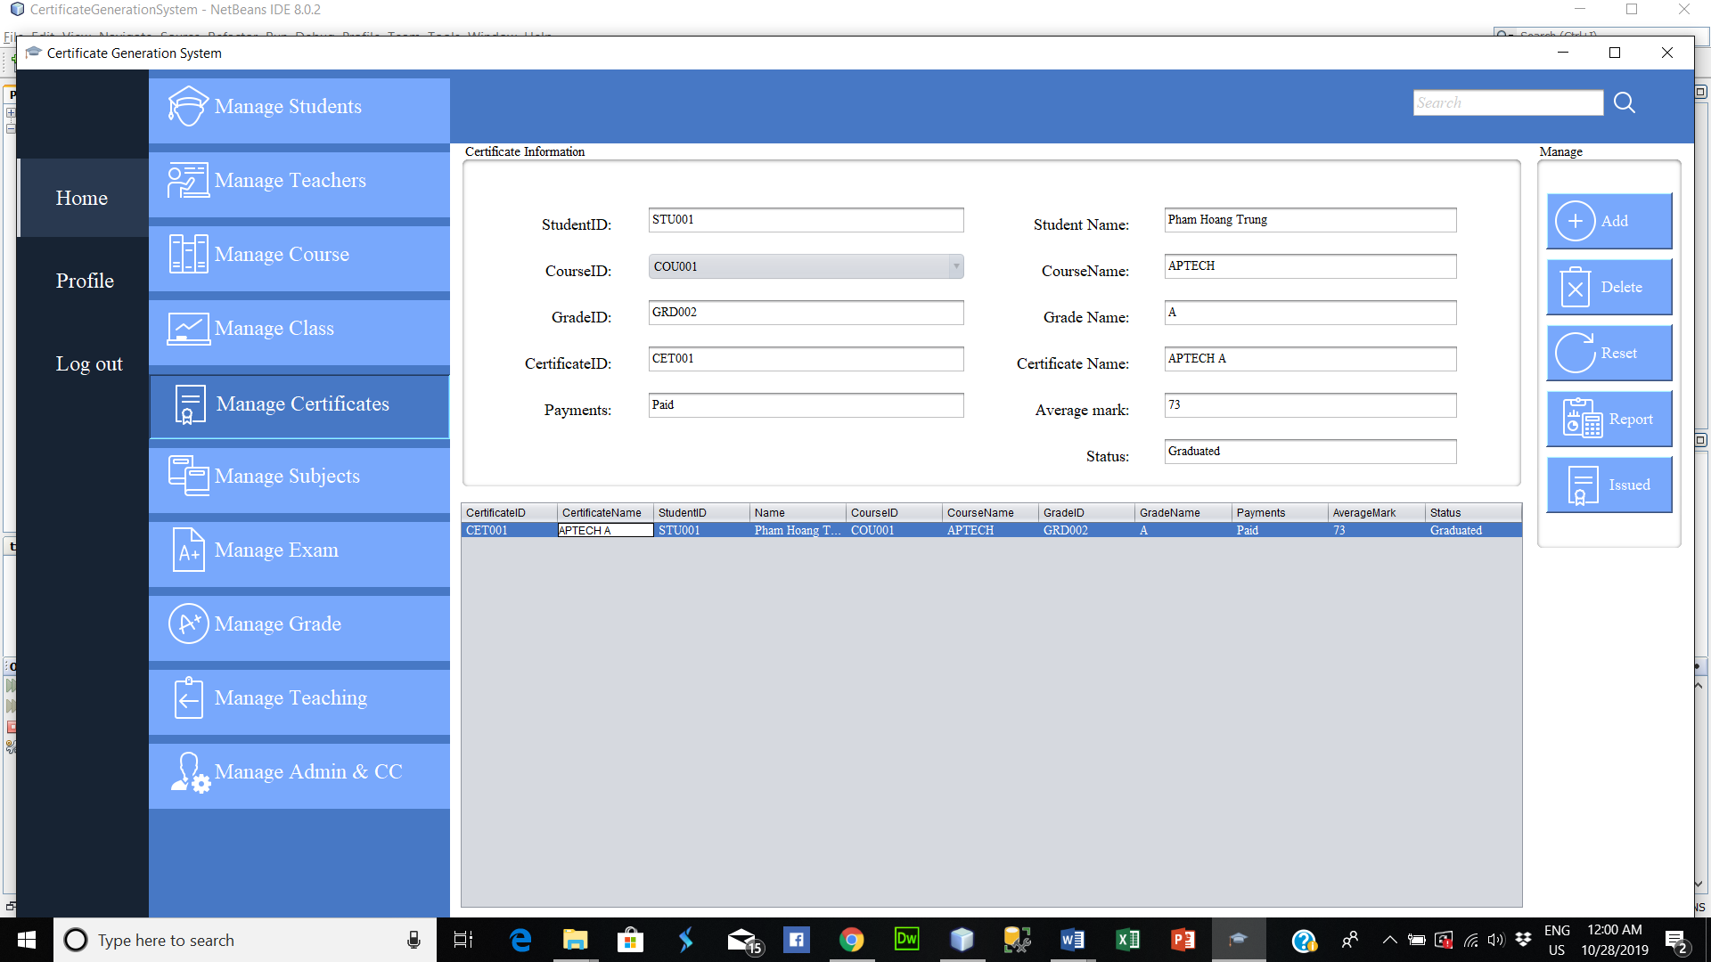

* Click student who have graduated from the table (a row in the table). The 'Issued' button will be displayed. Click the 'Issued' button to create the certificate with the extension .pdf. The certificate is saved in D:/

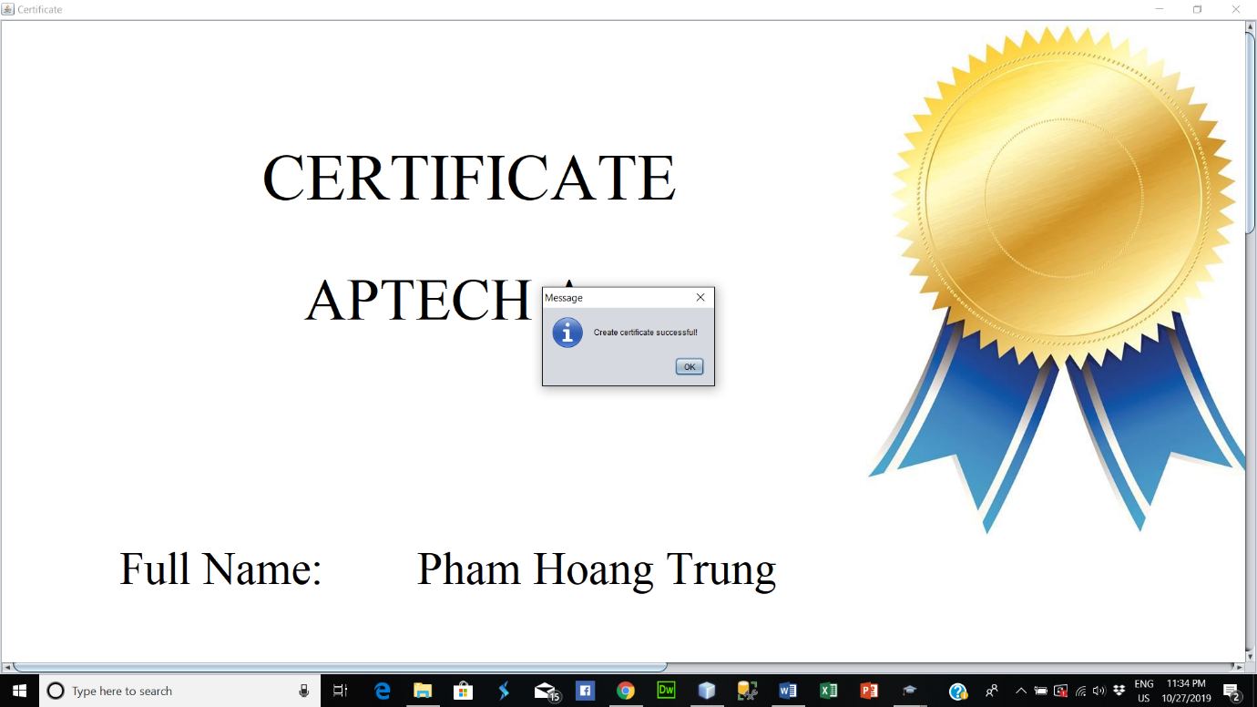

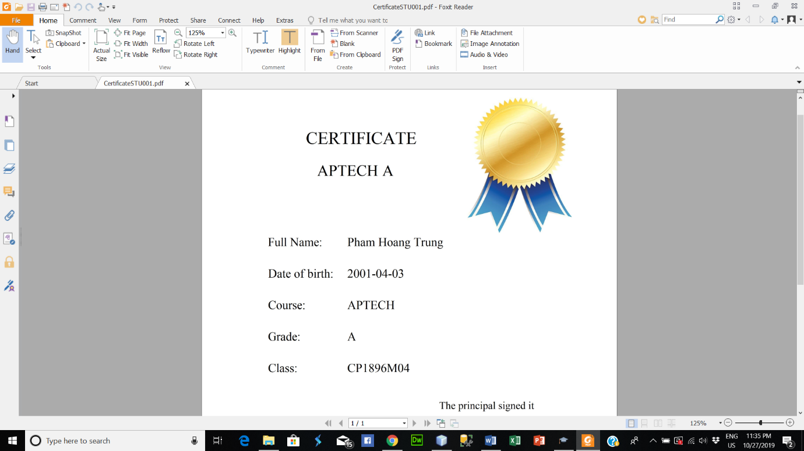

* Log in (with Certificate Cell role). The interface after successful login with Certificate Cell role

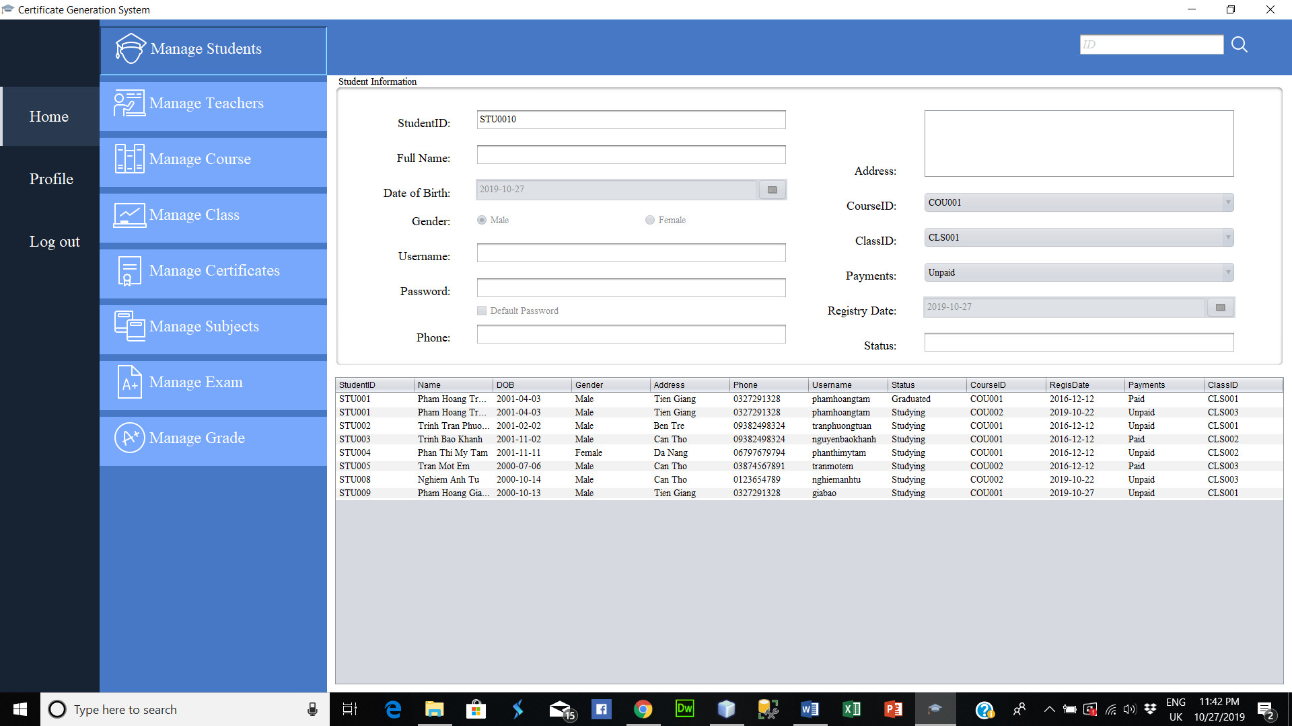

* Certificate Cell is allowed to view, search and verify student status
* Especially, for the “Manage Certificate” function, Certificate Cell is allowed to issue the same certificate as the administrator

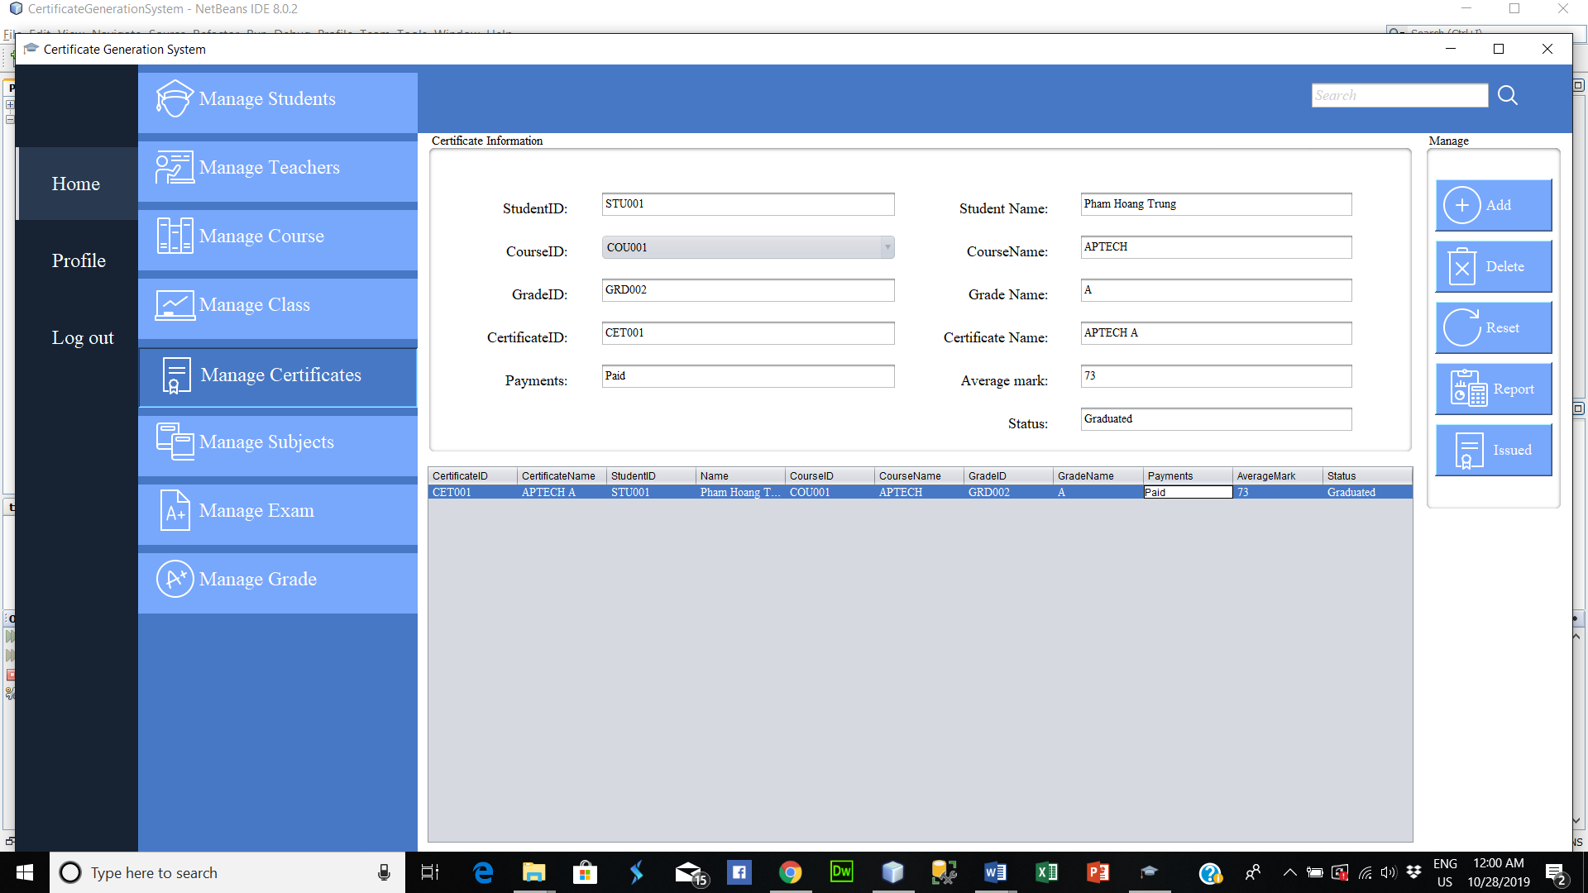

* Admin and Certificate Cell can view their profile by click the “Profile” button. Then, Admin and Certificate Cell can change their password by click the “Change password” button

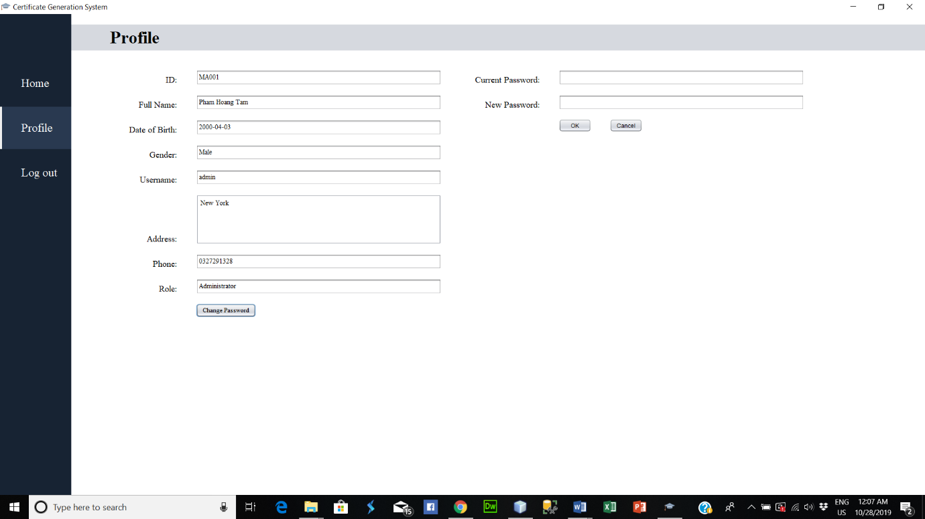

* Login (Student role). The interface after successful login with Student role. Student can view their profile by click the “Profile” button. Then, student can change their password by click the “Change password” button

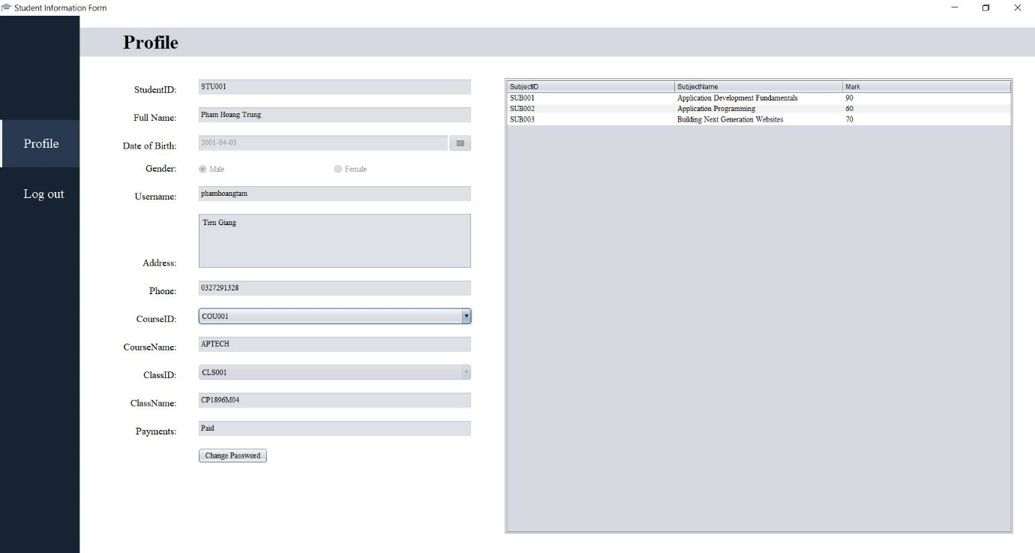

|  |  |  |  |  |  |  |
| --- | --- | --- | --- | --- | --- | --- |
| **Project Ref. No. :** | **Project Title:** | **Activity Plan Prepared By:** | | **Date of Preparation of Activity Plan:** | | |
| **Task Sub division** | **Description** | **Planned Start Date** | **Actual Start Date** | **Actual Days** | **Teams Members Names** | **Status** |
| 1 | Form 3 (Project Plan) | 10-Sep-2019 | 12-Sep-2019 | 3 | Phạm Hoàng Tâm | Completed 100% |
| 2 | Form 6 (ER) | 13-Sep-2019 | 16-Sep-2019 | 4 | Completed 100% |
| 3 | Form 5 (Interface Design) | 17-Sep-2019 | 19-Sep-2019 | 3 | Completed 100% |
| 4 | Form 7(DFD) | 20-Sep-2019 | 23-Sep-2019 | 4 | Completed 100% |
| 5 | Form 9 (Task Sheet) | 10-Sep-2019 | 17-Sep-2019 | 37 | Completed 100% |
| 6 | Form 10 (Testing Document) | 14-Oct-2019 | 17-Oct-2019 | 4 | Completed 100% |
| 7 | Form 11 (Project Review) | 17-Oct-2019 | 17-Oct-2019 | 1 | Completed 100% |
| 8 | Installation Instructions | 9-Oct-2019 | 12-Oct-2019 | 4 | Completed 100% |
| 9 | User manual | 12-Oct-2019 | 13-Oct-2019 | 2 | Completed 100% |
| 10 | Manage Students | 24-Sep-2019 | 27-Sep-2019 | 4 | Completed 100% |
| 11 | Manage Certificate | 28-Sep-2019 | 2-Oct-2019 | 5 | Completed 100% |
| 12 | Manage Authentication | 3-Oct-2019 | 4-Oct-2019 | 4 | Completed 100% |
| 13 | Manage Admin&CC | 5-Oct-2019 | 8-Oct-2019 | 4 | Completed 100% |
| 14 | Issued certificate | 9-Oct-2019 | 11-Oct-2019 | 3 | Completed 100% |
| 15 | Create Report | 11-Oct-2019 | 12-Oct-2019 | 3 | Completed 100% |
| 16 | Search and Verify Student Profile | 12-Oct-2019 | 13-Oct-2019 | 2 | Completed 100% |
| 17 | Form 2B (CRS) | 10-Sep-2019 | 12-Sep-2019 | 3 | Nguyễn Trường Giang | Completed 100% |
| 18 | Form 5 (Interface Design) | 13-Sep-2019 | 15-Sep-2019 | 3 | Completed 100% |
| 19 | Form 7 (DFD) | 16-Sep-2019 | 19-Sep-2019 | 4 | Completed 100% |
| 20 | Form 8 (Coding Standards) | 19-Sep-2019 | 20-Sep-2019 | 2 | Completed 100% |
| 21 | Form 10 (Testing Document) | 14-Oct-2019 | 17-Oct-2019 | 4 | Completed 100% |
| 22 | Manage Course | 20-Sep-2019 | 27-Sep-2019 | 8 | Completed 100% |
| 23 | Manage Exam | 28-Sep-2019 | 10-Oct-2019 | 13 | Completed 100% |
| 24 | Manage Subject | 9-Oct-2019 | 13-Oct-2019 | 5 | Completed 100% |
| 25 | Form 2A (CRS) | 10-Sep-2019 | 12-Sep-2019 | 3 | Nghiêm Anh Tú | Completed 80% |
| 26 | Form 5 (Interface Design) | 17-Sep-2019 | 19-Sep-2019 | 3 | Completed 80% |
| 27 | Form 7 (DFD) | 20-Sep-2019 | 23-Sep-2019 | 4 | Completed 80% |
| 28 | Form 10 (Testing Document) | 14-Oct-2019 | 17-Oct-2019 | 4 | Completed 100% |
| 29 | Mange Grade | 24-Sep-2019 | 2-Oct-2019 | 9 | Completed 90% |
| 30 | Manage Teachers | 3-Oct-2019 | 13-Oct-2019 | 11 | Completed 90% |
| 31 | Form 1 (Problem Definition) | 10-Sep-2019 | 12-Sep-2019 | 3 | Trần Một Em | Completed 100% |
| 32 | Form 4 (GUI Standards) | 13-Sep-2019 | 16-Sep-2019 | 4 | Completed 100% |
| 33 | Form 7 (DFD) | 17-Sep-2019 | 19-Sep-2019 | 3 | Completed 100% |
| 34 | Form 5 (Interface Design) | 20-Sep-2019 | 23-Sep-2019 | 4 | Completed 100% |
| 35 | Form 10 (Testing Document) | 14-Oct-2019 | 17-Oct-2019 | 4 | Completed 100% |
| 36 | Manage Class | 24-Sep-2019 | 30-Sep-2019 | 7 | Completed 100% |
| 38 | Manage Teaching | 1-Oct-2019 | 6-Oct-2019 | 6 | Completed 100% |
| 39 | Manage Personal Account of Student | 7-Oct-2019 | 13-Oct-2019 | 7 | Completed 100% |

|  |  |  |
| --- | --- | --- |
| **S. No** | **Features Tested** | **Remarks** |
| 1 | Authentication (Log In, Log Out) | Good |
| 2 | Manage Student | Good |
| 3 | Manage Teacher | Good |
| 4 | Mange Course | Good |
| 5 | Manage Class | Good |
| 6 | Manage Certificates | Good |
| 7 | Manage Subjects | Good |
| 8 | Manage Exam | Good |
| 9 | Manage Grade | Good |
| 10 | Manage Teaching | Good |
| 11 | Manage Admin & CC | Good |
| 12 | View Profile of Admin & Certificate Cell | Good |
| 13 | Search and Verify Student status | Good |
| 14 | Issued Certificate | Good |
| 15 | Create Report | Good |
| 16 | Manage Personal Account of Student | Good |

|  |  |  |  |  |  |
| --- | --- | --- | --- | --- | --- |
| **Date:** | **Project Plan Activity/ Miletones** | **Work Specification** | **Status of the Activity** | **Remarks** | **Responsibility** |
| From 10-Sep-2019 to 15-Sep-2019 | Analyzing | Analyze and find solutions to meet with the requirement of the problem. | Completed 100% | Good | All member |
| From 16-Sep-2019 to 23-Sep-2019 | Designing | Start designing database and the overall interface for the project after analyzing the problem. | Completed 100% | Good | All member |
| From 24-Sep-2019 to 13-Oct-2019 | Coding | Begin coding after designing database and interface. | Completed 100% | Good | All member |
| From 14-Oct-2019 to 17-Oct-2019 | Testing | Test all the functions to make sure that everything run correctly. | Completed 100% | Good | All member |

**Final Check List**

(This document has to be filled by the teacher only. The teacher will do a complete functionality testing of the application and add his/her findings and suggestions to this form.)

|  |  |  |
| --- | --- | --- |
| **S.No** | **Aspect tested** | **Suggestion/ Remarks** |
| 1. | Have all the modules been properly integrated and are they completely functional? |  |
| 2. | Does each unit meet its objective and purpose?  Are all the validations happening as specified in Process Design? |  |
| 3.. | Have all Design and Coding standards been followed and implemented? |  |
| 4 | Is the GUI design consistent all over? |  |
| 5. | Are the codes working as per the specification? |  |
| 6. | Does the application's functional ity resolve the client problem, and satisfy his needs completely? |  |
| 7. | Have the hard ware and software been correctly chosen? |  |
| 8. | Additional features and utilities that give value addition to the entire project. |  |